

Contents

Analysis 6

Problem Identification 6

Background 6

Current System 6

Research 7

General Overview of Cryptography 7

Classical Ciphers 7

The Caesar Cipher 7

Frequency Analysis 8

The Atbash Cipher 8

The Simple Substitution Cipher 8

The Affine Cipher 9

The Rail Fence Cipher 10

The Vigenère Cipher 10

Index of Coincidence 12

The Beaufort Cipher 12

The Columnar Transposition Cipher 13

The Playfair Cipher 15

The Polybius Square 17

The Autokey Cipher 18

The ADFGX Cipher 18

The ADFGVX Cipher 19

The Hill Cipher 19

The Bifid Cipher 22

Find & Replace 23

Existing Example: Text Mechanic 23

End User 25

User Needs 25

Objectives 26

Proposed Solution 28

Design 29

Screen Designs 29

Main Menu 29

Frequency Analysis 30

Index of Coincidence 31

Letter Mapping 32

Options 32

Main Menu (updated) 33

Find & Replace 34

Autokey Cipher Solver 35

Columnar Transposition Cipher Solver 36

Vigenère Cipher Solver 37

Diagrams 38

Forms 38

Data Flow Diagrams 39

Main Menu - Encryption & Decryption 39

Frequency Analysis 39

Index of Coincidence 40

Options 40

Find & Replace 40

Autokey Cipher Solver 41

Columnar Transposition Solver 41

Vigenère Cipher Solver 41

Validation 42

Main Menu 42

Index of Coincidence Form 43

Suitable Algorithms 44

Ciphers 44

The Caesar Cipher 44

The Atbash Cipher 45

The Simple Substitution Cipher 45

The Affine Cipher 46

The Rail Fence Cipher 48

The Vigenère Cipher 50

The Beaufort Cipher 51

The Columnar Transposition Cipher 51

The Playfair Cipher 53

The Polybius Square Cipher 55

The Autokey Cipher 57

The ADFGX Cipher 58

The ADFGVX Cipher 60

The Hill Cipher 61

The Bifid Cipher 64

Frequency Analysis 68

Index of Coincidence 69

Testing Strategy 70

Technical Solution 71

Stack 74

Main Menu: Creating controls 75

Main Menu: Functions 77

Positive Modulus 77

GetGCDByModulus 77

ModularInverse 77

ExtendedEuclidean 77

CalculateInverseMatrix 77

MakeGrid 80

Digrams 80

FormatOutput 80

Clicking a cell in the datagridview 80

Go Button 83

Reverse Text Button 84

Letters Only Button 84

Help Button 85

Main Menu: Ciphers 88

Caesar Cipher 88

Atbash Cipher 90

Substitution Cipher 90

Affine Cipher 92

Rail Fence Cipher 94

Vigenère Cipher 97

Beaufort Cipher 99

Columnar Transposition Cipher 100

Playfair Cipher 105

Polybius Square 108

Autokey Cipher 110

ADFGX Cipher 112

ADFGVX Cipher 113

Hill Cipher 116

Bifid Cipher 119

Output (normal) 124

Output (brute force) 125

Suggested Solutions 127

Frequency Analysis 128

Index of Coincidence 132

Find & Replace 137

Options 141

Map Letters 143

Autokey Cipher Solver 144

Columnar Transposition Solver 147

Vigenère Cipher Solver 150

Testing 155

Test Table 155

Screenshots 160

Trace Tables 187

GetGCDByModulus 187

ModularInverse & ExtendedEuclidean 187

ExtendedEuclidean Trace Table 187

Stack 188

Evaluation 189

Have the objectives been met? 189

User Feedback 192

Final Comments 193

Bibliography 194

# Analysis

## Problem Identification

A cipher is a set of steps (or ‘algorithm’) for performing encryption and decryption on a message. They are used to maintain both security and privacy by converting information into a form that is intended to only be understood by whoever the message is sent to. However, if an encrypted message is intercepted, the fact that it is encrypted doesn’t necessarily mean that whoever intercepted it cannot decrypt it.

### Background

Year 12 students who join Rochdale Sixth Form College are all invited to partake in some form of ‘enrichment’. This consists of one 70-minute long session a week of a specific activity that students can choose from. The enrichment option I chose to do in Year 12 encouraged and prepared students for certain national challenges and extra qualifications, one of which was the National Cipher Challenge. This challenge tests students’ ability to decrypt messages using a variety of different ciphers. The program I am going to create will hopefully be able to demonstrate the encryption and decryption of messages using different ciphers to future students who choose the same enrichment as I did. It may also be used to demonstrate additional techniques that can be used to solve ciphers, such as text analysis and ‘brute force’.

### Current System

Currently, it is difficult to find programs that provide all the tools necessary to be able to encrypt and decrypt ciphers. It is particularly difficult to find programs that can be used on their own to solve a cipher where the cipher type is unknown. From experience, cipher programs and websites tend to provide encryption and decryption tools, but any extra tools necessary to crack a cipher such as text analysis (e.g. frequency analysis, index of coincidence) and text formatting (e.g. reversing the text, removing spaces) have to be found from other sources. I am going to create a program that can encrypt and decrypt a wide range of ‘classical’ ciphers when the key is known, but also include features necessary to aid a user in solving a cipher that they know little about.

## Research

### General Overview of Cryptography

Cryptography is the study of protecting information by encrypting (‘transforming’) it into a form that is unreadable. This unreadable format is called ‘ciphertext’. Only those who know the key can decrypt (convert into readable form) ciphertext into plaintext (the original, unformatted message).

Cryptography has increased greatly in complexity over time and has gone through various ‘eras’. The earliest ciphers were designed to allow encryption and decryption to be done manually and are much less complex than ciphers used in the real world today.

### Classical Ciphers

Classical ciphers are those invented pre-computer up until around the 1950's (see ref. [1] in bibliography). This project will mainly focus on these kinds of cipher as the mathematics behind them are most realistically possible to implement in comparison to modern day algorithms which are very secure and complex.

The specific types of cipher that I am going to include are:

* The Caesar Cipher
* The Atbash Cipher
* The Simple Substitution Cipher
* The Affine Cipher
* The Rail Fence Cipher
* The Vigenère Cipher
* The Beaufort Cipher
* The Columnar Transposition Cipher
* The Playfair Cipher
* The Polybius Square
* The Autokey Cipher
* The ADFGX Cipher
* The ADFGVX Cipher
* The Hill Cipher
* The Bifid Cipher

#### The Caesar Cipher

The Caesar cipher is a type of substitution cipher in which each letter in the plaintext is replaced by a letter some fixed number of positions down the alphabet. For example, if the letter B was to be encrypted with a right shift of 3, it would become the letter E, and every other letter in the plaintext would be encrypted the same way to form the ciphertext. An example of this cipher being implemented would be:

Normal alphabet: A B C D E F G H I J K L M N O P Q R S T U V W X Y Z

Alphabet shifted by 5: V W X Y Z A B C D E F G H I J K L M N O P Q R S T U

Plaintext: THE CAESAR CIPHER IS A SUBSTITUTION CIPHER

Ciphertext: YMJ HFJXFW HNUMJW NX F XZGXYNYZYNTS HNUMJW

This cipher is very simple and easy to break as there are only 25 different shift values (excluding a shift of 0 since this would just return the ciphertext) assuming the text is in English, so a brute force attack (testing every possible key) could very quickly find the key and uncover the plaintext. Another weakness of the Caesar cipher is that since the plaintext letters have only been shifted, frequency analysis can be conducted on the ciphertext and it would be easy to recognise what certain characters have been shifted to if you compared their frequencies with that of letters in normal English text.

##### Frequency Analysis

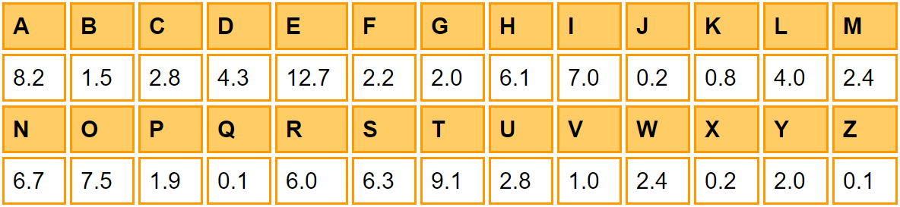

Percentages that the letters of the alphabet appear in English. [2]

Frequency analysis allows text to be decrypted by comparing letter frequencies in normal English text with letter frequencies in the ciphertext. This method is particularly effective against monoalphabetic ciphers such as the Caesar cipher as although the letters change in the ciphertext, the characteristic frequencies do not. So, for example, the most commonly occurring character in the ciphertext is most likely to correspond ‘E’ in the plaintext as ‘E’ is the most common letter in English text, whereas characters in the ciphertext that rarely appear are most likely to translate to letters like ‘X’, ‘J’, ‘Q’ or ‘Z’ in the plaintext.

#### The Atbash Cipher

The Atbash cipher is a type of monoalphabetic substitution cipher that was originally used to encode the Hebrew alphabet, but can also be used with English letters. The cipher alphabet is formed by reversing the normal alphabet so that the first letter becomes the last letter, the second letter becomes the second to last letter etc.

|  |  |  |  |  |  |  |  |  |  |  |  |  |  |  |  |  |  |  |  |  |  |  |  |  |  |  |
| --- | --- | --- | --- | --- | --- | --- | --- | --- | --- | --- | --- | --- | --- | --- | --- | --- | --- | --- | --- | --- | --- | --- | --- | --- | --- | --- |
| Normal Alphabet | A | B | C | D | E | F | G | H | I | J | K | L | M | N | O | P | Q | R | S | T | U | V | W | X | Y | Z |
| Cipher Alphabet | Z | Y | X | W | V | U | T | S | R | Q | P | O | N | M | L | K | J | I | H | G | F | E | D | C | B | A |

The Atbash cipher is not very secure because even if someone did not know the ciphertext was encrypted using the Atbash cipher, they could still break it if they assumed it was a substitution cipher and used frequency analysis to find the plaintext characters. It can also be decrypted using the Affine cipher with an ‘a’ value of 25 and a ‘b’ value of 25 (see Affine Cipher section).

#### The Simple Substitution Cipher

The simple substitution cipher consists of swapping every character in the plaintext for a different ciphertext character. It is different to the Caesar cipher as the cipher alphabet is not a simple shift of the normal alphabet - it is completely jumbled.

Any arrangement of the 26 letters of the alphabet can be used as the cipher alphabet. Traditionally, cipher alphabets are formed by first writing out a keyword, removing any repeated letters in it, then writing out the remaining letters of the alphabet in the conventional order. For example:

Normal alphabet: A B C D E F G H I J K L M N O P Q R S T U V W X Y Z

Cipher alphabet: K E Y W O R D A B C F G H I J L M N P Q S T U V X Z

Plaintext: THIS IS AN EXAMPLE MESSAGE

Ciphertext: QABP BP KI OVKHLGO HOPPKDO

The number of possible keys is 26! which is a very large number. Despite this, the simple substitution cipher is not very strong. This is because frequency analysis can be conducted on a ciphertext of reasonable length to identify what certain characters have been changed to. For example, the most common character in the ciphertext is most likely to be ‘E’ in the plaintext as ‘E’ is the most common character in English text.

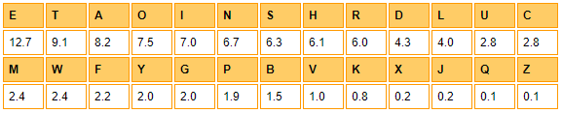

Percentages that the letters of the alphabet appear in English in order of most frequent letter. [2]

#### The Affine Cipher

The Affine cipher is a type of ‘monoalphabetic’ (the substitution is fixed for each letter of the alphabet) substitution cipher. Each letter in the plaintext is converted to its numerical equivalent (A = 0, B = 1, C = 2 etc.) and encrypted using a simple mathematical function. The resulting answer of the mathematical function is then converted back into a letter.

The function used to encrypt a letter is:

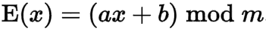

where ‘m’ is the size of the alphabet (26 for English) and both ‘a’ and ‘b’ are keys to be chosen by the user. However, the ‘a’ value must be coprime with ‘m’ which means that the only positive integer that divides both ‘a’ and ‘m’ must be 1. In other words, their greatest common divisor must be 1. This restriction is necessary because the multiplicative inverse of ‘a’ only exists if ‘a’ and ‘m’ are coprime and the multiplicative inverse of ‘a’ is needed as part of the decryption function, which is:

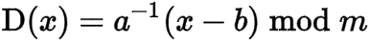

where ‘*a*−1’is the modular multiplicative inverse of ‘a’ modulo ‘m’. This basically means that the value ‘*a*−1’ is such that if ‘a’ is multiplied by (*a*−1 mod m), the answer would be 1.

When ‘m’ = 26, there are 12 possible values of ‘a’. These are 1, 3, 5, 7, 9, 11, 15, 17, 19, 21, 23, and 25. Each of these ‘a’ values can have 26 different shift (‘b’) values, therefore the total number of possible keys is 12 × 26 = 312. This is a relatively small number of keys, which makes a brute force attack realistically possible to be carried out by a computer.

#### The Rail Fence Cipher

The Rail Fence cipher is a form of transposition cipher. Transposition ciphers differ from substitution ciphers in that the letters from the plaintext are not replaced with different letters to form the ciphertext, they are just moved around.

To encrypt a message using the rail fence cipher, the plain text is written downwards and diagonally on a certain number of lines (or ‘rails’), then continues upwards and diagonally once the bottom line is reached. This upwards and downwards pattern repeats until each character in the plaintext has been placed on a ‘rail’. An alternate version of this cipher starts the ‘zigzag’ pattern going upwards and then downwards, but traditionally the pattern used is the one that starts going down first.

Each completed rail is read in order to form the ciphertext. For example, if the message “COMPUTER SCIENCE IS GREAT” was encrypted using 3 rails, the ciphertext would be worked out by first writing the message like this:

|  |  |  |  |  |  |  |  |  |  |  |  |  |  |  |  |  |  |  |  |  |  |
| --- | --- | --- | --- | --- | --- | --- | --- | --- | --- | --- | --- | --- | --- | --- | --- | --- | --- | --- | --- | --- | --- |
| C | - | - | - | U | - | - | - | S | - | - | - | N | - | - | - | S | - | - | - | A | - |
| - | O | - | P | - | T | - | R | - | C | - | E | - | C | - | I | - | G | - | E | - | T |
| - | - | M | - | - | - | E | - | - | - | I | - | - | - | E | - | - | - | R | - | - | - |

Then, after reading each row, the ciphertext becomes:

“CUSNSAOPTRCECIGETMEIER”

Since none of the letters have been changed to other letters, only rearranged, frequency analysis cannot be used to work out the plaintext as the results of the frequency analysis for both the ciphertext and the plaintext would be the same. However, the number of possible practical keys for the cipher is relatively small enough for all of them to be tried, making the cipher vulnerable to brute force attacks.

#### The Vigenère Cipher

The Vigenère cipher is a form of ‘polyalphabetic substitution’. This means that multiple substitution alphabets are used to encrypt the plaintext. Polyalphabetic substitution ciphers are useful because they are not as easily broken by frequency analysis, however if an attacker knows the period (the number of letters encrypted before a polyalphabetic substitution cipher returns to its first cipher alphabet) of the ciphertext, then they could simply frequency analyse each cipher alphabet individually to find the plaintext characters.

To encrypt using the Vigenère cipher, a table of alphabets (also known as a ‘tabula recta’) may be used. The table is made up of the alphabet written out in 26 different rows, each row differing from the previous one by a left shift of 1.

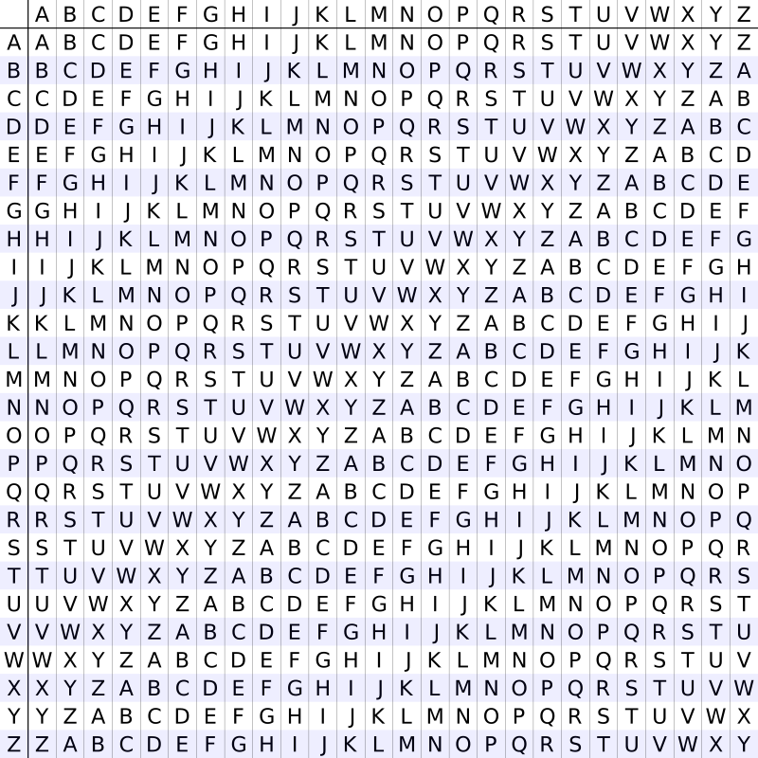

The Vigenère square or Vigenère table, also known as the tabula recta. [3]

At different points during encryption, the cipher uses a different alphabet from one of the rows. The alphabet used when encrypting each letter of the plaintext depends on a keyword that is repeated for the length of the plaintext. For example, using the keyword ‘FRANCE’:

Plaintext: THISCIPHERISNAMEDAFTERAFRENCHGUY

Key: FRANCEFRANCEFRANCEFRANCEFRANCEFR

For each letter in the key, we must first find its corresponding row in the Vigenère square. So, in this example, the first row we would look for is the row ‘F’. Then, we would go along the row and look for the column heading that matches the plaintext letter we are trying to encrypt. The letter at the intersection of the row (‘F’) and column (‘T’) is the ciphertext letter (‘Y’).

Ciphertext: YYIFEMUYEEKWSRMRFEKKEECJWVNPJKZP

To decrypt a message when the key is known, you would find the row in the Vigenère square that corresponds to the letter in the key, then go along the row and find the corresponding ciphertext letter. The column label of the ciphertext letter is the plaintext letter.

However, if the key is not known, it becomes more difficult to decipher. One way to try to decrypt the cipher would be to first discover what the period is i.e. how long the repeating keyword is. Since the keyword is repeated and the plaintext is encrypted depending on the keyword letters, every nth letter in the plaintext (where n is the keyword length) is encrypted using the same shift/row on the table. This is equivalent to every nth letter being encrypted using one kind of Caesar cipher, which means frequency analysis can be used on a string containing every nth letter to find the plaintext letters.

To find the keyword length, one method would be to test the index of coincidence for strings containing every nth letter, trying different values of n. The higher the index of coincidence for a certain value of n, the more likely n is to be the keyword length.

##### *Index of Coincidence*

The Index of Coincidence (or ‘I.C.’) is a statistical technique that indicates how similar to English a piece of text is. A useful property of this technique is that applying a substitution cipher to a piece of text does not change its I.C. value. This is because the I.C. value is dependent on letter frequencies, and substitution ciphers do not change the frequency of individual letters. Texts that are similar to English will have an I.C. of about 0.06, whereas texts where the characters are uniformly distributed will have an I.C. of about 0.03-0.04. The index of coincidence is calculated by:

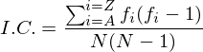

where fi is the count of letter ‘i’ (where ‘i’ = A,B,...,Z) in the ciphertext, and N is the total number of letters in the ciphertext [4].

#### The Beaufort Cipher

The Beaufort cipher is a polyalphabetic substitution cipher similar to the Vigenère cipher. The difference is that the Beaufort cipher encrypts messages using a slightly different algorithm.

Encryption is carried out using the same tabula recta as the Vigenère cipher and a chosen keyword (for example, “BEAUFORT”). The first step would be to write out the keyword repeatedly above the plaintext:

Keyword: BEAUFORTBEAUFORTBEAUFORTB

Plaintext: CRYPTOGRAPHYISINTERESTING

Then, find the column on the table that corresponds to the plaintext letter to encrypt (in this case, we would first look for the ‘C’ column). Go down the column until the corresponding key letter (here it would be ‘B’) is found. The ciphertext character is the row heading of the cell we have located (in this example, the ciphertext letter would be ‘Z’). The resulting ciphertext for the whole plaintext above would be:

Ciphertext: ZNCFMALCBPTWXWJGIAJQNVJGV

Decryption of the Beaufort cipher follows the exact same algorithm as encryption.

#### The Columnar Transposition Cipher

The Columnar Transposition cipher encrypts messages using a keyword of length n. The plaintext is written out in rows of length n, and if the final row is not completely filled, the letter ‘X’ is used to complete the row. For example, using the keyword ‘HIDDEN’:

Plaintext: THISISHOWTOUSETHECOLUMNARTRANSPOSITIONCIPHER

|  |  |  |  |  |  |
| --- | --- | --- | --- | --- | --- |
| **H** | **I** | **D** | **D** | **E** | **N** |
| T | H | I | S | I | S |
| H | O | W | T | O | U |
| S | E | T | H | E | C |
| O | L | U | M | N | A |
| R | T | R | A | N | S |
| P | O | S | I | T | I |
| O | N | C | I | P | H |
| E | R | X | X | X | X |

The columns would then be rearranged such that the letters in the keyword are in alphabetical order.

|  |  |  |  |  |  |
| --- | --- | --- | --- | --- | --- |
| **D** | **D** | **E** | **H** | **I** | **N** |
| I | S | I | T | H | S |
| W | T | O | H | O | U |
| T | H | E | S | E | C |
| U | M | N | O | L | A |
| R | A | N | R | T | S |
| S | I | T | P | O | I |
| C | I | P | O | N | H |
| X | X | X | E | R | X |

Then, each column would be read to form the ciphertext.

Ciphertext: IWTURSCXSTHMAIIXIOENNTPXTHSORPOEHOELTONRSUCASIHX

Since this is a transposition cipher, frequency analysis conducted on the ciphertext would return the exact same results as the plaintext, making it difficult to decipher without knowing the keyword.

If the keyword is known, the ciphertext can be decrypted by first writing out the keyword letters as column headings, and placing numbers underneath each letter to signify their order alphabetically.

|  |  |  |  |  |  |
| --- | --- | --- | --- | --- | --- |
| **H** | **I** | **D** | **D** | **E** | **N** |
| 4 | 5 | 1 | 2 | 3 | 6 |

Then, you would divide the length of the ciphertext by the keyword length to find the number of rows that the grid should have. So, using the ciphertext created above, the number of rows to create would be found by doing 48/6 = 8 rows. You would then fill out each column in the order defined by the numbers underneath the keyword letters using the characters from the ciphertext. The first column filled would look like this:

|  |  |  |  |  |  |
| --- | --- | --- | --- | --- | --- |
| **H** | **I** | **D** | **D** | **E** | **N** |
| 4 | 5 | 1 | 2 | 3 | 6 |
|  |  | I |  |  |  |
|  |  | W |  |  |  |
|  |  | T |  |  |  |
|  |  | U |  |  |  |
|  |  | R |  |  |  |
|  |  | S |  |  |  |
|  |  | C |  |  |  |
|  |  | X |  |  |  |

This process would repeat for the second column:

|  |  |  |  |  |  |
| --- | --- | --- | --- | --- | --- |
| **H** | **I** | **D** | **D** | **E** | **N** |
| 4 | 5 | 1 | 2 | 3 | 6 |
|  |  | I | S |  |  |
|  |  | W | T |  |  |
|  |  | T | H |  |  |
|  |  | U | M |  |  |
|  |  | R | A |  |  |
|  |  | S | I |  |  |
|  |  | C | I |  |  |
|  |  | X | X |  |  |

And so on until all the columns are filled:

|  |  |  |  |  |  |
| --- | --- | --- | --- | --- | --- |
| **H** | **I** | **D** | **D** | **E** | **N** |
| 4 | 5 | 1 | 2 | 3 | 6 |
| T | H | I | S | I | S |
| H | O | W | T | O | U |
| S | E | T | H | E | C |
| O | L | U | M | N | A |
| R | T | R | A | N | S |
| P | O | S | I | T | I |
| O | N | C | I | P | H |
| E | R | X | X | X | X |

The plaintext can then be read off a row at a time, removing the additional ‘X’s from the end of the message.

#### The Playfair Cipher

The Playfair cipher encrypts pairs of letters (called ‘digrams’) instead of single letters through substitution. As a result, it is harder to break as the type of frequency analysis described in the Caesar cipher section does not work for this kind of cipher. Frequency analysis can still be undertaken on the 25 × 25 = 625 possible digrams, but this is considerably more difficult than normal frequency analysis and requires a considerably large ciphertext in order to be useful.

Encryption using the Playfair cipher involves creating a 5 × 5 grid and a keyword. The keyword would be written in the grid starting from the top left corner, ignoring any duplicate letters. The rest of the grid would then be filled with the remaining letters of the alphabet in order, omitting the letter ‘J’. So, if the keyword ‘PLAYFAIR’ was used, the grid would look like this:

|  |  |  |  |  |
| --- | --- | --- | --- | --- |
| P | L | A | Y | F |
| I | R | B | C | D |
| E | G | H | K | M |
| N | O | Q | S | T |
| U | V | W | X | Z |

The plaintext would then be split into digrams. If the plaintext length is an odd number, an uncommon letter such as ‘X’ would be added to the end to make the plaintext divisible by 2.

Plaintext: HELLOMYNAMEISSOPHIE

Digrams: HE LL OM YN AM EI SS OP HI EX

If any of the digrams contain the same letter twice, it is changed so that the second letter in the digram becomes ‘X’ or any other uncommon letter.

Digrams: HE LX OM YN AM EI SX OP HI EX

Each digram is then encrypted using the following rules:

1. If both letters in the digram are on the same row in the grid created earlier, replace each of the digram letters with the letters on their immediate right respectively (wrapping around to the left of the grid if any of the original letters were already on the far right). In this example, the letters H and E are on the same row in the grid, so the H would become K and the E would become G in the ciphertext.
2. If both of the letters in the digram are in the same column on the grid, replace them with the letters that are immediately below them respectively (wrapping around to the top if any of the original letters are already at the bottom). In this example, E and I are in the same column, so E would become N and I would become E in the ciphertext.
3. If the letters are not on the same row or column, form a rectangle on the grid using each of the digram letters as corners. Then, replace each letter with the one in the same row as it but in the opposite corner. For example, using the digram LX:

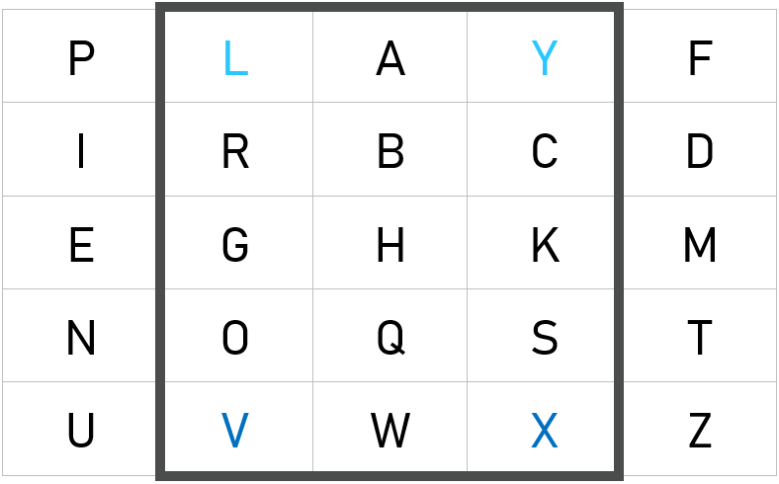

As you can see, L becomes Y and X becomes V.

After following these rules to encrypt each of the digrams, the ciphertext from this example becomes “KGYVTGPSFHNEXYNLEBKU”.

To decrypt, the inverse of the rules stated above is carried out on the ciphertext.

#### The Polybius Square

The Polybius Square uses a 5 × 5 grid just like the Playfair cipher and can be used with a keyword in the same way. However, each column and each row is labelled 1-5 as the coordinates of the letters on the grid are used to form the ciphertext. For example:

|  |  |  |  |  |  |
| --- | --- | --- | --- | --- | --- |
|  | **1** | **2** | **3** | **4** | **5** |
| **1** | P | O | L | Y | B |
| **2** | I | U | S | A | C |
| **3** | D | E | F | G | H |
| **4** | K | M | N | Q | R |
| **5** | T | V | W | X | Z |

To encrypt a message using the Polybius Square, you would take each letter in the plaintext and find its coordinates in the grid. The coordinates of each letter make up the ciphertext, meaning for each letter in the plaintext, there are two ciphertext characters as each coordinate is made up of two numbers. It is up to the encoder to decide whether the coordinates are read (row, column) or (column, row), as long as they are consistent i.e. if they start using (row, column) then they must encrypt the whole message by reading coordinates by (row, column). Here is an example (reading coordinates (row, column)):

Plaintext

FRACTIONATIONISWHENEACHPLAINTEXTCHARACTERISSPLITINTOMULTIPLECIPHERTEXTSYMBOLS

Ciphertext

33 45 24 25 51 21 12 43 24 51 21 12 43 21 23 53 35 32 43 32 24 25 35 11 13 24 21 43 51 32 54 51 25 35 24 45 24 25 51 32 45 21 23 23 11 13 21 51 21 43 51 12 42 22 13 51 21 11 13 32 25 21 11 35 32 45 51 32 54 51 23 14 42 15 12 13 23

Decryption follows the same rules as encryption, but reversed. To decrypt a message, each pair of numbers is taken and used as coordinates to find the plaintext letters in the grid.

This type of cipher is not particularly secure as it is essentially a form of monoalphabetic substitution cipher since each plaintext letter is represented by the same pair of digits each time. Therefore, it is susceptible to frequency analysis.

#### The Autokey Cipher

The Autokey Cipher is a polyalphabetic substitution cipher that is similar to the Vigenère cipher, but uses a different method to encrypt messages. It uses a keyword and a tabula recta to form the ciphertext. To encrypt a message, the keyword would be written above the plaintext. After all the characters from the keyword have been written, the plaintext would be written above the rest of the original plaintext. For example, using the keyword ‘AUTOKEY’:

Keystream: AUTOKEYPLAINTEXT

Plaintext: PLAINTEXTMESSAGE

Using the tabula recta, the row with the first letter to be encrypted is found, and the column that contains the first letter of the key. The intersection letter is the ciphertext letter.

Ciphertext: PFTWXXCMEMMFLEDX

To decrypt a message when the key is known, you would use the tabula recta and find the column that contains the first letter of the key. Then, the ciphertext letter would be located in the column and the row heading would be the plaintext letter. This plaintext letter must be added to the end of the key so that each letter in the ciphertext eventually has a corresponding key letter to be decrypted with.

#### The ADFGX Cipher

The ADFGX cipher is a fractionating transposition cipher which encrypts messages using a modified Polybius square, then applies a single columnar transposition to increase the security of the final ciphertext.

A 5 × 5 grid with the column and row headings ‘ADFGX’ is filled with all letters of the alphabet, omitting ‘j’ as it is an uncommon letter and there are only 25 spaces in the grid. The letters can be in any order. Just like with the Polybius Square, the coordinates of each of the plaintext letters are found (generally in the order (row, column)), but instead of resulting in numbers, the characters that the plaintext is converted into will be a combination of A, D, F, G and X.

Then, using a keyword, the resulting characters are subject to a columnar transposition to form the ciphertext.

Using the same keysquare as in the Polybius Square example and the keyword ‘GERMAN’:

Plaintext: THISCIPHERWASUSEDBYGERMANSINWWI

Before Transposition: XAFXDADFDXDAAAFXFDGXXFDGDFDDDFF DFAAXAGFGFDGXGDDGGFDFDAGFXFXFDA

After Transposition: DDFDDAFDDXXAFAXFDGXFFAXDAGDFAGG GDXXXFDAGDFFXAADGFXDGAFXFDFXDFF

GDXX

Decryption works by undoing the columnar transposition using the keyword and using the grid to find the plaintext letters corresponding to each pair of ‘coordinates’.

#### The ADFGVX Cipher

The ADFGVX cipher is an adaptation of the ADFGX cipher which uses a 6 × 6 grid filled with all the letters of the alphabet and the digits 0-9 in any order chosen by the person encrypting the message. The columns and rows are labelled with the letters A, D, F, G, V and X and the methods for both encryption and decryption are the same as the ADFGX cipher. For example, using the keysquare ‘WARBCDEFGHIJKLMNOPQSTUVXYZ012 3456789’ and the keyword ‘SECRET’:

Plaintext: MEETUSTHEREAT1400

Before transposition: FFDADAGFGGGDGFDGDAAFDAADGFVGXAVFVF

After transposition: DGDDVVFFFFFFDGDAXXAGGAGFFGGAGVADADAX

Decryption of the ADFGVX cipher follows the same method as decrypting the ADFGX cipher.

#### The Hill Cipher

The Hill cipher is a polygraphic (encrypts multiple letters under one operation) substitution cipher that uses matrices to encrypt messages. It uses a square matrix (a matrix with the same number of rows as columns) as a key. Generally, 2 × 2 or 3 × 3 matrices are used, but it could be any size as long as it is square.

If we say that the size of the key matrix used is n × n, then the next step for encryption would be to split the plaintext into chunks of letters, each chunk containing n letters. Extra letters may need to be added to the end of the plaintext to make it divisible by n.

Every letter in the plaintext is converted into numbers, where A = 0, B = 1 etc. Each chunk of letters can then be written as a vector. Each of these vectors is multiplied by the key matrix, then mod 26 is applied so that the resulting values can be converted back into letters. For example:

Plaintext: EXAMPLE

Numbers: 4 23 0 12 15 11 4

Key (3 × 3): $\left(\begin{matrix}16 & 23 & 10 \\ 6 & 17 & 1 \\ 13 & 15 & 20\end{matrix}\right)$

Matrix multiplication of first chunk ‘EXA’:

$\left(\begin{matrix}16 & 23 & 10 \\ 6 & 17 & 1 \\ 13 & 15 & 20\end{matrix}\right)\left(\begin{matrix}4 \\ 23 \\ 0\end{matrix}\right)$ = $\left(\begin{matrix}\left(16×4\right)+\left(23×23\right)+(10×0) \\ \left(6×4\right)+\left(17×23\right)+(1×0) \\ \left(13×4\right)+\left(15×23\right)+(20×0)\end{matrix}\right)$ = $\left(\begin{matrix}593 \\ 415 \\ 397\end{matrix}\right)$ = $\left(\begin{matrix}21 \\ 25 \\ 7\end{matrix}\right) mod 26$

21 = V, 25 = Z and 7 = H therefore the chunk ‘EXA’ would be encrypted into ‘VZH’. This process is repeated for every chunk of letters to form the complete ciphertext.

To decrypt a Hill cipher, you need the decryption matrix and the ciphertext. The decryption matrix can be calculated from the encryption matrix as they are inverses of each other. However, not all matrices have inverses so there will be some matrices that are unsuitable for use as Hill cipher keys. To calculate the decryption matrix from the encryption matrix, you would do the following [5]:

1. If the matrix is 2 × 2, you would first calculate the determinant. If the values in the 2 × 2 matrix are labelled $\left(\begin{matrix}a & b \\ c & d\end{matrix}\right)$, the determinant would be calculated by doing $ad - bc$. Then, to find the inverse matrix, you would do $\left(\frac{1}{determinant}\left(\begin{matrix}d & -b \\ -c & a\end{matrix}\right)\right) mod 26$. If the determinant is 0, an inverse matrix does not exist as $\frac{1}{0}$ is not defined [6]. If the matrix is not 2 × 2, the following steps would need to be taken.
2. Calculate the matrix of minors. For each value in the matrix, ignore all values in the same row and all values in the same column as the current value. Then, calculate the determinant of the remaining values. These determinants are used to form the matrix of minors, which should be the same size as the original matrix.  
     
   The matrix of minors for the encryption key used in the example above would be calculated like this:  
     
   Looking at the first number in the matrix, 16: $\left(\begin{matrix}16 & 23 & 10 \\ 6 & 17 & 1 \\ 13 & 15 & 20\end{matrix}\right)$ $ad - bc=\left(17 ×20\right)-\left(1×15\right)= 325$
     
      
     
   Looking at the next number in the matrix, 23: $\left(\begin{matrix}16 & 23 & 10 \\ 6 & 17 & 1 \\ 13 & 15 & 20\end{matrix}\right)$ $ad - bc=\left(6 ×20\right)-\left(1×13\right)=107$
     
      
     
   This process is repeated for every number in the matrix. The last two calculations would be: $\left(\begin{matrix}16 & 23 & 10 \\ 6 & 17 & 1 \\ 13 & 15 & 20\end{matrix}\right)$ $ad - bc=\left(16 ×1\right)-\left(10×6\right)= -44$ $\left(\begin{matrix}16 & 23 & 10 \\ 6 & 17 & 1 \\ 13 & 15 & 20\end{matrix}\right)$ $ad - bc=\left(16 ×17\right)-\left(23×6\right)= 134$
     
      
     
      
     
   The matrix of minors would be: $$\left(\begin{matrix}325 & 107 & -131 \\ 310 & 190 & -59 \\ -147 & -44 & 134\end{matrix}\right)$$
3. Find the matrix of cofactors. This is done by applying a ‘checkerboard’ of minuses to the matrix of minors that we just calculated. $\left(\begin{matrix}325 & 107 & -131 \\ 310 & 190 & -59 \\ -147 & -44 & 134\end{matrix}\right)$  
     
    → $\left(\begin{matrix}+ & - & + \\ - & + & - \\ + & - & +\end{matrix}\right)$ → $\left(\begin{matrix}325 & -107 & -131 \\ -310 & 190 & 59 \\ -147 & 44 & 134\end{matrix}\right)$  
     
    Matrix of minors Matrix of cofactors
4. Find the adjugate. This is done by swapping the diagonal numbers as shown: $\left(\begin{matrix}325 & -107 & -131 \\ -310 & 190 & 59 \\ -147 & 44 & 134\end{matrix}\right)$ 
     
    → $\left(\begin{matrix}325 & -310 & -147 \\ -107 & 190 & 44 \\ -131 & 59 & 134\end{matrix}\right)$
5. Find the determinant of the original matrix. This is done by multiplying each of the elements in the top row of the original matrix by their matching ‘minor’ determinants. The equation for finding the determinant of a 3 × 3 is: $$|A| = a(ei - fh) - b(di - fg) + c(dh - eg)$$ 
     
    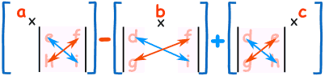  
    Calculating the determinant [5]  
     
   For our example, the calculation would be: $$\left(16 ×325\right)-\left(23 ×107\right)+\left(10 × -131\right)=1429$$
6. Calculate the inverse matrix. The equation for this is $\frac{1}{determinant} ×adjugate$. However, this calculation would result in a matrix full of fractions but we need integers so that we can convert the numbers back into letters. So, instead of using $\frac{1}{determinant}$ we use the modular multiplicative inverse of the determinant since our answer will have mod 26 applied. The modular multiplicative inverse of the determinant is a number *t* such that: $$determinant × t ≡1 (mod 26)$$ 
     
   To find *t*, you would test every number under 26 as the value of *t* to see if $$\left(determinant × t\right) mod 26=1 \\ The value of$$  
   *t* that satisfies the equation is the modular multiplicative inverse. There won’t always be a value that satisfies this equation however; this is because not all matrices have an inverse. Multiply the modular multiplicative inverse by the adjugate matrix to find the inverse matrix. In this example, the inverse matrix is $\left(\begin{matrix}13 & 24 & 17 \\ 3 & 18 & 8 \\ 1 & 19 & 22\end{matrix}\right)$.

This inverse matrix is then used on the ciphertext using the same method as if the ciphertext was being encrypted by the inverse matrix. The result should be the plaintext.

#### The Bifid Cipher

The Bifid cipher uses a Polybius Square and transposition to encrypt messages. Each letter in the plaintext is replaced by its coordinates in the 5 × 5 square and arranged such that the row coordinates of the plaintext letters are all in one line and the column coordinates are in a line directly underneath. For example:

|  |  |  |  |  |  |
| --- | --- | --- | --- | --- | --- |
|  | **1** | **2** | **3** | **4** | **5** |
| **1** | B | I | F | D | A |
| **2** | C | E | G | H | K |
| **3** | L | M | N | O | P |
| **4** | Q | R | S | T | U |
| **5** | V | W | X | Y | Z |

Plaintext: THIS IS THE PLAINTEXT MESSAGE

Row Coordinates: 4214 14 422 335134254 3244122

Column Coordinates: 4423 23 442 515234234 2233532

The numbers are then grouped into certain sized blocks. The size of the groups is called the ‘period’ and forms part of the key. Using a period of 5:

Row Coordinates: 42141 44223 35134 25432 44122

Column Coordinates: 44232 34425 15234 23422 33532

The groups are read left to right, first reading from the top row, then the group underneath it, before reading the groups on the right.

Numbers: 4214144232 4422334425 3513415234 2543223422 4412233532

This string of numbers is then converted back into letters using the original keysquare.

Ciphertext: RDDRMTENTKLFQWOKSEOETIGPM

### Find & Replace

This is a feature that allows substrings entered by the user to be located in a piece of text. It also allows for all located occurrences of the substring to be replaced by a different substring with ease. This is a relevant part to include in the project because there are often times when ciphertext that needs to be decrypted has been formed from an adaptation of a cipher and needs to be modified slightly so that it can be processed by the decryption algorithm. An example of this would be if letters were used instead of numbers in a type of Polybius Square cipher. The Polybius Square decryption algorithm relies on the ciphertext being comprised solely of numbers 1-5, so it would not be able to decrypt ciphertext modified so that the numbers correspond to letters instead. To get around this issue, all occurences of each letter could be found and replaced with the relevant number 1-5 and then put through the decryption algorithm.

I did not initially think to include this feature until a conversation with potential end users during the Design phase (see page 33). I have gone back and added this section to my analysis to aid the design and implementation of the feature.

#### Existing Example: Text Mechanic

‘Text Mechanic’ is a website (<http://textmechanic.com/text-tools/basic-text-tools/find-and-replace-text/>) that allows users to enter a piece of text and find substrings inside the text to replace with different substrings. There is a feature that allows the user to make the substring being located case sensitive, so for example, if I tried to locate ‘chemistry’ with a lowercase c instead of ‘Chemistry’ in the screenshot above, nothing would be replaced because the text contains ‘Chemistry’ with an uppercase C. Additional helpful features include the ‘Select All’ button and the ‘Clear All’ button (labelled ‘S’ and ‘C’).

I think that the case sensitive option and the S/C buttons would be useful to include in my project. The case sensitive feature would be helpful because it improves the searching ability by only locating exact matches case-wise and the S/C buttons would save the user time trying to highlight/clear everything when they could do it with the click of a button. However, I would personally not label the buttons just ‘S’ and ‘C’ as it is not very clear what the buttons do until the user actually uses them. I would instead label the buttons ‘Select All’ and ‘Clear Textbox’ to increase clarity and usability.

## End User

The primary end users of this project will be students from the college who will partake in the National Cipher Challenge. As these students may potentially have no prior knowledge about cryptography, the program should provide help and additional information features as well as a simple user interface to make it easier to use. Beneficial features include labelled controls so that the user knows what each button/text box etc. is for and message boxes when invalid input is given so that the user knows what they have done wrong.

### User Needs

After speaking to other students from college who participated in last year’s challenge, I have identified certain needs that should be fulfilled by the program in order to be of benefit to the end user.

1. The program should be able to encrypt and decrypt all of the ciphers listed in order to give users a first-hand experience of how different ciphers are used.
2. It should be able to perform frequency analysis on a text as this is a key method for figuring out what type of cipher has been used to encrypt a message.
3. The program should be able to calculate the index of coincidence of a piece of text as this is also a common method for analysing ciphertext.
4. There should be information provided about each kind of cipher to help educate students about the steps involved in the encryption and decryption of different ciphers. This could be achieved via labels and/or help buttons.
5. The program should be able to use brute force on ciphers that have a relatively small number of possible keys. This would demonstrate the lack of security of some of the simplest cipher types.
6. There should be tools to aid the user in finding the key and decrypting text without knowing the key in advance.

## Objectives

1. The user should be able to encrypt and decrypt text using each kind of cipher added to the program after inputting necessary information such as the text to be enciphered/deciphered and any keys. The cipher types include:
   1. The Caesar Cipher
      1. The user should be able to use shift values of their choice, within the acceptable range (1-25).
   2. The Atbash Cipher
   3. The Simple Substitution Cipher
      1. The user should be able to use any arrangement of the letters of the alphabet as the key for the cipher.
   4. The Affine Cipher
      1. The user should be able to choose their own ‘a’ and ‘b’ values.
   5. The Rail Fence Cipher
      1. There should be a setting that allows the user to decide which direction the ‘zigzag’ starts in.
   6. The Vigenère Cipher
      1. The user should be able to provide their own keyword.
   7. The Beaufort Cipher
      1. The user should be able to provide their own keyword.
   8. The Columnar Transposition Cipher
      1. The user should be able to provide their own keyword.
   9. The Playfair Cipher
      1. The user should be able to provide their own keysquare.
   10. The Polybius Square
       1. The user should be able to provide their own keysquare.
   11. The Autokey Cipher
       1. The user should be able to provide their own keyword.
   12. The ADFGX Cipher
       1. The user should be able to provide their own keysquare.
       2. The user should be able to provide their own keyword.
   13. The ADFGVX Cipher
       1. The user should be able to provide their own keysquare.
       2. The user should be able to provide their own keyword.
   14. The Hill Cipher
       1. The user should be able to provide their own key matrix.
   15. The Bifid Cipher
       1. The user should be able to provide their own keysquare.
       2. The user should be able to choose a value for the period.
2. There should be a feature that can conduct frequency analysis on a piece of text.
   1. It should be able to display the amount of times each letter appears in the text.
   2. It should be able to display the letter counts in percentage form.
   3. The data should be able to be displayed in a graph.
3. There should be a feature that can calculate the index of coincidence of a text.
   1. The program must be able to calculate the index of coincidence of the whole text given.
   2. It should also be able to calculate the index of coincidence of streams taken from the text that the user has specified the length of i.e. if the user wants to test every third letter in the text, the program should be able to calculate the IC of a string that contains every third letter from the original text.
4. The program should provide information on each type of cipher. This information needs to be detailed enough for someone who is new to cryptography to understand.
5. Brute force should be able to be used on ciphers with a feasible number of possible solutions. These ciphers are:
   1. The Caesar Cipher
   2. The Affine Cipher
   3. The Rail Fence Cipher
6. As there may be a vast amount of brute force solutions, the most feasible solutions found from using brute force should be displayed separately.
   1. The user should be able to provide ‘cribs’ (words that are highly suspected to be in the solution) for the program to search brute force solutions for.
      1. These cribs should be stored in a text file which can be read from, added to and have contents removed from.
      2. If the text file does not already exist, one should be created.
7. The program should be able to help the user find the key for certain ciphers without knowing the key in advance. The ciphers that such a feature would be feasible for are:
   1. The Vigenère cipher
   2. The Columnar Transposition cipher
   3. The Autokey cipher
8. There should be a ‘Find & Replace’ feature for formatting and searching through strings.
   1. The user should be able to input substrings to look for and the number of matches should be displayed.
   2. All instances of the substring that has been searched for should be able to be replaced by a different substring as specified by the user.

## Proposed Solution

I am going to create a Windows Forms Application because although the majority of the program will just involve working with text, which may be achieved from a console based program, I feel that prospective users would find it easier to use a program with a clear interface and features such as buttons and textboxes instead of having to type every instruction. Also, there are many different ciphers and additional features that the user will be able to choose from so it would be tedious to try and list every single possibility in a console program and have the user have to keep entering things into the console when they could achieve the same results faster by pressing buttons on a form application. In addition, objective 2c requires data to be displayed graphically, and form applications are a lot better suited to displaying graphs than console applications.

The user interface needs to be easy to understand, with clear labelling on the controls so that users will be able to quickly figure out what everything does and what inputs are required to give the desired output. For example, the textbox(es) that the key(s) will be entered into for each kind of cipher should be labelled with a relevant instruction stating what the key should contain.

I am going to use C# because it is the programming language I have the most experience with and it is the language we are taught to use in sixth form. It is a suitable choice of language because it integrates well with the Windows operating system, which is what is used in sixth form and therefore very likely to be used by future users. Another advantage is that I know how to implement regular expressions in C# which will be useful when validating user inputs i.e. ensuring that inputted keys are in the correct format for the certain cipher being used.

An alternative programming language I could have decided to use is Python, which I have some experience with as I was taught it in high school. However, I decided against it because I do not have as much experience with it as I do with C# and I do not know how to make a proper GUI in Python, which is an important aspect of my project.

# Design

## Screen Designs

### Main Menu

The program will have a main menu where the user can choose what cipher to use and provide all the necessary inputs for encryption/decryption. The main menu will also have buttons that open new forms for the other features such as frequency analysis and finding the index of coincidence. There will be a help/information button that can be pressed to give background details on the currently selected cipher.

The information shown when the help button is clicked varies depending on which cipher is currently selected.

Data grid view containing the names of the ciphers. One type of cipher can be selected at once.

Help/information button

Textbox that the plaintext/ciphertext should be entered into. It is scrollable to accommodate large amounts of text.

Textbox that the key should be entered into. The text in the label above changes depending on which cipher is selected.

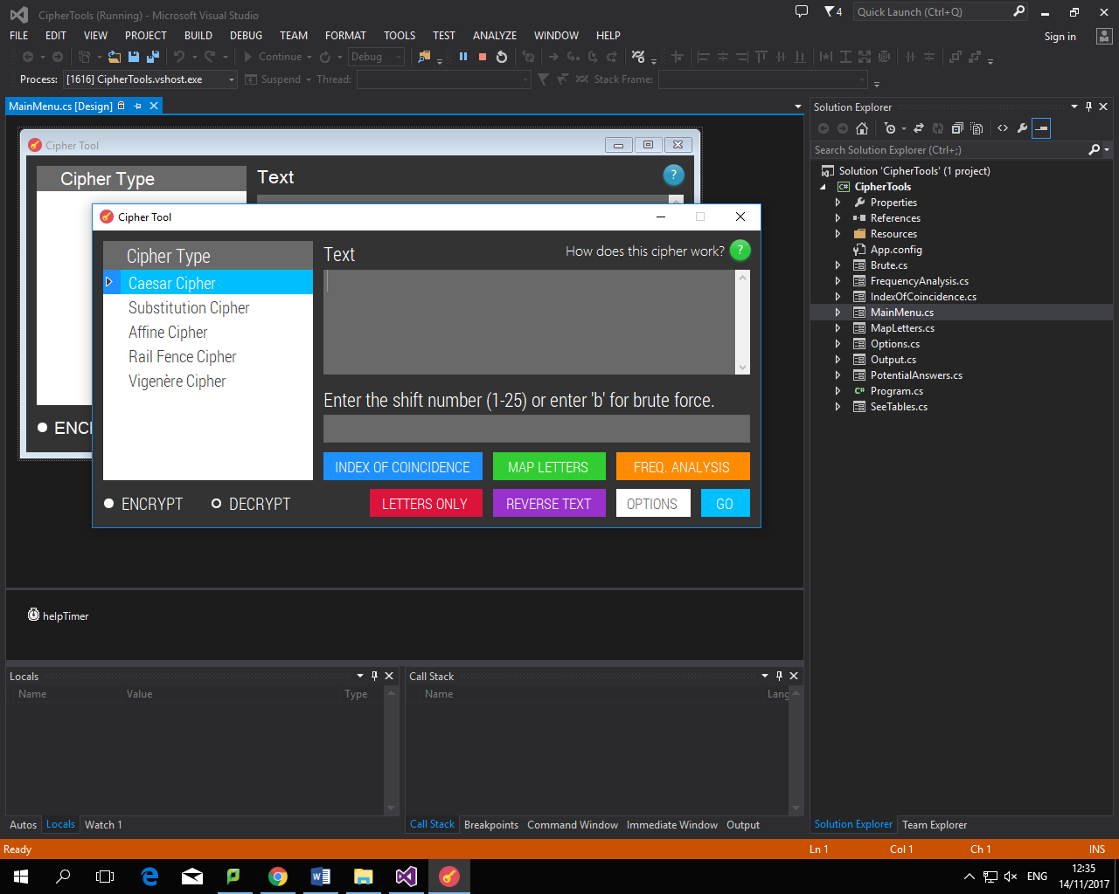

Textbox for the key to be inputted into

These buttons will cause new forms to open with relevant controls. I chose to design it this way as I thought the form would get too crowded if I tried to put everything on one screen

Radio buttons used to change between encrypt/decrypt mode – only one of the buttons can be selected at once because the program needs to know whether to encrypt or decrypt

Opens new form that allows a substitution alphabet/key to be easily made

Formats the text in the main text box as described in the button text. Reversing text before/after encryption is a common technique from experience so I thought this feature would be useful.

Opens new form with the brute force settings

Starts encrypting/

decrypting the message, then displays the result in a new form

### Frequency Analysis

Textbox for the text to be analysed to be entered into.

Help/information button. Once pressed, a message box will open detailing what ‘Frequency Analysis’ is and how to use this tool.

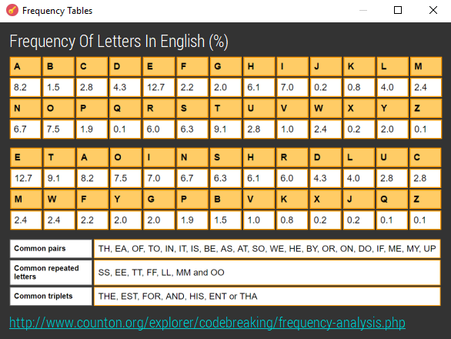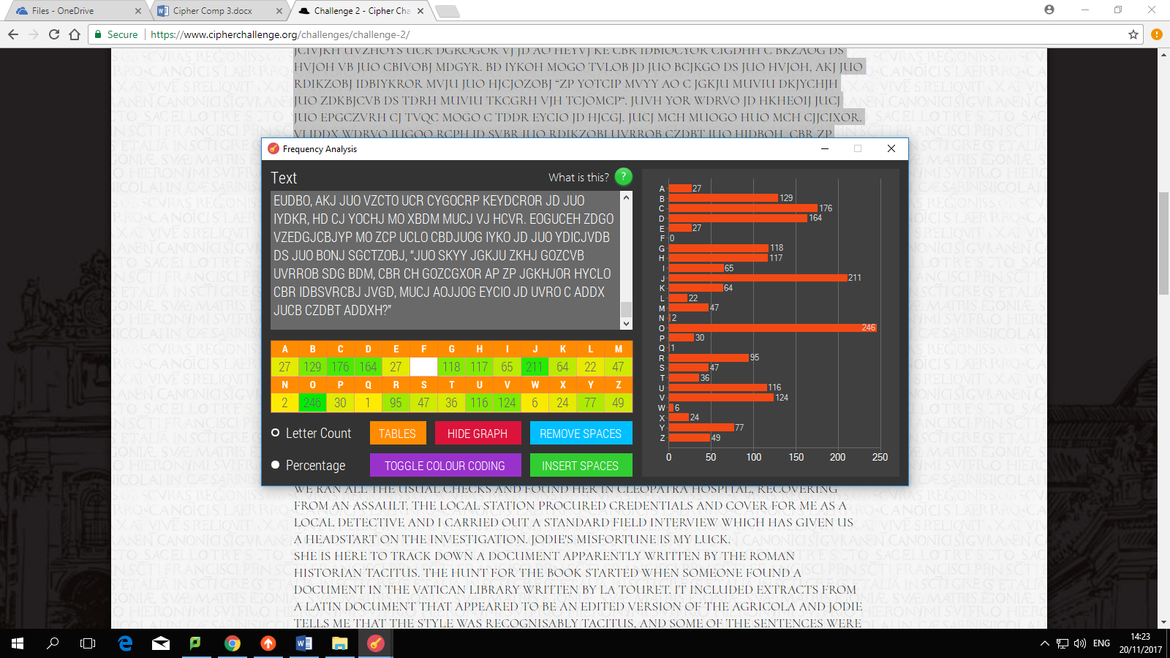

The link should open when clicked; the website provides more information on frequency analysis

The user can choose whether the colour in the frequency table is turned off/on.

Text formatting tools:

Remove Spaces - replaces the text in the textbox with the same text but without any spaces.

Insert Spaces - inserts a space after every 5 characters.

Opens a new form containing information on English character frequencies displayed in tables to be used as a reference.

The frequencies of the letters may be displayed by count or by percentage.

The frequencies of the letters are displayed in graphical form.

### Index of Coincidence

This form will open when the ‘Index of Coincidence’ button is pressed on the main menu. It has a textbox for the user to enter the text that they want to calculate the index of coincidence of. There are two options; one to calculate the IC of the text as it is, and the other option allows the IC of different strings containing every n letters (n = period) to be calculated.

Help/information button. Once pressed, a message box will open detailing what ‘Index of Coincidence’ is and how to use this tool.

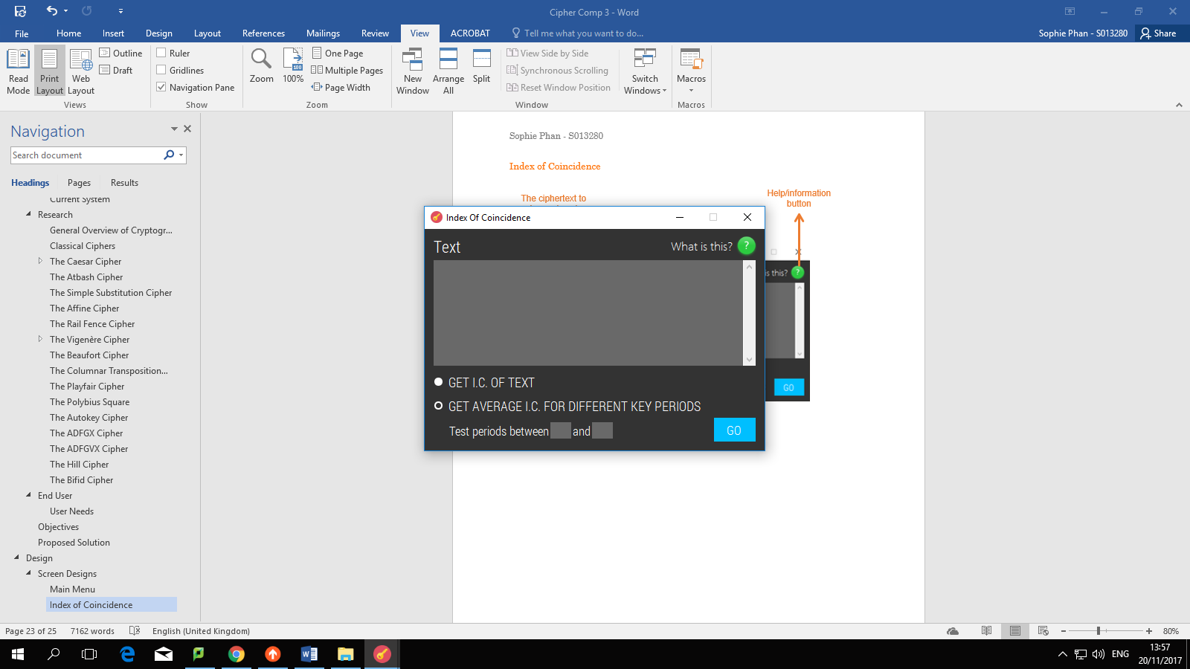

Allows the user to choose a range of periods to test. The lower and upper limits of the range should be entered in these text boxes.

Tells the program to do the calculations once pressed.

When this is selected, the average index of coincidence is calculated for strings of every n letters. The values of n tested are chosen by the user.

If this radio button is selected, the index of coincidence of the whole text is calculated and will be displayed in a message box once the ‘Go’ button is pressed.

The ciphertext to be analysed should be entered here.

### Letter Mapping

Help/information button. Once pressed, a message box will open explaining how to use this tool.

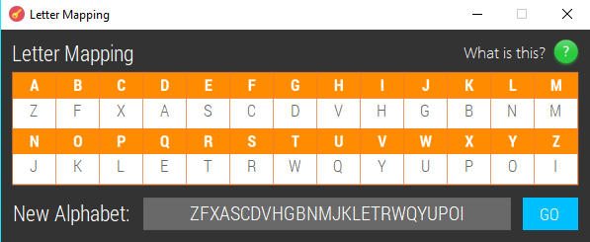

Each of the white boxes are text boxes that should each accept one character. Once all the text boxes are filled, a substitution alphabet can be made.

This textbox will appear with the mapped alphabet once the ‘Go’ button is pressed. This makes it easy for the user to copy and paste the substitution alphabet they have made.

This button will cause the new alphabet to be displayed in the text box on the left of the button.

### Options

Help/information button. Once pressed, a message box will open explaining how to use this tool.

Textbox that allows the user to enter a keyword to add to file. These keywords are searched for during brute force decryption to try to identify the best solutions.

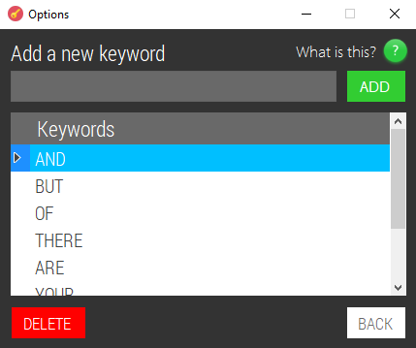

Deletes the currently selected keyword from file.

Button that returns to the main menu

If the word entered in the textbox is valid (does not already exist in file) it is added to the keyword file and displayed in the table. Otherwise, an error message will be shown.

From speaking to potential users, I found that a feature I had not previously thought of would be useful for the program. The suggestion was a ‘Find & Replace’ feature that could be used to search and modify strings. I have added appropriate objectives for this to the ‘Objectives’ section.

### Main Menu (updated)

Features that were not shown in the original main menu screen design are described here:

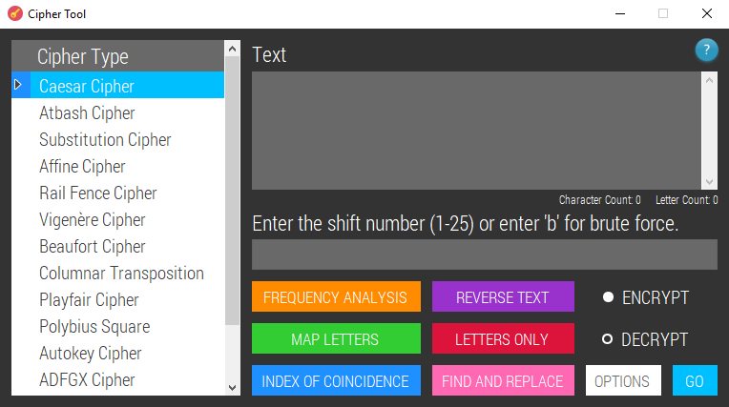

Keeps track of both the number of characters in the main textbox and the number of characters that are specifically letters. I added this because it is sometimes useful to be able to work out the factors of the text length to help find the key for transposition ciphers.

Button that opens a new form with the ‘Find & Replace’ features

### Find & Replace

The substring to search the text for should be entered into this textbox. Occurrences of the substring should be highlighted in the main textbox.

The text that the user wants to search through should be pasted into this textbox.

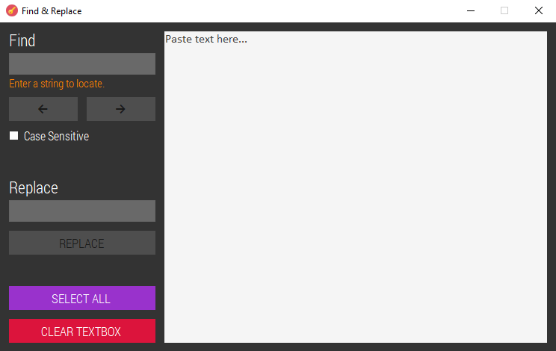

All of the text in the main white textbox is selected when this button is pressed. This makes it easier for the user to copy and paste text.

All instances of the located substring will be replaced with whatever is entered in this textbox once the ‘Replace’ button is pressed.

When checked, occurrences of the specified substring are only highlighted if both the letters and whether or not the letters are upper/lowercase match

‘Next’ and ‘Previous’ buttons - the various occurrences of the substring can be navigated through using these buttons.

Clears all of the text in the main textbox.

### Autokey Cipher Solver

The output text will be displayed here. The user should not be able to modify this text from typing into the textbox; the output should only be modified by the sliders.

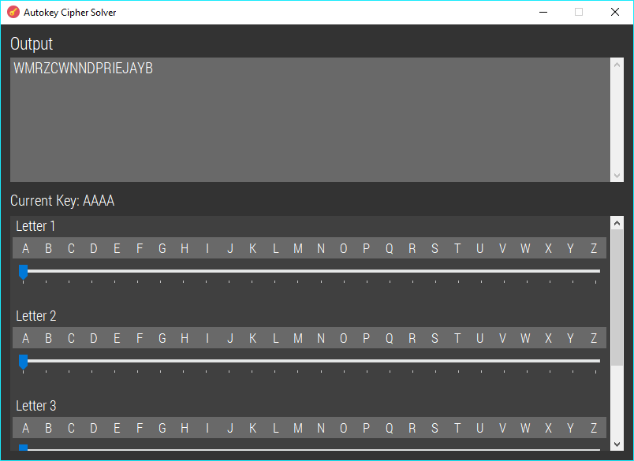

From the main menu, the user will first input the size of the key (n) and this form will open with ‘n’ amount of sliders. The sliders can be used to attempt different combinations of letters as the key and the text in the output box will change in real-time.

Displays the current key being used in accordance with the sliders.

### Columnar Transposition Cipher Solver

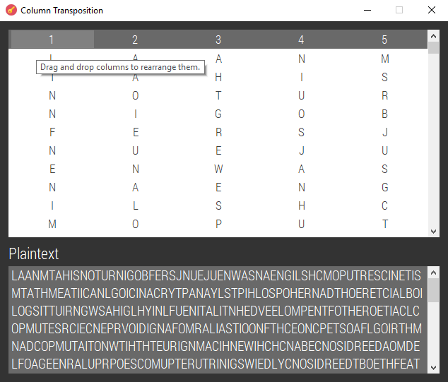

The columns can be moved by the user to try and find the right arrangement. The number of columns is specified by the user from the main menu.

The text in this box is formed by reading across the columns. It should automatically update after the user changes the column order.

### Vigenère Cipher Solver

The output text will be displayed here. The user should not be able to modify this text from typing into the textbox; the output should only be modified by the sliders.

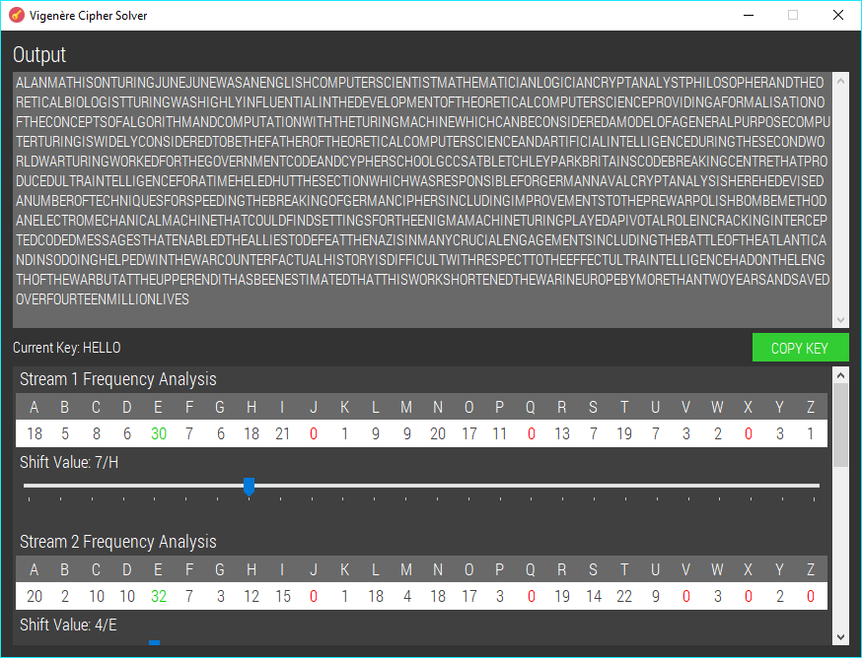

The highest number in each stream should be highlighted green for easy identification. When the form loads, the sliders should automatically move to the setting where the most common letter is shifted/assumed to be ‘E’ as ‘E’ is the most common letter in English text. The user can adjust the sliders so they can try to find the right key.

From the main menu, the user will first input the size of the key (n) and this form will open with ‘n’ amount of sliders. The frequency analyses show the number of occurrences of each letter in each stream; for example, if the key were 5 letters long, the first stream would show the frequency analysis for every 5 letters starting from the first letter; the second stream would show the frequency analysis for every 5 letters starting from the second letter etc.

Allows the key to be copied to the clipboard.

Displays the current key being used in accordance with the sliders.

## Diagrams

### Forms

This diagram shows how the forms link together. I have made annotations with extra details about forms/message boxes that should appear under different circumstances.

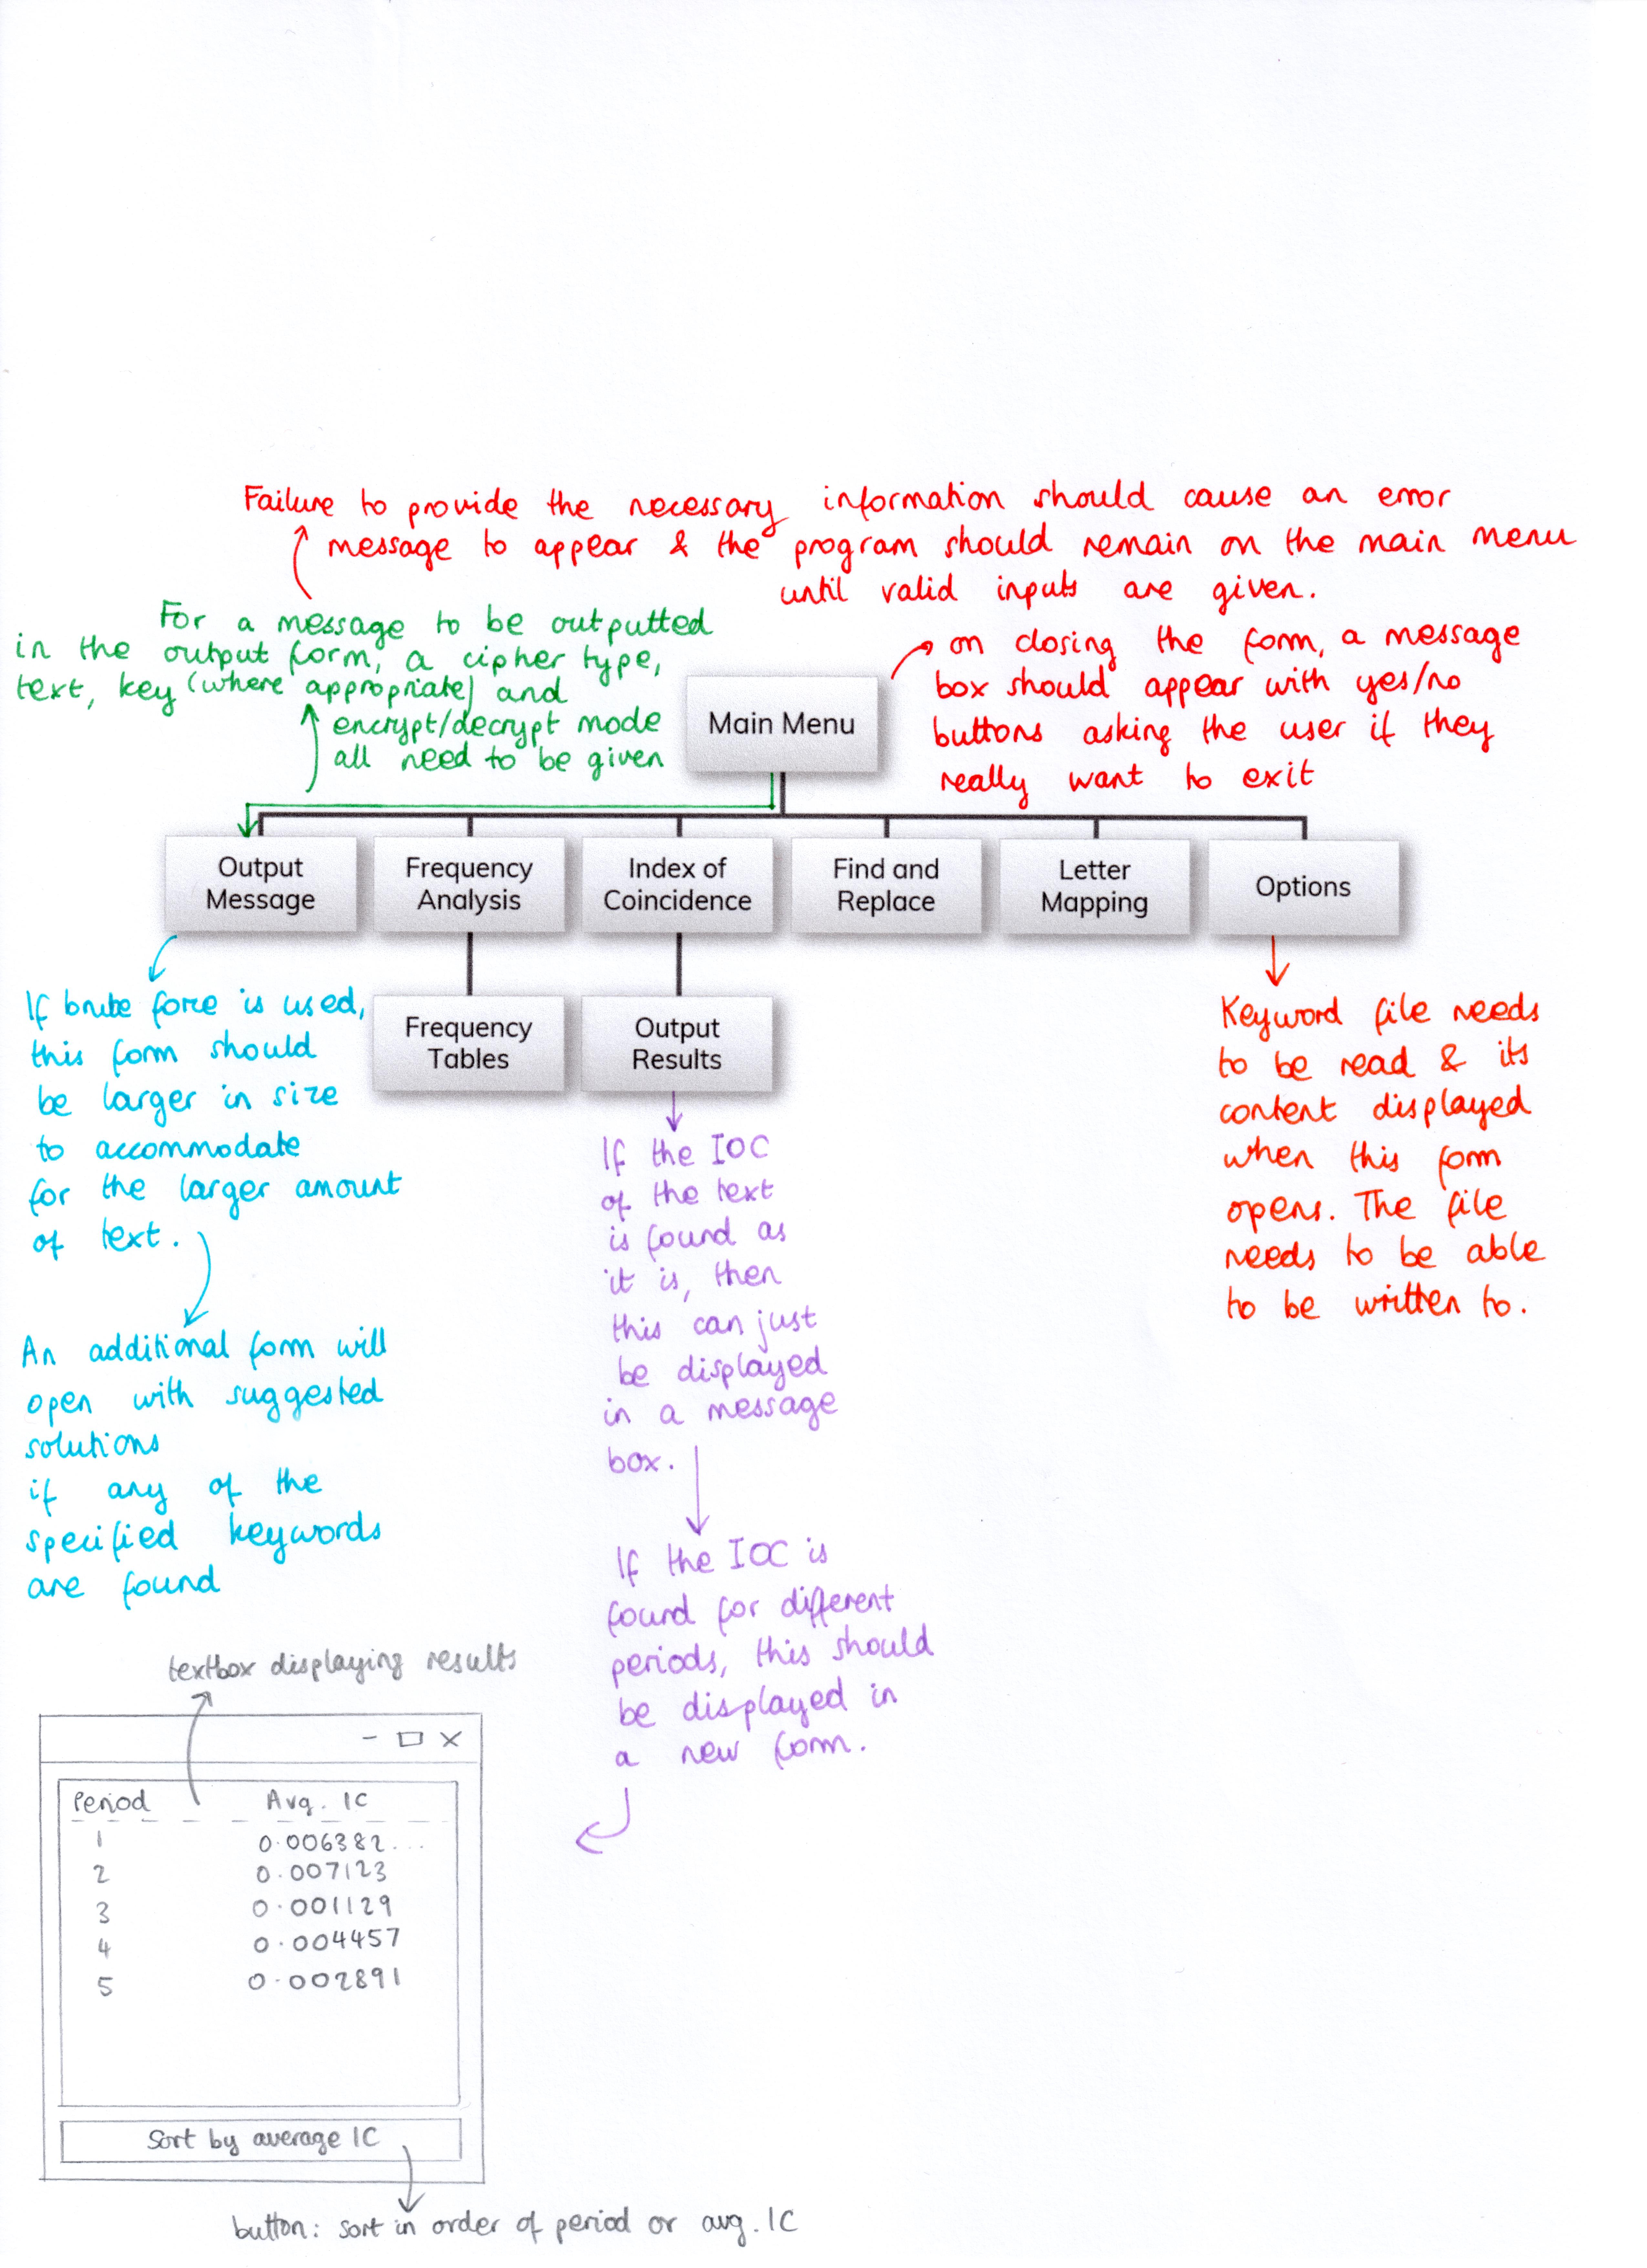

### Data Flow Diagrams

These diagrams show how data moves and is processed between the forms.

#### Main Menu - Encryption & Decryption

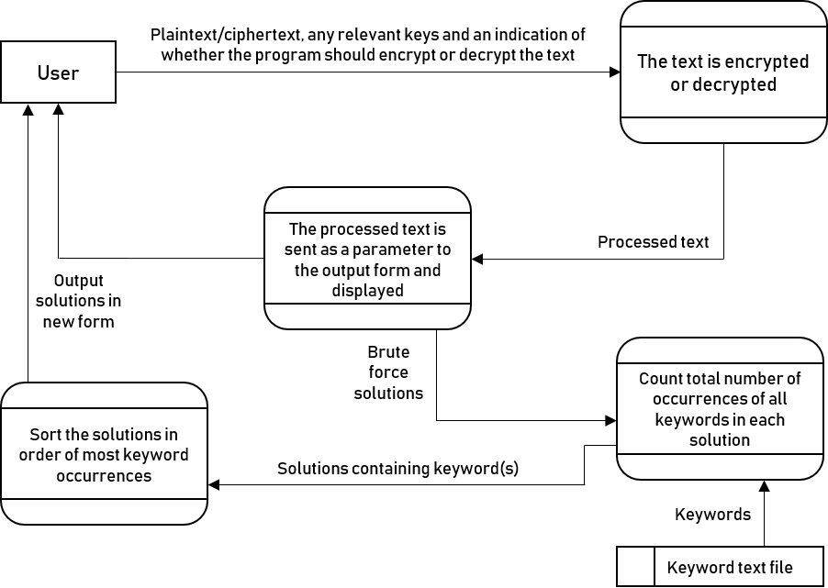

#### Frequency Analysis

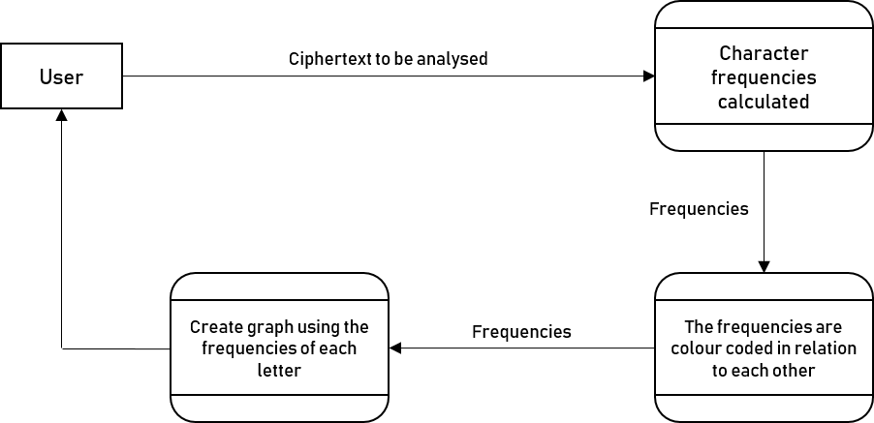

#### Index of Coincidence

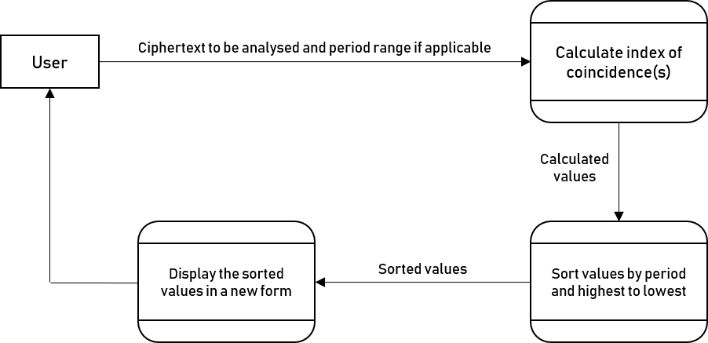

#### Options

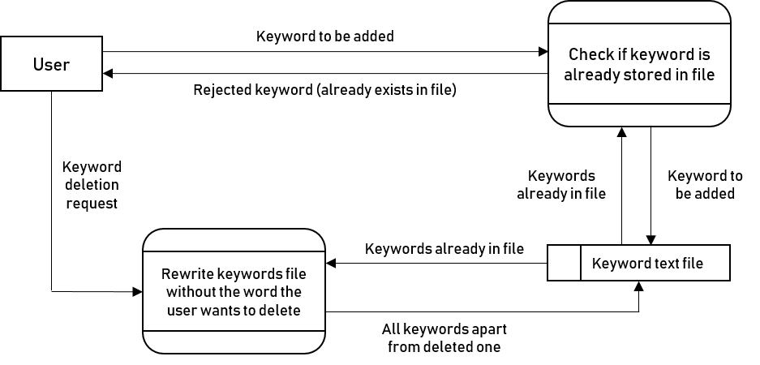

#### Find & Replace

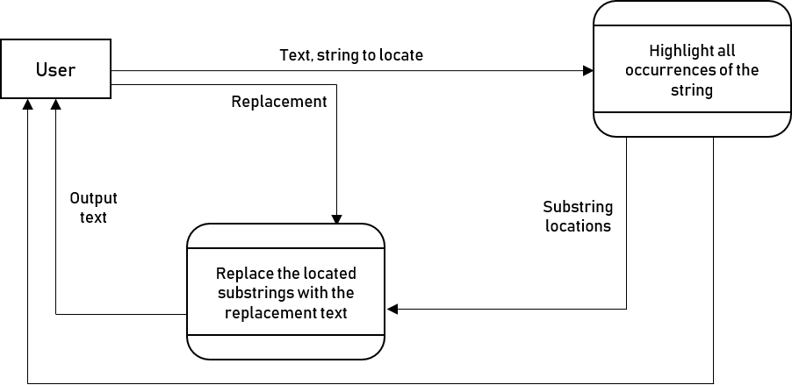

#### Autokey Cipher Solver

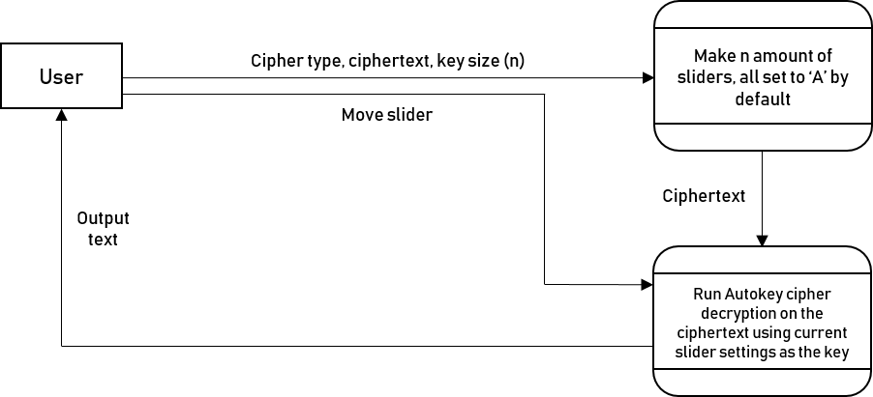

#### Columnar Transposition Solver

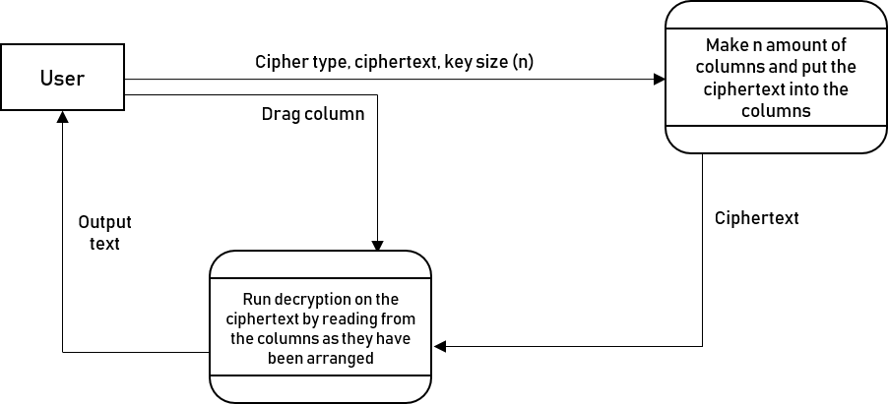

#### Vigenère Cipher Solver

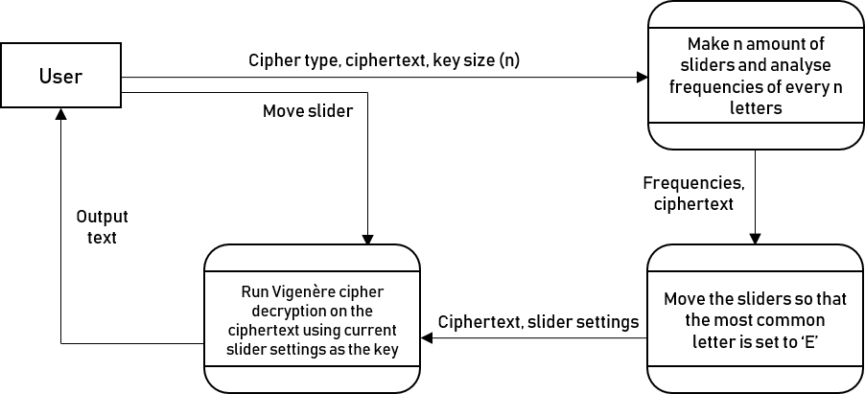

## Validation

### Main Menu

|  |  |  |
| --- | --- | --- |
| Data Item | Check Type | Check Details |
| Text to be encrypted/decrypted | Presence | There must be at least one character in the textbox otherwise there would be no plaintext/ciphertext to work with. |
| Key for currently selected cipher | Presence | Any keys that are necessary for the encryption/decryption of the currently selected cipher to take place should be provided. Otherwise, the user should be prompted to provide the right input. |
| Caesar Cipher Key (shift value) | Length | The length of the input should be a maximum of 2 characters because the largest key is 25 (a key of 26 would just return the same text) |
| Caesar Cipher Key (shift value) | Format | The key should be either an integer or the letter ‘b’ for brute force. |
| Caesar Cipher Key (shift value) | Range | If the key is an integer, it must be between 1-25 because there are 26 letters in the alphabet that the text could be shifted by but a shift of 26 would just return the plaintext again. |
| Substitution Cipher Key | Length | It should contain 26 characters so that each of the 26 characters in the alphabet can be replaced. |
| Substitution Cipher Key | Format | The key should only contain letters and/or hyphens. The hyphens should be used in place of letters that are unknown. |
| Affine Cipher Key: ‘A’ value | Length | The maximum length should be 2 because the highest possible ‘A’ value that works is 25. |
| Affine Cipher Key: ‘A’ value | Format | The ‘A’ value must be an integer. The only accepted values should be 1, 3, 5, 7, 9, 11, 15, 17, 19, 21, 23, and 25. These are the only values that are coprime with 26. |
| Affine Cipher Key: ‘B’ value | Length | The ‘B’ value is a shift value so the maximum length should be 2 characters as the maximum shift is 25. |
| Affine Cipher Key: ‘B’ value | Range | It should be an integer between 0-25 because the ‘B’ value is a shift value. |
| Rail Fence Cipher Key | Format | It should be either an integer or the letter ‘b’ for brute force. |
| Vigenère Cipher Key | Format | It should either be a string containing letters only, or an integer if the user only knows the size of the key. |
| Beaufort Cipher Key | Format | It should be a string containing letters only. |
| Columnar Transposition Key | Format | It should either be a string containing letters only, or an integer if the user only knows the size of the key. |
| Playfair Cipher Key | Format | It should be a string containing letters only. |
| Polybius Square Key | Format | It should be a string containing letters only. |
| Polybius Square Key | Length | It should be 25 letters long because the 5 x 5 grid which acts as the key can only contain 25 letters. |
| Autokey Cipher Key | Format | It should be a string containing letters only. |
| ADFGX Cipher Keysquare | Format | It should be a string containing letters only. |
| ADFGX Cipher Keysquare | Length | It should be 25 letters long because the 5 x 5 grid which acts as the key can only contain 25 letters. |
| ADFGX Cipher Keyword | Format | It should be a string containing letters only. |
| ADFGVX Cipher Keysquare | Length | It should contain 36 characters to fill the 6 x 6 keysquare. |
| Hill Cipher Key | Format | It should be a string containing all letters or all numbers, each separated by a space. The number of letters/numbers must be a square number. |
| Bifid Cipher Keysquare | Length | It should be 25 letters long because the 5 x 5 grid which acts as the key can only contain 25 letters. |
| Bifid Cipher Keysquare | Format | It should be a string containing letters only. |
| Bifid Cipher Period | Format | The period should be an integer. |

### Index of Coincidence Form

|  |  |  |
| --- | --- | --- |
| Data Item | Check Type | Check Details |
| Text entered in main textbox | Presence | There must be at least one character in the textbox otherwise there would be nothing to calculate the index of coincidence of. |
| Average IC: lower limit textbox | Presence | If the average IC radio button is selected, a lower limit for the period range should be entered, otherwise the program won’t know what period to start with. |
| Average IC: lower limit textbox | Format | It must be an integer because period values are integers. |
| Average IC: upper limit textbox | Presence | If the average IC radio button is selected, an upper limit for the period range should be entered, otherwise the program won’t know what period to end at. |
| Average IC: upper limit textbox | Format | It must be an integer because period values are integers. |

## Suitable Algorithms

Listed below is an overview of the proposed algorithms for my program.

### Ciphers

Each of the ciphers will have their own procedure because it would be more organised to keep everything relevant to each cipher together and some of the ciphers use other ciphers as part or all of their algorithm (e.g. Atbash cipher is just a certain substitution cipher) so it would reduce the amount of code if procedures were reused.

For all of the cipher algorithms that involve alphabetical input, the encryption/decryption will be carried out on uppercase versions of the input strings that only contain the letter characters. Before the processed text is outputted, it will be formatted to match the input i.e. punctuation will be put back in the same places, upper and lowercase characters will occur in the same positions etc.

#### The Caesar Cipher

This cipher takes a shift value and swaps every plaintext letter for the letter that is the shift number of positions further along the alphabet.

Encryption

1. Find the ASCII value of each character in the plaintext.

letterIndex ← ASCII value of current character

1. Subtract 65 from each index so that A = 0, B = 1 etc. then add the shift value. Apply MOD 26 to ensure that the letters wrap around the alphabet in the event that the shift causes the index to be more than 26. Then, add 65 back onto the index and convert this into a character - this is the ciphertext character.

FOR index = 0 TO index < plaintext length

letterIndex ← (letterIndex - 65 + shift) MOD 26

letterIndex ← letterIndex + 65 // ASCII ‘A’ = 65, not 0

ciphertextArray[index] ← letterIndex as an ASCII character

END FOR

1. Convert the ciphertext array into a string. This is the ciphertext.

Decryption

Decryption would follow the same method as encryption, but the shift value given would be converted into its negative equivalent before being used.

IF decryption mode

shift ← -shift

END IF

Brute Force

For the integers 1 to 25 as the shift value, follow the same algorithm shown above under ‘Encryption’. If the mode is set to ‘decrypt’, set shift to its negative equivalent before running the algorithm.

#### The Atbash Cipher

The Atbash cipher can simply be thought of as a simple substitution cipher with the substitution alphabet ‘zyxwvutsrqponmlkjihgfedcba’. So, for both encryption and decryption, the substitution cipher procedure can be used instead of re-writing the same code:

Substitution(text, “zyxwvutsrqponmlkjihgfedcba”)  
// the key is the alphabet in reverse; this gives the same effect as an Atbash cipher

#### The Simple Substitution Cipher

The simple substitution cipher swaps plaintext letters for certain other letters depending on a key (a rearranged alphabet). Each letter is converted to one other letter e.g. all ‘A’s could get converted to ‘Q’s.

Encryption

1. Find the ASCII value of each character in the plaintext.

letterIndex ← ASCII value of current character

1. Subtract 65 from each letter index so that A = 0, B = 1 etc. Then, use this new value to find the index of the new ciphertext character in the key string.

FOR index = 0 TO index < plaintext length

letterIndex ← letterIndex – 65

ciphertextArray[index] ← key[letterIndex]

END FOR

1. Convert the ciphertext array into a string. This is the ciphertext.

Decryption

1. Find the index of each of the ciphertext letters in the key string. If the letter is not found in the key string, append a hyphen to the ciphertext array. Otherwise, add 65 to the index and convert this value into an ASCII character before appending it to the character array.

FOR counter = 0 TO counter < ciphertext length

index ← the index of currentChar in the key string

IF currentChar has been found in key

index ← index + 65 // A = 65 in ASCII, B = 66 etc.  
charactersArray[counter] ← (char)index

ELSE

charactersArray[counter] ← ‘-‘

END IF

END FOR

1. Convert the characters array into a string to form the plaintext.

#### The Affine Cipher

The Affine cipher is a monoalphabetic substitution cipher that uses a mathematical function to encrypt text.

Encryption

1. Find the ASCII value of each character in the plaintext.

letterIndex ← ASCII value of current character

1. Subtract 65 from each letter index so that A= 0, B = 1 etc. then apply the following mathematical function:

FOR index = 0 TO index < plaintext length

letterIndex ← letterIndex - 65 // A = 0, B = 1 etc.  
ctextArray[index] ← (char)((A * letterIndex + B)+ 65)

END FOR

1. Convert the ciphertext array into a string.

Decryption

1. Find the modular inverse of the A value. This is the value ‘*a*−1’ is such that if ‘A’ is multiplied by (*a*−1 mod m), where in this case m is 26, the answer is 1.

INT modularInverse ← 0

FOR INT i = 0 to i < 25 // the modular inverse will be in this range

INT repeatTil1 ← (A * i) MOD 26

IF repeatTil1 = 1

modularInverse ← i

END IF

END FOR

1. Subtract 65 from each letter index so that A= 0, B = 1 etc. then apply the following mathematical function:

FOR index = 0 TO index < ciphertext length

letterIndex ← ASCII value of letter - 65 // A = 65 in ASCII  
ptextArray[index] ← (char)((modularInverse * (letterIndex - B))+ 65) // the ASCII value calculated will be converted into a character then stored in the array

END FOR

1. Convert the plaintext array into a string.

Brute Force

1. For every possible A and B value, run the decryption algorithm.

INT arrayCounter ← 0

FOR every possible A value

FOR every possible B value

AffineDecryption(ciphertext, A, B)

END FOR

END FOR

1. Display the solutions.

#### The Rail Fence Cipher

The rail fence cipher is a transposition cipher that works by writing the plaintext letters on alternating lines in a ‘zigzag’ pattern, then reading the lines in turn to form the ciphertext.

Encryption

1. If the zigzag setting is down (default) set the initial rail line to 0 and the increment to 1. If the zigzag setting is up, set the initial rail line to key-1 (array starts at 0) and the increment to -1 so that instead of going down the array it goes up.

INT RailLine // stores the current line to add the next letter to

INT Increment // how many rails it should move by each time

IF Zigzag is down

RailLine ← 0 // starts at the first rail

Increment ← 1 // after each letter is added, the RailLine will increase by 1

ELSE IF Zigzag is up

RailLine ← Key – 1 // starts at the last rail; since the ‘rail’ will be simulated using an array, and arrays are 0 based, the last array value will be Key - 1

Increment ← -1

END IF

1. For each character in the original text, check if either the top or bottom rail has been reached. If so, change the increment value so that the direction that the letters are moving goes in the opposite direction. Add the current letter onto the fence and set the rail line to the next value.

FOREACH Character in the plaintext

IF bottom rail reached

Increment ← -1 // reverses the direction that the letters will be put into the array – zigzag movement

ELSE IF top rail reached

Increment ← 1

END IF

RailFence[RailLine] += Character // character added to the array

RailLine += Increment

END FOREACH

1. Put all the strings in the RailFence array together to form one big string; this is the ciphertext.

Decryption

1. Do the same first step as in the encryption process.
2. Make a list for each rail line. Each list should contain the indexes of plaintext letters that should be on the line.

FOR INT i = 0 TO i < ciphertext length

IF bottom rail reached

Increment ← -1 // moves back up the rail

ELSE IF top rail reached

Increment ← 1 // moves down the rail

END IF

RailFence[RailLine].Add(i) // for each line, an array is made which contains the position values of letters that lie on that line

RailLine += Increment

END FOR

1. Output the plaintext:

INT counter = 0

FOR INT i = 0 TO i < number of rail lines

FOR INT j = 0 TO j < number of values on the current line

outputArray[RailFence[i][j]] ← originalText[counter]

// each letter from the original (cipher) text is put in the right place

counter++

END FOR

END FOR

Brute Force

1. Run the decryption procedure for rail key values ranging from two to the text length. It should start from 2 instead of 1 because if there was only 1 rail, the ciphertext would be the same as the plaintext.

FOR INT i = 2 TO i = originalText.Length

RailFenceDecryption(originalText, i)

END FOR

1. Display all the possible messages.

#### The Vigenère Cipher

The Vigenère cipher is a polyalphabetic substitution cipher that uses several Caesar ciphers in sequence with different shift values.

Encryption

1. Repeat the key so that it has the same number of characters as the plaintext.

FOR INT i = 0 TO i < plaintext.Length

keyArray[i] ← key[i MOD key.Length] // the mod allows the word to repeat over and over again

END FOR

1. Add the current key value to the current letter value:

FOR INT i = 0 TO i < plaintext.Length

INT originalLetterValue ← (int)plaintext[i] - 65 // the -65 is to make 'A' correspond to 0

INT keyLetterValue ← (int)keyArray[i] - 65

newMessageArray[i] ← (char)(((originalLetterValue + keyLetterValue) MOD 26) + 65) // mod 26 makes the alphabet wrap around

END FOR

1. Display the ciphertext.

Decryption

1. Do the same first step as in the encryption process.
2. Subtract the current key value from the current letter value.

FOR INT i = 0 TO i < ciphertext.Length

INT subtractKey ← originalLetterValue - keyLetterValue

INT findLetter ← subtractKey MOD 26 // wraps around the alphabet

newMessageArray[i] ← (char)(findLetter + 65)

END FOR

1. Display the plaintext.

#### The Beaufort Cipher

The Beaufort cipher is a substitution cipher similar to the Vigenère cipher but uses a slightly different algorithm to encrypt text. Encryption & decryption follow the same algorithm.

Encryption & Decryption

1. Do the same first step as the Vigenère encryption algorithm.
2. Subtract the letter values from the key values.

FOR INT i = 0 TO i < originalArray.Length

INT originalLetterValue ← (int)originalArray[i] - 65

INT keyLetterValue ← (int)keyArray[i] - 65

newMessageArray[i] ← (char)((keyLetterValue – originalLetterValue MOD 26) + 65)

END FOR

1. Display the new message.

#### The Columnar Transposition Cipher

The columnar transposition cipher works by writing out the plaintext characters in rows, then reading the ciphertext off in columns.

Encryption

1. Calculate the number of rows by dividing the original text length by the key length. If the key length does not perfectly divide the original text length, round the number of rows up.

INT noOfRows ← originalText.Length / key.Length

IF originalText.Length MOD key.Length does not = 0

noOfRows++ // rounds up because even if the final row will only be partially filled there must be enough rows to store the text

END IF

1. Store all of the letters in the original text in a grid with the same number of columns as the number of letters in the key, and the number of rows calculated in step one.

INT letterCounter ← 0 // will ensure all the letters are added

Store original text in 2D char array “grid”

1. Store the characters in each column in a string.

FOR INT i = 0 TO i < number of columns

FOR INT j = 0 TO j < noOfRows

columnArray[j] ← grid[j, i]

END FOR

columns[i] ← new string(columnArray) // each column is converted to a string and stored in an array called ‘columns’

END FOR

1. Sort the columns in the columns array according to the alphabetical order of the characters in the key.

Sort(key, columns) // the characters in the key are sorted alphabetically and this sorts the columns at the same time

1. The sorted strings in the columns array can then be read one after the other to form the ciphertext.

Decryption

1. Do the same first step as in the encryption process, but store whether or not the number of rows had to be rounded up.
2. If the number of rows was rounded up, store how many columns will be filled completely.

IF roundedUp = true

INT temp ← noOfRows * key.Length // key.Length is the number of columns

INT noOfPlaceholders ← temp - originalText.Length

INT noOfFullCols ← key.Length - noOfPlaceholders

END IF

1. Create a sorted array of values corresponding to the order that the keyword characters should occur alphabetically.

INT indexes[] ← array containing the values 0 to number of columns

Sort(key, indexes) // the index numbers are re-ordered in conjunction with the alphabetical order of the key

1. Fill each column with the same number of characters.

FOR INT i = 0 TO i < number of columns

IF roundedUp = true

Fill each column with the same number of characters (each column should have the same number of characters as the number of rows). Append ‘X’s when characters run out.

ELSE

Fill each column with the same number of characters (each column should have the same number of characters as the number of rows).

END IF

END FOR

1. Put each of the columns into a grid so that the rows can be read to find the plaintext.

FOR INT i = 0 TO i < number of columns

CHAR[] columnChars ← characters in the current column

FOR INT j = 0 TO j < noOfRows

grid[j, indexes[i]] ← columnChars[j] // goes through each row one at a time and places the current column char in the right column using the index

END FOR

END FOR

#### The Playfair Cipher

The Playfair cipher uses a 5 by 5 grid containing all of the letters of the alphabet apart from one to encrypt text. Certain rules are followed depending on the location of letters in the grid.

Encryption & Decryption

1. Since the cipher works on digraphs, the length of the inputted text needs to be checked. If it is odd, an extra letter needs to be appended so that there are no unpaired letters.

INT seeIfOdd ← originalText.Length MOD 2

IF seeIfOdd = 1

originalText += ‘X’

END IF

1. Store every pair of letters in the original text in an array. Then, check the digrams. If both letters in the digram are the same, one of them needs to be replaced with a different letter.

FOR INT i = 0 TO i < digrams.Length

CHAR[] charsInTheDigram ← current digram

IF both letters in the digram are the same

charsInTheDigram[1] ← 'X' // the second letter is changed to an X

digrams[i] ← charsInTheDigram

END IF

END FOR

1. Remove any repeated letters from the key. Then, form the keysquare.

INT counter ← 0

FOR INT i = 0 TO i < 5

FOR INT j = 0 TO j < 5

IF counter < keyWithoutRepeats.Length

keysquare[counter] ← keyWithoutRepeats[counter] // puts each of the key letters into the list of letters first

counter++

ELSE

FOR INT k = 0 TO k < 26

STRING currentLetters ← keysquare

IF currentLetters does not contain(char)(k + 65)

// goes through the alphabet looking for characters that aren't already in the alphabet array

IF (k + 65) is not ‘J’

keysquare[counter] ← (char)(k + 65)

counter++

END IF

END IF

END FOR

END IF

END FOR

END FOR

counter ← 0 // counter is reset and reused

FOR INT i = 0 TO i < 5

FOR INT j = 0 TO j < 5

keyTable[i, j] ← keysquare[counter] // the keysquare array has the letters in the right order; now they just need to be put into the 2D array

counter++

END FOR

END FOR

1. Apply the appropriate rules for encrypting each pair of letters as explained in the Research section.

INT counter = 0

FOREACH digram IN digrams

IF both letters in digram on same row

newDigram[counter] ← letters to immediate right of original digram letters

ELSE IF both letters in same column

newDigram[counter] ← letters immediately below original letters

ELSE (not in same row or column)

newDigram[counter] ← letters in same row, opposite corners

END IF

counter ++

END FOREACH

1. Turn the newDigrams array into one string to form the output text.

#### The Polybius Square Cipher

The Polybius square cipher uses a 5 by 5 grid containing letters and encrypts characters by replacing them with their ‘coordinates’ on the grid.

Encryption

1. Put the key into a 2D array.

FOR INT i = 0 TO i < 5

FOR INT j = 0 TO j < 5

grid[i, j] ← key[counter] // the grid is filled with the key

counter++

END FOR

END FOR

1. For every letter in the inputted text, check the grid for the same letter and add the coordinates of the letter to the ciphertext.

FOR INT i = 0 TO i < originalText.Length

FOR INT j = 0 TO j < 5

FOR INT k = 0 TO k < 5

IF originalText[i] = grid[j,k] // if the plaintext letter matches the grid letter

IF row coordinate written before column coordinate

ciphertext += (j + 1) + (k + 1) // the coordinates are written (row, column); +1 because j and k start at 0

ELSE

ciphertext += (k + 1) + (j + 1) // the coordinates are written (column, row)

END IF

END IF

END FOR

END FOR

END FOR

1. Display ciphertext.

Decryption

1. Do the same first step as the encryption process.
2. Store every pair of letters in the inputted text in an array. Then, compare the numbers in each pair to the grid coordinates, adding the letters in the intersections to the plaintext string.

FOREACH pair IN digitPairs

IF row coordinate is first, then column coordinate

plaintext += grid[pair[0] - 1, pair[1] - 1]

ELSE

plaintext += grid[pair[1] - 1, pair[0] - 1]

END IF

END FOREACH

1. Display plaintext.

#### The Autokey Cipher

The Autokey cipher uses a keyword and the plaintext as the key for encryption. It then follows a similar method to the Vigenère cipher to find the ciphertext.

Encryption

1. Calculate the number of letters that need to be appended to the key. Form the key by adding the calculated number of letters from the plaintext to the key given.

INT lettersToAppend ← originalText.Length - key.Length

STRING longKey ← key + originalText.Substring(0, lettersToAppend)

1. Encrypt each of the letters according to the corresponding key letter.

FOR INT i = 0 TO i < originalText.Length

INT originalLetterValue ← (int)originalText[i] - 65 // the -65 is to make 'A' correspond to 0

INT keyLetterValue ← (int)longKey[i] - 65

newMessageArray[i] ← (char)(((originalLetterValue + keyLetterValue) MOD 26) + 65) // mod 26 makes the alphabet wrap around and 65 is added so that the values match the ASCII letters they are supposed to represent

END FOR

1. Convert the newMessageArray into a string and display it.

Decryption

1. Decrypt the first few letters using the key given. After each letter in the ciphertext is decrypted, add the newly found plaintext letter to the key so that the next ciphertext letter can be decrypted.

INT[] longKey ← NEW INT[ciphertext.Length]

FOR INT i = 0 TO i < key.Length

longKey[i] ← key[i] // puts the keyword given by the user into the array

END FOR

FOR INT i = 0 TO i < longKey.Length

INT cipherLetterValue ← (int)ciphertext[i] - 65 // the -65 is to make 'A' correspond to 0

INT keyLetterValue ← (int)longKey[i] - 65

INT subtractKey ← cipherLetterValue - keyLetterValue

INT findLetter ← subtractKey MOD 26

plaintext[i] ← (char)(findLetter + 65)

IF i < longKey.Length - key.Length

longKey[i + key.Length] ← (char)(findLetter + 65)

END IF

END FOR

1. Output the plaintext.

#### The ADFGX Cipher

The ADFGX cipher is similar to the Polybius square cipher, but the ‘coordinates’ that form the ciphertext are not numbers; they are a combination of the letters A, D, F, G and X.

Encryption

1. Put the key into a 2D array as shown in step one under the encryption of the Polybius Square cipher.
2. Store the numerical coordinates of each of the plaintext letters from the grid.

FOR INT i = 0 TO i < originalText.Length

FOR INT j = 0 TO j < 5

FOR INT k = 0 TO k < 5

IF originalText[i] = grid[j, k] // if the plaintext letter matches the grid letter

numbers += (j).ToString() + (k).ToString() // the coordinates are written (row, column)

END IF

END FOR

END FOR

END FOR

1. Swap all the numbers in the string of numbers for A/D/F/G/X.

FOREACH CHAR c IN numbers

SWITCH (c)

CASE '0':

ciphertext += 'A'

BREAK

CASE '1':

ciphertext += 'D'

BREAK

CASE '2':

ciphertext += 'F'

BREAK

CASE '3':

ciphertext += 'G'

BREAK

CASE '4':

ciphertext += 'X'

BREAK

END SWITCH

END FOREACH

1. Using the intermediate ciphertext just created, apply a columnar transposition using the keyword given by the user.

Columnar(ciphertext, keyword)

1. Display the final ciphertext.

Decryption

1. Put the key into a 2D array as shown in step one under the encryption of the Polybius Square cipher.
2. Undo the columnar transposition using the ciphertext and the keyword given as parameters for the columnar transposition procedure.
3. Replace the A/D/F/G/X characters with corresponding numbers.

FOREACH CHAR c IN temp

SWITCH (c)

CASE 'A':

numbers += '0'

BREAK

CASE 'D':

numbers += '1'

BREAK

CASE 'F':

numbers += '2'

BREAK

CASE 'G':

numbers += '3'

BREAK

CASE 'X':

numbers += '4'

BREAK

END SWITCH

END FOREACH

1. Store the numbers in pairs then use each pair as grid coordinates to find the plaintext letters.

FOREACH pair in digitPairs

plaintext += grid[pair[0], pair[1]]

END FOREACH

1. Display the plaintext.

#### The ADFGVX Cipher

The ADFGVX cipher is the same as the ADFGX cipher but makes use of an additional letter, V, and allows for numbers to be encrypted as well as letters.

Encryption

1. Form a 6x6 grid using the key.

FOR INT i = 0 TO i < 6

FOR INT j = 0 TO j < 6

grid[i, j] ← keyGrid[counter]

counter++

END FOR

END FOR

1. Follow the same second step as in the ADFGX cipher, but instead of doing the loops until the counter is 5, do them while they are less than 6 because the grid is not 5x5 any more, it is 6x6.
2. The same third step can be used from the ADFGX cipher, but case 4 will add ‘V’ to the ciphertext instead of ‘X’ and a case for ‘5’ needs to be added; this will add ‘X’ to the ciphertext.
3. Follow the same fourth and fifth steps from the ADFGX encryption process.

Decryption

1. Do the same first step as the encryption process.
2. Undo the columnar transposition using the ciphertext and the keyword given as parameters for the columnar transposition procedure.
3. Replace the A/D/F/G/V/X characters with corresponding numbers.

FOREACH CHAR c IN temp

SWITCH (c)

CASE 'A':

numbers += '0'

BREAK

CASE 'D':

numbers += '1'

BREAK

CASE 'F':

numbers += '2'

BREAK

CASE 'G':

numbers += '3'

BREAK

CASE 'V':

numbers += '4'

BREAK

CASE 'X':

numbers += '5'

BREAK

END SWITCH

END FOREACH

1. Do the same steps 4 and 5 from the ADFGX cipher decryption algorithm.

#### The Hill Cipher

The Hill cipher uses a square matrix key and matrix multiplication to form the ciphertext.

Encryption

1. Form a grid using the matrix key values inputted.

FOREACH value IN matrixValues

IF rowCounter < size // size = square root of the number of values given

keyMatrix[rowCounter, colCounter] ← value

colCounter++

END IF

IF colCounter = size // if the final column of the current row has been filled

rowCounter++

colCounter ← 0

END IF

END FOREACH

1. Check if the length of the plaintext given is divisible by the matrix size. If not, append the appropriate number of letters to the text.

INT remainder ← originalText.Length MOD size

IF remainder does not = 0 // i.e. if the division isn’t perfect

FOR INT i = 0 TO i < size - remainder

originalText += ‘X’ // appends extra letters to make text divisible by n

END FOR

END IF

1. Store the integer values of each of the plaintext letters in chunks of the matrix size.

INT counter ← 0

FOR INT i = 0 TO i < originalText.Length / size

FOR INT j = 0 TO j < size

ptChunks[i, j] ← (int)originalText[counter] - 65 // stores the int values of the letters in chunks of n

counter++

END FOR

END FOR

1. Perform matrix multiplication on the chunks, multiplying each of them by the key matrix made in step one.

FOR INT i = 0 TO i < originalText.Length / size

FOR INT tempRow = 0 TO tempRow < size

FOR INT tempCol = 0 TO tempCol < size

tempMatrix[tempRow, tempCol] ← keyMatrix[tempRow, tempCol] * ptChunks[i, tempCol] // makes a matrix of numbers that will be added together (each row) to form the final matrix

END FOR

END FOR

FOR INT row = 0 TO row < size

INT sum ← 0

FOR INT col = 0 TO col < size

sum += tempMatrix[row, col] // the values in each row are totalled

END FOR

ciphertext += (char)((sum MOD 26) + 65) // each letter is appended to the ciphertext string

END FOR

END FOR

1. Display ciphertext.

Decryption

1. Follow the same first step as the encryption process.
2. Use the matrix values given and carry out the encryption algorithm because this would return the right plaintext assuming that the user has given the decryption matrix.
3. Calculate the inverse matrix using the matrix values provided – this will allow plaintext results to be displayed in the event that the matrix values given were the original encryption matrix values, not the decryption matrix.

IF 4 matrix values given i.e. the matrix is 2 x 2

a ← keyMatrix[0, 0]

b ← keyMatrix[0, 1]

c ← keyMatrix[1, 0]

d ← keyMatrix[1, 1]

INT denominator ← (a * d) - (b * c)

IF denominator = 0 or is not coprime with 26 // dividing by 0 is undefined; inverse matrix only exists if the denominator (determinant) and 26 are coprime

DISPLAY Error message

ELSE

INT[,] tempMatrix ← NEW INT[2, 2]

tempMatrix[0, 0] ← d

tempMatrix[0, 1] ← -b

tempMatrix[1, 0] ← -c

tempMatrix[1, 1] ← a

INT modularInverse ← modular inverse of denominator

IF modularInverse doesn’t exist

// The inverse matrix calculated cannot be used

DISPLAY Error message

ELSE

FOR INT i = 0 TO i < 2

FOR INT j = 0 TO j < 2

inverseMatrix[i, j] ← (modularInverse * tempMatrix[i, j]) MOD 26

END FOR

END FOR

END IF

ELSE IF matrix is 3 x 3

Calculate matrix of minors

Calculate matrix of cofactors

Calculate adjoint matrix

Calculate determinant

Calculate inverse matrix

END IF

1. Use the calculated inverse matrix and the encryption algorithm to decrypt the ciphertext.

#### The Bifid Cipher

The Bifid cipher is a cipher which combines the Polybius square cipher with the columnar transposition cipher.

Encryption

1. Form a grid as shown in step one of the Polybius Square cipher.
2. Calculate the number of groups needed by dividing the original text length by the period.

INT numberOfGroups ← originalText.Length / period

IF originalText.Length MOD period does not = 0 // if the period doesn’t divide the original text length perfectly

numberOfGroups += 1 // another group is needed to accommodate for all of the letters

END IF

1. Find the row and column coordinates of each of the plaintext letters.

FOR INT i = 0 TO i < originalText.Length // for every letter

FOR each row

FOR each column

IF originalText[i] = grid[currentRow, currentCol]

// if the plaintext letter matches the grid letter

IF row coordinates read before column coordinates

rowCoordinates[i] ← currentRow + 1

colCoordinates[i] ← currentCol + 1

ELSE

rowCoordinates[i] ← currentCol + 1

colCoordinates[i] ← currentRow + 1

END IF

END IF

END FOR

END FOR

END FOR

1. Put the coordinates into groups that each contain the same number of values as specified by the period.

INT[,,] groups ← NEW INT[numberOfGroups, 2, period]

// [group number, row(0)/col(1), position in the group]

INT rowCharCounter = 0

INT colCharCounter = 0

FOR INT groupNo = 0 TO groupNo < numberOfGroups

FOR each position in the group

IF rowCharCounter < originalText.Length // since there are two coordinate values per letter in the original text (a row coordinate and a col coordinate), originalText.Length will be the same as half the total number of coordinates; or the same as the number of row coordinates.

groups[groupNo, 0, currentGroupPosition] ← rowCoordinates[rowCharCounter] // row coordinates are added to the groups

rowCharCounter++

END IF

IF colCharCounter < originalText.Length

groups[groupNo, 1, currentGroupPosition] ← colCoordinates[colCharCounter] // column coordinates are added to the groups

colCharCounter++

END IF

END FOR

END FOR

1. Read the groups in order to form a string of numbers.

FOR INT i = 0 TO i < numberOfGroups

FOR INT j = 0 TO j < period

numbers += groups[i, 0, j] // the row coordinates of the group are added to the string first

END FOR

FOR INT k = 0 TO k < period

numbers += groups[i, 1, k] // then the column coordinates

END FOR

END FOR

1. Store each pair of numbers in an array, then form the ciphertext.

FOREACH pair of numbers IN numbers

IF reading row before column

ciphertext += grid[pair[0] - 1, pair[1] - 1] // -1 because arrays are 0 based and the pair values are not 0 based

ELSE

ciphertext += grid[pair[1] - 1, pair[0] - 1]

END IF

END FOREACH

1. Display the ciphertext.

Decryption

1. Form the key grid as shown in the encryption algorithm.
2. Find the coordinates of the ciphertext letters in the grid and store them.

FOR INT i = 0 TO i < originalText.Length // for every ciphertext letter

FOR each row

FOR each column

IF originalText[i] = grid[currentRow, currentCol] // if the ciphertext letter matches the grid letter

IF row read before column

numbers += (currentRow + 1) + (currentCol + 1) // the coordinates are written (row, column)

ELSE

numbers += (currentCol + 1) + (currentRow + 1) // the coordinates are written (column, row)

END IF

END IF

END FOR

END FOR

END FOR

1. Put the numbers into groups.

INT numCounter ← 0

FOR INT groupNo = 0 TO groupNo < numberOfGroups

FOR INT currentGroupPosition = 0 TO currentGroupPosition < period

IF numCounter < originalText.Length * 2

groups[groupNo, 0, currentGroupPosition] ← numbers[numCounter] - 48 // -48 changes the ASCII vaules of the numbers to the actual numbers (48 = 0); the numbers are added to the row sections of the groups

numCounter++

END IF

END FOR

FOR INT currentGroupPosition = 0 TO currentGroupPosition < period

IF numCounter < originalText.Length * 2

groups[groupNo, 1, currentGroupPosition] ← numbers[numCounter] - 48 // puts the rest of the numbers into the column sections

numCounter++

END IF

END FOR

END FOR

1. Order the numbers by group.

FOR INT groupNo = 0 TO groupNo < numberOfGroups

FOR INT currentGroupPosition = 0 TO currentGroupPosition < period

orderedNums += all the row values in groups

END FOR

END FOR

FOR INT groupNo = 0 TO groupNo < numberOfGroups

FOR INT currentGroupPosition = 0 TO currentGroupPosition < period

orderedNums += all the column values in groups

END FOR

END FOR

1. Sort the numbers into separate arrays of row coordinates and column coordinates.

FOR INT i = 0 TO i < orderedNums.Length

IF i < orderedNums.Length/2 // the first half of the ordered numbers will be row coordinates

rowNumbers[rowCounter] ← orderedNums[i]

rowCounter++

ELSE

colNumbers[colCounter] ← orderedNums[i]

colCounter++

END IF

END FOR

1. Order the numbers into one string.

FOR INT i = 0 TO i < rowNumbers.Length

orderedNums += rowNumbers[i]

orderedNums += colNumbers[i]

END FOR

1. Form the plaintext using the numbers as coordinates.

FOREACH pair in digitPairs

IF reading row before column

plaintext += grid[pair[0] - 1, pair[1] - 1]

ELSE

plaintext += grid[pair[1] - 1, pair[0] - 1]

END IF

END FOREACH

1. Display the plaintext.

### Frequency Analysis

1. Count how many of each letter of the alphabet is in the text that has been given by the user.

FOR INT i = 0 TO i < 26

CurrentLetter ← (char)(i + 97)

LetterCount[i] ← Regex.Matches(text.ToLower, CurrentLetter).Count

// the Regex finds all occurences of the current letter in the text

END FOR

1. If the user chooses to view the counts as percentages, convert all values in the LetterCount array to percentages by dividing all the values by the total number of letters in the input text.

Percentage ← (LetterCount[i]/TotalNoOfLetters) * 100

1. Display the individual frequencies of each letter.

### Index of Coincidence

1. Store the integer values of each character in the text.

FOR INT i = 0 TO i < text.Length

intArray[i] ← (int)(text[i] - 65) // stores the int values of each character in the text (A = 0)

END FOR

1. Find the count of every letter of the alphabet to calculate the numerator.

FOR INT i = 0 TO i < 25 // for every letter in the alphabet

INT count ← 0

FOREACH INT c in intArray

IF c = i

count += 1

END IF

END FOREACH

numerator += count * (count - 1)

END FOR

1. Calculate the denominator.

denominator ← text.Length * (text.Length - 1)

1. Calculate the index of coincidence.

IC ← numerator / denominator

## Testing Strategy

I am going to test my program as it is being created because it will be easier to keep track of how and where errors in the code should be modified. To evidence my testing I will record video evidence of my program working. I will also take screenshots and describe the most relevant features of the program that need testing i.e. the features that are necessary for the objectives to be met.

I will create trace tables for some of the algorithms to show that they work as intended.

# Technical Solution

|  |  |  |  |
| --- | --- | --- | --- |
| Form | Section/  Subroutine(s) | Description/  Skills Demonstrated | Page Number |
|  | Stack | This class allows the methods contained within it to be used across the program. Uses ‘pushing’ and ‘popping’ to simulate a stack. Used to reverse arrays. | 74 |
| **Main Menu: Creating controls** | Button creation | Making new controls and event handlers through code. | 75 |
| **Main Menu: Functions used throughout the code** | Positive Modulus | The mod function in C# can return negative mod values when the positive value is the one needed, so this function can be used to return the positive version. | 77 |
|  | GetGCDByModulus | Finds the greatest common divisor of two numbers. Uses recursion. | 77 |
|  | ModularInverse | Makes use of the extended Euclidean algorithm to find the modular inverse of a number. | 77 |
|  | ExtendedEuclidean | A recursive algorithm that can be used to find the modular inverse of a number. | 77 |
|  | CalculateInverseMatrix | Self-explanatory; uses calculations with matrices | 77 |
|  | MakeGrid | Stores a string in an n x n 2D array, which is returned. | 80 |
|  | Digrams | Converts a string into an array where each element is made up of two characters. | 80 |
|  | FormatOutput | Compares the encrypted/decrypted text to the original text given in the main text box so that the outputted text is displayed in a similar format to the input text. | 80 |
|  | Clicking a cell in the datagridview | Changes the instruction displayed in the label as appropriate. | 80 |
|  | Go Button | Allows inputs to be validated. | 83 |
|  | Reverse Text Button | Uses a stack to reverse the text. | 84 |
|  | Letters Only Button | Removes all characters that are not letters. | 84 |
|  | Help Button | Displays message telling the user about the currently selected cipher. A similar button appears on other forms, providing relevant information when pressed. | 85 |
| **Main Menu: Ciphers** | Caesar Cipher | Encrypts/decrypts using the Caesar cipher. Brute force can be used. | 88 |
|  | Atbash Cipher | Uses the Substitution cipher procedure to accomplish encryption/decryption of Atbash ciphertext. | 90 |
|  | Substitution Cipher | Encrypts/decrypts using the Substitution cipher. | 90 |
|  | Affine Cipher | Encrypts/decrypts using the Affine cipher. The decryption algorithm involves finding the modular inverse of a number. Brute force can be used. | 92 |
|  | Rail Fence Cipher | Encrypts/decrypts using the Rail Fence cipher. Brute force can be used. Makes use of lists to store ‘rails’ and brute force solutions. | 94 |
|  | Vigenère Cipher | Encrypts/decrypts using the Vigenère cipher. | 97 |
|  | Beaufort Cipher | Encrypts/decrypts using the Beaufort cipher. | 99 |
|  | Columnar Transposition Cipher | Encrypts/decrypts using the Columnar Transposition cipher. | 100 |
|  | Playfair Cipher | Encrypts/decrypts using the Playfair cipher. Uses regular expressions. | 105 |
|  | Polybius Square | Encrypts/decrypts using the Polybius Square. | 108 |
|  | Autokey Cipher | Encrypts/decrypts using the Autokey cipher. | 110 |
|  | ADFGX Cipher | Encrypts/decrypts using the ADFGX cipher. Uses regular expressions and switch-case statements. | 112 |
|  | ADFGVX Cipher | Encrypts/decrypts using the ADFGVX cipher. Uses regular expressions and switch-case statements. | 113 |
|  | Hill Cipher | Encrypts/decrypts using the Hill cipher. Uses matrix multiplication. | 116 |
|  | Bifid Cipher | Encrypts/decrypts using the Bifid cipher. Uses 3D arrays. | 119 |
| **Output** | Normal Output | Displays the text that is passed to the subroutine as an argument in a new form. | 124 |
|  | Brute Force Output | Displays all possible solutions. All solutions are numbered. Uses regular expressions and reads from a text file. | 125 |
| **Suggested Solutions** | Display Solutions | The solutions containing keywords from the text file are displayed in order of number of keyword occurrences (descending count order/high to low). A stack is used to reverse the solutions so that they are in high to low order. | 127 |
| **Frequency Analysis** | Analysing Frequencies | Calculates percentages. | 128 |
|  | Create Graph | Creates a graph which can change during runtime. | 128 |
| **Index of Coincidence** | Calculate Index of Coincidence | Uses lists and can calculate averages as well as the index of coincidence. | 132 |
| **Find & Replace** | Locating and replacing substrings | Uses regular expressions. | 137 |
| **Options** | Add/remove keywords | Read/write to an existing file, and/or create a text file if one does not already exist. | 141 |
| **Map Letters** | Map letters | Use text from multiple textboxes to form one string. | 143 |
| **Autokey Cipher Solver** | Changing slider value | Decrypts a message using the Autokey cipher using a key determined by slider values. | 144 |
| **Columnar Transposition Solver** | Changing column order | Drag and drop – decrypts a message using the Columnar Transposition cipher depending on the order that the columns are arranged in. | 147 |
| **Vigenère Cipher Solver** | Changing slider value | Decrypts a message using the Vigenère cipher using a key determined by slider values. | 150 |

## Stack

using System;

using System.Collections.Generic;

using System.Linq;

using System.Text;

using System.Threading.Tasks;

namespace CipherTools

{

class Stack<T> // generic; can be any type

{

private T[] items;

private int pointer = -1;

public T[] Items

{

get

{

return items;

}

set

{

items = value;

}

}

public void Push(T item) // adds items to the stack

{

if (pointer < items.Length - 1) // if stack isn't full

{

pointer++;

items[pointer] = item;

}

}

public void Pop(ref T item) // stores the item at the top of the stack; moves the pointer down

{

if (pointer > -1) // if stack isn't empty

{

item = items[pointer];

pointer--;

}

}

public T[] ReverseArray(T[] array) // flips the array back to front

{

items = new T[array.Length];

for (int i = 0; i < array.Length; i++)

{

Push(array[i]); // puts all of the original array items onto the stack

}

for (int i = 0; i < array.Length; i++)

{

Pop(ref array[i]); // LIFO - the output is the original array but in reverse

}

return array;

}

}

}

## Main Menu: Creating controls

Button btnZigzagDirection = new Button(); // an additional button is needed for the Rail Cipher

Button btnOrder = new Button(); // button needed for Polybius cipher - determines whether to read row, then column or other way round

private void CreateZigzagBtn() // makes a button for the zigzag setting to be modified in the rail fence cipher

{

btnZigzagDirection.Location = new Point(612, 221);

btnZigzagDirection.Size = new Size(140, 32);

btnZigzagDirection.Text = "ZIGZAG DOWN";

myFont = new Font(fonts.Families[0], 12.5F);

btnZigzagDirection.Font = myFont;

btnZigzagDirection.ForeColor = Color.White;

btnZigzagDirection.FlatStyle = FlatStyle.Flat;

btnZigzagDirection.TextAlign = ContentAlignment.MiddleCenter;

btnZigzagDirection.BackColor = Color.RoyalBlue;

btnZigzagDirection.FlatAppearance.BorderColor = Color.RoyalBlue;

this.Controls.Add(btnZigzagDirection);

btnZigzagDirection.BringToFront();

btnZigzagDirection.Visible = false;

btnZigzagDirection.Click += new EventHandler(btnZigzagDirection_Click);

}

private void CreateOrderBtn() // button is made which will allow certain ciphers to be read row first, then column or the other way round

{

btnOrder.Location = new Point(612, 221);

btnOrder.Size = new Size(140, 32);

btnOrder.Text = "(ROW, COL)";

myFont = new Font(fonts.Families[0], 12.5F);

btnOrder.Font = myFont;

btnOrder.ForeColor = Color.White;

btnOrder.FlatStyle = FlatStyle.Flat;

btnOrder.TextAlign = ContentAlignment.MiddleCenter;

btnOrder.BackColor = Color.DeepPink;

btnOrder.FlatAppearance.BorderColor = Color.DeepPink;

this.Controls.Add(btnOrder);

btnOrder.BringToFront();

btnOrder.Visible = false;

btnOrder.Click += new EventHandler(btnOrder_Click);

}

private void btnZigzagDirection_Click(object sender, EventArgs e) // event handler which is fired when the zigzag button is pressed

{

if (btnZigzagDirection.Text == "ZIGZAG UP") // if the user clicks the button while it says 'ZIGZAG UP' it will change to 'ZIGZAG DOWN'

{

btnZigzagDirection.Text = "ZIGZAG DOWN";

btnZigzagDirection.BackColor = Color.RoyalBlue;

btnZigzagDirection.FlatAppearance.BorderColor = Color.RoyalBlue;

}

else

{

btnZigzagDirection.Text = "ZIGZAG UP";

btnZigzagDirection.BackColor = Color.DeepPink;

btnZigzagDirection.FlatAppearance.BorderColor = Color.DeepPink;

}

}

private void btnOrder_Click(object sender, EventArgs e) // event handler which is fired when the order button is clicked

{

if (btnOrder.Text == "(ROW, COL)")

{

btnOrder.Text = "(COL, ROW)";

btnOrder.BackColor = Color.RoyalBlue;

btnOrder.FlatAppearance.BorderColor = Color.RoyalBlue;

}

else

{

btnOrder.Text = "(ROW, COL)";

btnOrder.BackColor = Color.DeepPink;

btnOrder.FlatAppearance.BorderColor = Color.DeepPink;

}

}

public MainMenu()

{

InitializeComponent();

SetFont(); // sets the font of certain controls

// stops the grey highlight

btnHelp.FlatAppearance.MouseOverBackColor = System.Drawing.Color.Transparent;

btnHelp.FlatAppearance.MouseDownBackColor = System.Drawing.Color.Transparent;

btnHelp.FlatAppearance.BorderColor = System.Drawing.Color.FromArgb(51, 51, 51);

// these buttons are shown for certain ciphers that have additional settings

CreateZigzagBtn();

CreateOrderBtn();

this.DoubleBuffered = true; // reduces flashing due to lag during animation of the help button

}

## Main Menu: Functions

### Positive Modulus

private int PositiveModulus(int dividend, int divisor) // the normal mod function sometimes returns negative values when positive values are needed; this function returns a positive value

{

int a = dividend % divisor;

int b = a + divisor; // ensures the number is positive before it is modded on the next line

int c = b % divisor;

return c;

}

### GetGCDByModulus

private int GetGCDByModulus(int number, int modValue) // GCD = greatest common divisor

{

if (modValue == 0) // base case

{

return number;

}

int remainder = number % modValue;

return GetGCDByModulus(modValue, remainder); // recursion

}

### ModularInverse

private int ModularInverse(int valueToFindInverseOf, int modNumber)

{

// returns (d,s,t) such that d = gcd(a,b) and d == a*s + b*t

// the GCD must be 1 i.e. the numbers must be coprime for an inverse to exist.

// if this is satisfied: a*s + b*t == 1

// the MODULAR inverse is a number [s] that multiplies by the other number [a] to give 1 (mod [b])

// so from the equation above: a*s + b*t == 1 (mod b)

// b*t (mod b) = 0 so: a*s == 1 (mod b)

// so 's' is the modular inverse

int[] dst = ExtendedEuclidean(valueToFindInverseOf, modNumber);

int inverse = PositiveModulus(dst[1], 26); // the inverse is the 's' value

return inverse;

}

### ExtendedEuclidean

private int[] ExtendedEuclidean(int a, int b) // used to help find modular inverse

{

// returns (d,s,t) such that d = gcd(a,b) and d == a*s + b*t

if (b == 0) // base case

{

int[] returnArray = { a, 1, 0 }; // gcd(a,b) = a*1 + b*0 = a

return returnArray;

}

int[] dst = ExtendedEuclidean(b, a % b); // recursion

int d = dst[0];

int s = dst[2];

int t = dst[1] - (a / b) * dst[2];

int[] dst1 = { d, s, t };

return dst1;

}

### CalculateInverseMatrix

private string CalculateInverseMatrix(ref int[,] keyMatrix)

{

// using a formula to find the inverse of 2 x 2 matrices

int size = keyMatrix.GetLength(0);

int a;

int b;

int c;

int d;

if (size == 2)

{

a = keyMatrix[0, 0];

b = keyMatrix[0, 1];

c = keyMatrix[1, 0];

d = keyMatrix[1, 1];

int denominator = (a * d) - (b * c); // the denominator is also the determinant

if (denominator == 0 || GetGCDByModulus(denominator, 26) != 1) // dividing by 0 is undefined; the determinant has to be coprime with 26 (GCD = 1) for an inverse to be found

{

return "Inverse matrix does not exist."; // not all 2 x 2 matrices have an inverse

}

else

{

int[,] tempMatrix = new int[2, 2];

tempMatrix[0, 0] = d;

tempMatrix[0, 1] = -b;

tempMatrix[1, 0] = -c;

tempMatrix[1, 1] = a;

int modularInverse = ModularInverse(denominator, 26);

if (modularInverse == 0)

{

return "The inverse matrix calculated cannot be used.";

}

else

{

int[,] inverseMatrix = new int[2, 2];

for (int i = 0; i < 2; i++)

{

for (int j = 0; j < 2; j++)

{

inverseMatrix[i, j] = (int)(PositiveModulus((modularInverse * tempMatrix[i, j]), 26));

}

}

keyMatrix = inverseMatrix;

return "";

}

}

}

else if (size == 3)

{

// step 1: find matrix of minors

int[,] matrixOfMinors = new int[size, size];

for (int i = 0; i < 3; i++)

{

for (int j = 0; j < 3; j++)

{

// for each number in the matrix

int[] abcd = new int[4];

int counter = 0;

for (int k = 0; k < 3; k++)

{

for (int l = 0; l < 3; l++)

{

if (k != i && l != j) // if number is not in same row and column as current number

{

abcd[counter] = keyMatrix[l, k];

counter++;

}

}

}

a = abcd[0];

b = abcd[1];

c = abcd[2];

d = abcd[3];

matrixOfMinors[j, i] = (a * d) - (b * c);

}

}

// step 2: matrix of cofactors

int[,] matrixOfCofactors = new int[3, 3];

for (int i = 0; i < 3; i++)

{

for (int j = 0; j < 3; j++)

{

matrixOfCofactors[i, j] = matrixOfMinors[i, j];

}

}

matrixOfCofactors[0, 1] = matrixOfMinors[0, 1] * -1;

matrixOfCofactors[1, 0] = matrixOfMinors[1, 0] * -1;

matrixOfCofactors[1, 2] = matrixOfMinors[1, 2] * -1;

matrixOfCofactors[2, 1] = matrixOfMinors[2, 1] * -1;

// step 3: adjoint/adjugate

int[,] adjointMatrix = new int[3, 3];

for (int i = 0; i < 3; i++)

{

for (int j = 0; j < 3; j++)

{

adjointMatrix[i, j] = matrixOfCofactors[i, j];

}

}

adjointMatrix[0, 1] = matrixOfCofactors[1, 0];

adjointMatrix[0, 2] = matrixOfCofactors[2, 0];

adjointMatrix[1, 0] = matrixOfCofactors[0, 1];

adjointMatrix[1, 2] = matrixOfCofactors[2, 1];

adjointMatrix[2, 0] = matrixOfCofactors[0, 2];

adjointMatrix[2, 1] = matrixOfCofactors[1, 2];

// step 4: determinant

int temp1 = keyMatrix[0, 0] * matrixOfCofactors[0, 0];

int temp2 = keyMatrix[0, 1] * matrixOfCofactors[0, 1];

int temp3 = keyMatrix[0, 2] * matrixOfCofactors[0, 2];

int determinant = temp1 + temp2 + temp3;

int modularInverse = 0;

for (int i = 0; i < 26; i++)

{

int repeatTil1 = (determinant * i) % 26;

if (repeatTil1 == 1)

{

modularInverse = i;

}

}

if (modularInverse == 0)

{

return "The inverse matrix calculated cannot be used.";

}

else

{

for (int i = 0; i < 3; i++)

{

for (int j = 0; j < 3; j++)

{

keyMatrix[i, j] = (int)(PositiveModulus((modularInverse * adjointMatrix[i, j]), 26));

}

}

return "";

}

}

else

{

return "Inverse matrix too complex to calculate.";

}

}

### MakeGrid

private char[,] MakeGrid(string input, int size) // puts a string into an n x n 'grid'

{

int counter = 0; // increments for each letter in the key

char[,] grid = new char[size, size]; // will store the letters in the grid

for (int i = 0; i < size; i++)

{

for (int j = 0; j < size; j++)

{

grid[i, j] = input[counter]; // the grid is filled with the key

counter++;

}

}

return grid;

}

### Digrams

private string[] Digrams(string input) // turns input text into an array of digrams

{

string[] digrams = new string[input.Length / 2];

int index = 0;

for (int i = 0; i < input.Length / 2; i++)

{

digrams[i] = input.Substring(index, 2);

index += 2;

}

return digrams;

}

### FormatOutput

private string FormatOutput(string text) // reinserts punctuation & modifies upper/lowercase letters as inputted

{

string finalMessage = "";

int counter = 0;

for (int i = 0; i < textBox.Text.Length; i++)

{

if (Char.IsLetter(textBox.Text[i]))

{

if (Char.IsUpper(textBox.Text[i]))

{

finalMessage += Char.ToUpper(text[counter]);

}

else if (Char.IsLower(textBox.Text[i]))

{

finalMessage += Char.ToLower(text[counter]);

}

counter++;

}

else

{

finalMessage += textBox.Text[i];

}

}

return finalMessage;

}

### Clicking a cell in the datagridview

private void dgvCipherType_CellClick(object sender, DataGridViewCellEventArgs e)

{

if (e.RowIndex != -1) // if the cell that is clicked on is not the header

{

// each time a new cipher type is clicked, the text box size resets & all the key textboxes are hidden by default because only the appropriate ones will be enabled for each cipher

textBox.Size = new System.Drawing.Size(488, 124);

HideKeyBoxes();

lblCharCount.Location = new Point(453, 171); // the label location is reset

if (dgvCipherType.CurrentCell.Value.ToString() == " Caesar Cipher")

{

EnableKeyTextBox();

labelInstruction.Text = "Enter the shift number (1-25) or enter 'b' for brute force.";

textBoxKey.MaxLength = 2; // the maximum length of input which will be valid is 2 characters

cipherType = "caesar";

}

else if (dgvCipherType.CurrentCell.Value.ToString() == " Atbash Cipher")

{

textBox.Size = new System.Drawing.Size(488, 191); // the main textbox is resized to fill in the space where the key textbox(es) would be

lblCharCount.Location = new Point(453, 238);

cipherType = "atbash";

}

else if (dgvCipherType.CurrentCell.Value.ToString() == " Substitution Cipher")

{

EnableKeyTextBox();

labelInstruction.Text = "Enter the alphabet you want to use (the key).";

textBoxKey.MaxLength = 26; // the key needs to be 26 characters long

cipherType = "substitution";

}

else if (dgvCipherType.CurrentCell.Value.ToString() == " Affine Cipher")

{

EnableABTextBoxes(); // 2 textboxes are needed for the key to be inputted as the key is made up of an A value and a B value

labelInstruction.Text = "'A' Value 'B' Value";

labelExtra.Text = "(leave A and B blank for brute force)";

labelExtra.Visible = true;

cipherType = "affine";

}

else if (dgvCipherType.CurrentCell.Value.ToString() == " Rail Fence Cipher")

{

EnableKeyTextBox();

labelInstruction.Text = "Enter the rail key (number of lines) or 'b' for brute force.";

textBoxKey.MaxLength = 5; // 5 characters is a reasonable maximum length for a rail fence key

cipherType = "railfence";

btnZigzagDirection.Visible = true;

btnZigzagDirection.BringToFront();

if (btnZigzagDirection.Text == "ZIGZAG UP") // will be set to 'DOWN' by default whenever rail fence cipher is selected

{

btnZigzagDirection_Click(btnZigzagDirection, EventArgs.Empty);

}

}

else if (dgvCipherType.CurrentCell.Value.ToString() == " Vigenère Cipher")

{

EnableKeyTextBox();

labelInstruction.Text = "Enter the key (a word/phrase) or the size of the key.";

textBoxKey.MaxLength = 30; // 30 characters should be long enough to accommodate for the key

cipherType = "vig";

}

else if (dgvCipherType.CurrentCell.Value.ToString() == " Beaufort Cipher")

{

EnableKeyTextBox();

labelInstruction.Text = "Enter the keyword.";

textBoxKey.MaxLength = 30;

cipherType = "beaufort";

}

else if (dgvCipherType.CurrentCell.Value.ToString() == " Columnar Transposition")

{

EnableKeyTextBox();

labelInstruction.Text = "Enter the keyword or the key size.";

textBoxKey.MaxLength = 30;

cipherType = "columnar";

}

else if (dgvCipherType.CurrentCell.Value.ToString() == " Playfair Cipher")

{

EnableKeyTextBox();

labelInstruction.Text = "Enter the keyword/key.";

textBoxKey.MaxLength = 30;

cipherType = "playfair";

}

else if (dgvCipherType.CurrentCell.Value.ToString() == " Polybius Square")

{

EnableKeyTextBox();

labelInstruction.Text = "Enter the keysquare.";

textBoxKey.MaxLength = 25; // the amount of letters that a Polybius Square key needs is 25

cipherType = "polybius";

btnOrder.Visible = true;

btnOrder.BringToFront();

if (btnOrder.Text == "(COL, ROW)") // the button is initially set to (Row, Col)

{

btnOrder_Click(btnOrder, EventArgs.Empty);

}

}

else if (dgvCipherType.CurrentCell.Value.ToString() == " Autokey Cipher")

{

EnableKeyTextBox();

labelInstruction.Text = "Enter the keyword or key size.";

textBoxKey.MaxLength = 50;

cipherType = "autokey";

}

else if (dgvCipherType.CurrentCell.Value.ToString() == " ADFGX Cipher" || dgvCipherType.CurrentCell.Value.ToString() == " ADFGVX Cipher" || dgvCipherType.CurrentCell.Value.ToString() == " Bifid Cipher") // all these ciphers require an additional key textbox

{

EnableKeyTextBox();

// the size of the form increases to fit the extra textbox

this.Size = new Size(780, 506);

dgvCipherType.Size = new Size(240, 443);

if (makeBox == true) // if the extra key textbox has not yet been made

{

BoxForADFGVX();

makeBox = false; // prevents more textboxes being made

}

else // if the extra textbox and label have already been made, they are made visible

{

lblKeyword.Visible = true;

tbKeyword.Visible = true;

}

if (dgvCipherType.CurrentCell.Value.ToString() == " ADFGX Cipher")

{

cipherType = "adfgx";

lblKeyword.Text = "Enter the keyword.";

labelInstruction.Text = "Enter the alphabet you want to use (the key).";

textBoxKey.MaxLength = 25; // 25 characters need to be given to fill the 5x5 grid that makes up part of the key

}

else if (dgvCipherType.CurrentCell.Value.ToString() == " Bifid Cipher")

{

cipherType = "bifid";

labelInstruction.Text = "Enter the keysquare.";

textBoxKey.MaxLength = 25; // 25 characters need to be given to fill the 5x5 grid that makes up part of the key

lblKeyword.Text = "Enter the period.";

btnOrder.Visible = true;

btnOrder.BringToFront();

if (btnOrder.Text == "(COL, ROW)") // the button is initially set to say (Row, Col)

{

btnOrder_Click(btnOrder, EventArgs.Empty);

}

}

else

{

cipherType = "adfgvx";

lblKeyword.Text = "Enter the keyword.";

labelInstruction.Text = "Enter the key (must contain the full alphabet and digits 0-9).";

textBoxKey.MaxLength = 36; // 36 characters are needed to fill the 6x6 grid

}

}

else if (dgvCipherType.CurrentCell.Value.ToString() == " Hill Cipher")

{

EnableKeyTextBox();

labelInstruction.Text = "Enter the key, separating each number (or letter) by a space.";

textBoxKey.MaxLength = 50;

cipherType = "hill";

}

}

}

### Go Button

private void btnGo_Click(object sender, EventArgs e)

{

bool textEntered = TextEntered();

bool keyEntered = false; // an error message will be shown if the user has not given a key.

if (textBoxKey.Text != "")

{

keyEntered = true;

}

else

{

if (cipherType == "affine")

{

keyEntered = true; // the Affine cipher uses different text boxes; setting this to 'true' allows the program to check other things later

}

else if (cipherType == "atbash")

{

keyEntered = true;

}

else

{

keyEntered = false;

MessageBox.Show("You haven't entered a key.", "Message");

}

}

if (textEntered == true && keyEntered == true)

{

if (cipherType == "caesar") // if the user has selected 'Caesar Cipher'

{

CaesarCheck();

}

else if (cipherType == "atbash")

{

Atbash(textBox.Text);

}

else if (cipherType == "substitution")

{

SubstitutionCheck();

}

else if (cipherType == "affine")

{

AffineCheck();

}

else if (cipherType == "railfence")

{

RailFenceCheck();

}

else if (cipherType == "vig")

{

VigCheck();

}

else if (cipherType == "beaufort")

{

BeaufortCheck();

}

else if (cipherType == "columnar")

{

ColumnarCheck();

}

else if (cipherType == "playfair")

{

PlayfairCheck();

}

else if (cipherType == "polybius")

{

PolybiusCheck();

}

else if (cipherType == "autokey")

{

AutokeyCheck();

}

else if (cipherType == "adfgvx" || cipherType == "adfgx")

{

ADFGVXCheck();

}

else if (cipherType == "hill")

{

HillCheck();

}

else if (cipherType == "bifid")

{

BifidCheck();

}

}

}

### Reverse Text Button

private void btnReverse_Click(object sender, EventArgs e) // reverses the text in the main textbox

{

string input = textBox.Text;

char[] inputarray = input.ToCharArray();

Stack<char> stack = new Stack<char>();

inputarray = stack.ReverseArray(inputarray);

textBox.Text = new string(inputarray);

}

### Letters Only Button

private void btnLettersOnly_Click(object sender, EventArgs e) // replaces the text in the main textbox with the same text, but without any characters that are not letters

{

textBox.Text = new String(textBox.Text.Where(Char.IsLetter).ToArray());

}

### Help Button

private void ButtonHelp_MouseClick(object sender, MouseEventArgs e)

{

btnHelp.BackgroundImage = Properties.Resources.helpClick;

if (cipherType == "caesar")

{

MessageBox.Show("The Caesar cipher is a type of substitution cipher in which each letter in the plaintext is 'shifted' a certain number of places down the alphabet. For example, with a shift of 1, A would be replaced by B, B would become C, and so on.\r\n'Brute force' tries all possibilities in an attempt to quickly find the solution without knowing the key. \r\n\r\nInstructions:\r\n1. Enter the plaintext/ciphertext in the main textbox.\r\n2. Enter

a shift value between 1 and 25 in the smaller textbox, or input\t 'b' in the textbox to use brute force.\r\n3. Select 'Encrypt' or 'Decrypt' accordingly.\r\n4. Press GO to see the encrypted/decrypted message.", "The Caesar Cipher");

}

else if (cipherType == "atbash")

{

MessageBox.Show("The Atbash cipher is a type of monoalphabetic substitution cipher that was originally used to encode the Hebrew alphabet, but can also be used with English letters. The cipher alphabet is formed by reversing the normal alphabet so that the first letter becomes the letter, the second letter becomes the second to last letter etc.\nThe Atbash cipher is not very secure because even if someone did not know the ciphertext was encrypted using the Atbash cipher, they could still break it if they assumed it was a substitution cipher and used frequency analysis to find the plaintext characters. It can also be decrypted using the Affine cipher with an ‘a’ value of 25 and a ‘b’ value of 25\r\n\r\nInstructions:\r\n1. Enter the plaintext/ciphertext in the main textbox.\r\n2. Press GO to see the encrypted/decrypted message.", "The Atbash Cipher");

}

else if (cipherType == "substitution")

{

MessageBox.Show("The simple substitution cipher consists of substituting every plaintext character for a different ciphertext character. It differs from the Caesar cipher in that the cipher alphabet is not simply the alphabet shifted, it is completely jumbled. Keys for the simple substitution cipher usually consist of 26 letters. \r\n\r\nInstructions:\r\n1. Enter the plaintext/ciphertext in the main textbox.\r\n2. Enter the key in the smaller textbox - this should be a string of length 26 containing letters and/or hyphens (-) in place of letters that are unknown.\r\n3. Press GO to see the encrypted/decrypted message.", "The Substitution Cipher");

}

else if (cipherType == "affine")

{

MessageBox.Show("The Affine cipher uses modular arithmetic to transform the integer that each plaintext letter corresponds to into another integer that corresponds to a ciphertext letter.\nThe encryption function for a single letter is E(x) = (ax + b) mod m, where m is the alphabet size and a and b are the keys of the cipher. The value a must be chosen such that a and m are coprime. If the alphabet is 26 characters long, then a only has 12 possible values, and b has 26 values, so there are only 312 possible keys. \r\n\r\nInstructions:\r\n1. Enter the plaintext/ciphertext in the main textbox. If you would like\t to use brute force, skip steps 2 and 3.\r\n2. Enter an 'A' value - this could be any one of the following numbers:\t 1, 3, 5, 7, 9, 11, 15, 17, 19, 21, 23, 25.

\r\n3. Enter a 'B' value - this should be between 0 and 25.\r\n4. Select 'Encrypt' or 'Decrypt' accordingly.\r\n5. Press GO to see the encrypted/decrypted message.", "The Affine Cipher");

}

else if (cipherType == "railfence")

{

MessageBox.Show("The Rail Fence cipher is a form of transposition cipher that gets its name from the way in which it is encoded. In the rail fence cipher, the plaintext is written downwards on successive 'rails' of an imaginary fence, then moving up when we get to the bottom. The message is then read off in rows. See https://en.wikipedia.org/wiki/Transposition_cipher for more information. r\n\r\nInstructions:\r\n1. Enter the plaintext/ciphertext in the main textbox. If you would like\t to use brute force, skip step 2 and enter 'b' in the smaller textbox.\r\n2. Enter a rail key - this should be an integer.\r\n3. Choose a 'zigzag' direction by pressing the button (the setting\t\t displayed on the button is the setting that will be used). The default\t setting is 'Zigzag Down'.\r\n4. Select 'Encrypt' or 'Decrypt' accordingly.\r\n5. Press GO to see the encrypted/decrypted message.", "The Rail Fence Cipher");

}

else if (cipherType == "vig")

{

MessageBox.Show("The Vigenère cipher is a method of encrypting alphabetic text by using a series of interwoven Caesar ciphers based on the letters of a keyword. It is a form of polyalphabetic substitution.\nTo encrypt, a table of alphabets can be used. It consists of the alphabet written out 26 times in different rows, each alphabet shifted cyclically to the left compared to the previous alphabet, corresponding to the 26 possible Caesar ciphers. At different points in the encryption process, the cipher uses a different alphabet from one of the rows. The alphabet used at each point depends on a repeating keyword.\nSee https://en.wikipedia.org/wiki/Vigen%C3%A8re_cipher for more information.\r\n\r\nInstructions:\r\n1. Enter the plaintext/ciphertext in the main textbox.\r\n2. Enter the key, or if you don't know the key, try to find the key length\t using the Index of Coincidence tool, then enter the key size in the key\t textbox. \r\n3. Select 'Encrypt' or 'Decrypt' accordingly.\r\n4. Press GO to see the encrypted/decrypted message.", "The Vigenère Cipher");

}

else if (cipherType == "beaufort")

{

MessageBox.Show("The Beaufort cipher is a polyalphabetic substitution cipher similar to the Vigenère cipher. The difference is that the Beaufort cipher encrypts messages using a slightly different algorithm. Encryption is carried out using the same tabula recta as the Vigenère cipher and a chosen keyword. The keyword is written repeatedly above the plaintext. Then, the column corresponding to the plaintext letter to encrypt is found. The corresponding key letter is found in the column and the ciphertext letter is the row heading.\r\n\r\nInstructions:\r\n1. Enter the plaintext/ciphertext in the main textbox.\r\n2. Enter the key - this should be a string of letters.\r\n3. Select 'Encrypt' or 'Decrypt' accordingly.\r\n4. Press GO to see the encrypted/decrypted message.", "The Beaufort Cipher");

}

else if (cipherType == "columnar")

{

MessageBox.Show("The Columnar Transposition cipher is a transposition cipher that follows a simple rule for mixing up the characters in the plaintext to form the ciphertext. The message is written out in rows of a fixed length, and then read out again column by column; however, the columns are chosen in some scrambled order. Both the width of the rows and the permutation of the columns are usually defined by a keyword. For example, the keyword ZEBRAS is of length 6 (so the rows are of length 6), and the permutation is defined by the alphabetical order of the letters in the keyword. In this case, the order would be '6 3 2 4 1 5'.\r\n\r\nInstructions:\r\n1. Enter the plaintext/ciphertext in the main textbox.\r\n2. Enter the key - this should be a string of letters. Alternatively, enter\t the key size - this will open a form allowing you to manipulate the\t columns after you press GO." \r\n3. Select 'Encrypt' or 'Decrypt' accordingly.\r\n4. Press GO to see the encrypted/decrypted message.", "The Columnar Transposition Cipher");

}

else if (cipherType == "playfair")

{

MessageBox.Show("The Playfair cipher was the first practical digraph substitution cipher. The technique encrypts pairs of letters (digraphs), instead of single letters as in the simple substitution cipher. The Playfair is significantly harder to break since the frequency analysis used for simple substitution ciphers does not work with it.\nSee http://practicalcryptography.com/ciphers/playfair-cipher/ for more information. \r\n\r\nInstructions:\r\n1. Enter the plaintext/ciphertext in the main textbox.\r\n2. Enter the key - this should be a string of letters.\r\n3. Select 'Encrypt' or 'Decrypt' accordingly.\r\n4. Press GO to see the encrypted/decrypted message.", "The Playfair Cipher");

}

else if (cipherType == "polybius")

{

MessageBox.Show("The Polybius Square uses a 5 x 5 grid containing the alphabet (omitting/combining 'j' with 'i'). Each column and row is labelled 1-5 and each letter in the grid

is represented by its co-ordinates. The co-ordinates can be read either way round but it must be consistent throughout e.g. (column, row) or (row, column). The cipher is not particularly secure because each plaintext letter is represented by the same pair of digits every time, and thus an intercept is susceptible to frequency analysis.\r\n\r\nInstructions:\r\n1. Enter the plaintext/ciphertext in the main textbox.\r\n2. Enter the key - this should be a string of 25 letters.\r\n3. Select 'Encrypt' or 'Decrypt' accordingly.\r\n4. Press GO to see the encrypted/decrypted message.", "The Polybius Square");

}

else if (cipherType == "autokey")

{

MessageBox.Show("The Autokey cipher is a polyalphabetic substitution cipher. It uses a keyword and the plaintext to encrypt. The term autokey refers to any cipher where the key is based on the original plaintext. To encrypt a message, the keyword is written above the plaintext, then after the keyword is written, the plaintext is written. This long string is the key and should be the same length as the plaintext. The same method for encryption as the Vigenère cipher is then used.\r\n\r\nInstructions:\r\n1. Enter the plaintext/ciphertext in the main textbox.\r\n2. Enter the key - this should be a string of letters.\r\n3. Select 'Encrypt' or 'Decrypt' accordingly.\r\n4. Press GO to see the encrypted/decrypted message.", "The Autokey Cipher");

}

else if (cipherType == "adfgx")

{

MessageBox.Show("The ADFGX cipher is a fractionating transposition cipher which combines a modified Polybius square with a single columnar transposition. A 5 x 5 grid containing the alphabet (omitting/combining 'j' with 'i') with column and row headings 'ADFGX' is used to encrypt messages by reading off the row and column heading of each plaintext letter, so that each letter in the plaintext forms two intermediate letters. A columnar transposition is then performed on the new letters using the keyword provided to form the final ciphertext.r\n\r\nInstructions:\r\n1. Enter the plaintext/ciphertext in the main textbox.\r\n2. Enter the keysquare - this should be a string of 25 letters.\r\n3. Enter a keyword. This should be a string of letters.\r\n4. Select 'Encrypt' or 'Decrypt' accordingly.\r\n5. Press GO to see the encrypted/decrypted message.", "The ADFGX Cipher");

}

else if (cipherType == "adfgvx")

{

MessageBox.Show("The ADFGVX cipher is a fractionating transposition cipher that combines a modified Polybius square with a single columnar transposition. A 6 x 6 grid containing all the letters of the alphabet and the digits 0-9 in a random order is used to encrypt

messages. The columns and rows are labelled ADFGVX and each plaintext letter is converted into ciphertext by reading the column and row headings of the plaintext letter in the grid (typically in the order (row, column). Then, a keyword is used and a columnar transposition is applied to produce the final ciphertext.\r\n\r\nInstructions:\r\n1. Enter the plaintext/ciphertext in the main textbox.\r\n2. Enter the keysquare - this should be a string containing 26 letters\t and the digits 0-9.r\n3. Enter a keyword. This should be a string of letters.\r\n4. Select 'Encrypt' or 'Decrypt' accordingly.\r\n5. Press GO to see the encrypted/decrypted message.", "The ADFGVX Cipher");

}

else if (cipherType == "hill")

{

MessageBox.Show("The Hill cipher encrypts messages using matrix multiplication. The key is a square n x n matrix (generally 3 x 3) containing values between 0-25 chosen by the user. The plaintext is split into many n-letter chunks (if the length of the text is not a multiple of n, extra letters can be appended to make it work) and each chunk is converted into a n x 1 vector using the numerical values of the letters (where A = 0, B = 1 etc.). Each plaintext vector is multiplied by the key matrix to form ciphertext vectors which are converted to letters.\r\n\r\nTo enter the key matrix into this program, type in each number (or letter) from the matrix row by row, separating each value with a space.r\n\r\nInstructions:\r\n1. Enter the plaintext/ciphertext in the main textbox.\r\n2. Enter the key - this should be a string of either integers OR letters,\t each separated by a space. There should be a square number of\t letters/integers.\r\n3. Select 'Encrypt' or 'Decrypt' accordingly.\r\n4. Press GO to see the encrypted/decrypted message.", "The Hill Cipher");

}

else if (cipherType == "bifid")

{

MessageBox.Show("The Bifid cipher works by using a 25 letter keysquare to find the 'coordinates' of each plaintext letter. These coordinates are then written on top of each other so that all of the row values are in one line and all the column values are in a line beneath the row

values. The numbers are then grouped into blocks of a certain size (this is called the period, and forms part of the key). Then, each block is read from left to right; the top (row) block is read first, then the (col) block underneath it is read, then the next row block is read and so on. The string is then converted into ciphertext using the original keysquare.\r\n\r\nInstructions:\r\n1. Enter the plaintext/ciphertext in the main textbox.\r\n2. Enter the keysquare - this should be a string of 25 letters.\r\n3. Enter the period. This should be an integer.\r\n4. Select 'Encrypt' or 'Decrypt' accordingly.\r\n5. Press GO to see the encrypted/decrypted message.", "The Bifid Cipher");

}

}

## Main Menu: Ciphers

### Caesar Cipher

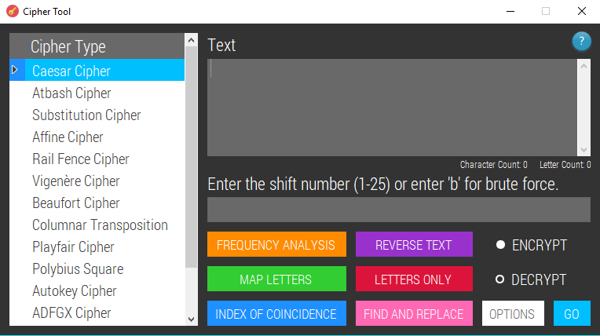

private void CaesarCheck()

{

int shift; // if a shift value is given it will be stored here

// checks if the given key is an int

bool isNumeric = int.TryParse(textBoxKey.Text, out shift);

bool inRange = false;

if (Enumerable.Range(1, 25).Contains(shift)) // checks if the number given is between 1-25

{

inRange = true;

}

else

{

inRange = false;

}

if (textBoxKey.Text.ToLower() == "b" || inRange == true) // if all inputs are valid or brute force has been chosen

{

if (textBoxKey.Text.ToLower() == "b") // with brute force

{

Caesar(textBox.Text, textBoxKey.Text, true);

}

else // without brute force

{

Caesar(textBox.Text, textBoxKey.Text, false);

}

}

else if (inRange == false) // if the shift value isn't in range, an error message is shown

{

MessageBox.Show("Your shift value is invalid.", "Message");

}

}

private void Caesar(string originalText, string key, bool brute) // if brute = false, a shift number has been given

{

originalText = new String(originalText.Where(Char.IsLetter).ToArray()).ToUpper(); // stores the uppercase letters that will be enciphered

if (brute == false) // if brute force isn't being used

{

int shift = int.Parse(key); // turns the shift value into an int

string finalMessage = CaesarEncryptDecrypt(originalText, shift);

// the resulting text is outputted in a new form

Output output = new Output(finalMessage);

output.Show();

}

else if (brute == true) // if brute force is being used

{

string[] solutions = new string[25]; // will store the brute force solutions

for (int shift = 1; shift < 26; shift++) // for every possible shift value

{

string finalMessage = CaesarEncryptDecrypt(originalText, shift);

solutions[shift - 1] = finalMessage; // the for loop starts with shift = 1; arrays are 0 based hence 'shift - 1' in the square brackets

}

Brute output = new Brute(solutions, originalText);

output.Show();

}

}

private string CaesarEncryptDecrypt(string originalText, int shift)

{

// if the user wants to decrypt, the negative value of the key is needed to revert the message

if (enOrDe == 'd')

{

shift = -shift;

}

char[] characters = new char[originalText.Length]; // all the characters in the ciphertext will be stored in an array

for (int i = 0; i < characters.Length; i++)

{

char letter = originalText[i]; // stores the current letter that will be manipulated

int index = (int)letter; // stores the ASCII value of the letter

index = index - 65 + shift; // sets A to 0, B to 1 etc. then applies the shift

index = PositiveModulus(index, 26);

letter = (char)(65 + index); // turns the index back into an ASCII value so that a letter is shown

characters[i] = letter; // adds the plaintext/ciphertext letter to the array

}

return FormatOutput(new string(characters)); // puts all of the translated letters into a string & formats the output

}

### Atbash Cipher

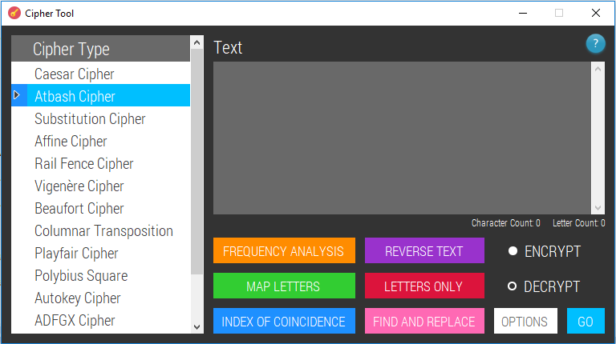

private void Atbash(string originalText)

{

Substitution(originalText, "zyxwvutsrqponmlkjihgfedcba"); // the Atbash cipher is the same as the substitution cipher using a reversed alphabet

}

### Substitution Cipher

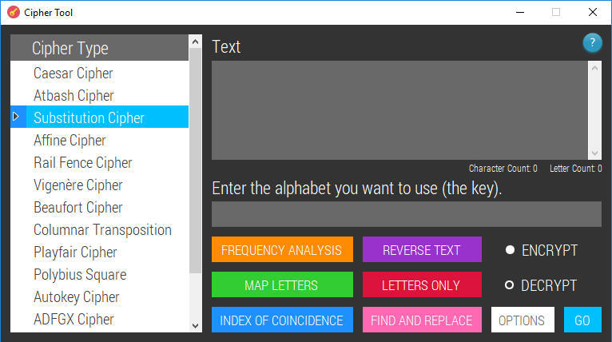

private void SubstitutionCheck()

{

if (textBoxKey.Text.Length != 26)

{

MessageBox.Show("The key must be 26 characters long.", "Message");

}

else

{

Match match = Regex.Match(textBoxKey.Text, @"^[A-Za-z-]+$"); // if the key textbox only contains letters and/or hyphens the match will be successful

if (match.Success)

{

Substitution(textBox.Text, textBoxKey.Text.ToLower());

}

else // error message

{

MessageBox.Show("Key must only contain letters and/or hyphens (-).", "Message");

}

}

}

private void Substitution(string originalText, string key)

{

originalText = new String(originalText.Where(Char.IsLetter).ToArray()).ToUpper();

string finalMessage = ""; // will store the message that has been created after the original message has been encrypted/decrypted

if (enOrDe == 'e') // if the user has chosen to encrypt a message

{

char[] characters = new char[originalText.Length]; // this array will store each character in the translated message

for (int i = 0; i < originalText.Length; i++) // for each character in the original message

{

int currentIndex = originalText[i]; // the index of the current letter is found

currentIndex -= 65; // 'A' = 65 in ASCII; doing this makes 'A' = 0

characters[i] = char.ToUpper(key[currentIndex]); // the index is used to find its corresponding new letter in the key

// and this new letter is added to the new message

}

finalMessage = new string(characters); // the character array is converted into a string

}

else if (enOrDe == 'd') // if the user chooses to decrypt

{

char[] characters = new char[originalText.Length]; // this char array will store the translated message characters

for (int i = 0; i < originalText.Length; i++)

{

int index = key.IndexOf(char.ToLower(originalText[i]));

if (index != -1) // if letter is found in the key

{

index += 65;

characters[i] = (char)index; // the key is used to find the right letters to swap

}

else

{

characters[i] = '-';

}

}

finalMessage = new string(characters); // the character array is converted to a string

}

Output output = new Output(FormatOutput(finalMessage));

output.Show();

}

### Affine Cipher

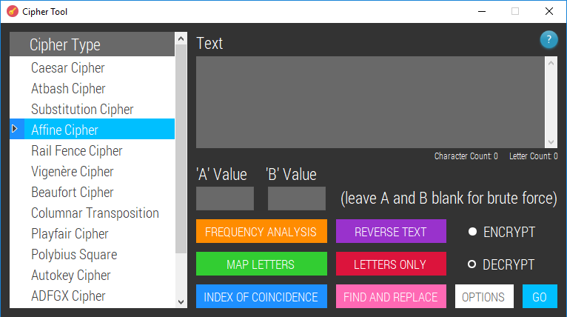

private void AffineCheck()

{

if (textBoxA.Text == "" && textBoxB.Text == "") // brute force

{

Affine(textBox.Text.ToLower(), 1, 0, true);

}

else

{

int A;

bool isANumeric = int.TryParse(textBoxA.Text, out A); // checks if the given A value is an int

int B;

bool isBNumeric = int.TryParse(textBoxB.Text, out B); // checks if the given B value is an int

if (isANumeric == false) // if the A value is not a whole number

{

MessageBox.Show("'A' must be a whole number.", "Message");

}

else

{

if (isBNumeric == false)

{

MessageBox.Show("'B' must be a whole number.", "Message");

}

else

{

if (A == 0)

{

MessageBox.Show("'A' cannot be 0.", "Message");

}

else if (A > 25)

{

MessageBox.Show("'A' must be less than 26.", "Message");

}

else

{

if (GetGCDByModulus(A, 26) == 1) // if A is coprime with 26, it is acceptable

{

Affine(textBox.Text, A, B, false);

}

else

{

MessageBox.Show("Your 'A' value is not coprime with 26. The possible values that A could be are 1, 3, 5, 7, 9, 11, 15, 17, 19, 21, 23, and 25.", "Message");

}

}

}

}

}

}

private void Affine(string originalText, int A, int B, bool brute)

{

originalText = new String(originalText.Where(Char.IsLetter).ToArray()).ToUpper();

string finalMessage = "";

if (enOrDe == 'e') // if encrypting

{

if (brute == false)

{

finalMessage = FormatOutput(AffineEncryption(originalText, A, B));

Output output = new Output(finalMessage);

output.Show();

}

else if (brute == true)

{

int arrayCounter = 0; // tracks the array positions where the possible affine solutions are stored

string[] solutions = new string[312]; // will store the brute force solutions

int[] possibleAValues = { 1, 3, 5, 7, 9, 11, 15, 17, 19, 21, 23, 25 }; // the possible A values are every odd number under 26 apart from 13

for (int a = 0; a < possibleAValues.Length; a++)

{

for (int b = 0; b < 26; b++)

{

solutions[arrayCounter] = "\tA = " + possibleAValues[a] + "\t\tB = " + b + "\r\n" + FormatOutput(AffineEncryption(originalText, possibleAValues[a], b));

arrayCounter += 1;

}

}

Brute newForm = new Brute(solutions, textBox.Text);

newForm.Show();

}

}

else if (enOrDe == 'd')

{

if (brute == false)

{

finalMessage = FormatOutput(AffineDecryption(originalText, A, B));

Output output = new Output(finalMessage);

output.Show();

}

else if (brute == true)

{

int arrayCounter = 0;

string[] solutions = new string[312]; // will store the brute force solutions; there are 312 possible solutions

int[] possibleAValues = { 1, 3, 5, 7, 9, 11, 15, 17, 19, 21, 23, 25 }; // the possible A values are every odd number under 26 apart from 13

for (int a = 0; a < possibleAValues.Length; a ++)

{

for (int b = 0; b < 26; b++)

{

solutions[arrayCounter] = "\tA = " + possibleAValues[a] + "\t\tB = " + b + "\r\n" + FormatOutput(AffineDecryption(originalText, possibleAValues[a], b));

arrayCounter += 1;

}

}

Brute newForm = new Brute(solutions, textBox.Text);

newForm.Show();

}

}

}

private string AffineEncryption(string originalText, int A, int B)

{

char[] charArray = new char[originalText.Length];

for (int i = 0; i < originalText.Length; i++)

{

int currentCharCode = (int)originalText[i] - 65; // converts letters to numbers where A=0

charArray[i] = (char)(((A * currentCharCode + B) % 26) + 65); // applies mathematical encryption function

}

return new string(charArray);

}

private string AffineDecryption(string originalText, int A, int B)

{

int modularInverse = ModularInverse(A,26);

char[] charArray = new char[originalText.Length];

for (int i = 0; i < originalText.Length; i++)

{

int currentCharCode = (int)originalText[i] - 65; // converts letters to numbers where A=0

charArray[i] = (char)(PositiveModulus((modularInverse * (currentCharCode - B)),26) + 65);

}

return new string(charArray);

}

### Rail Fence Cipher

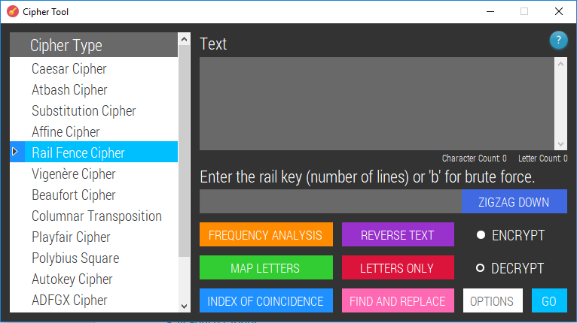

private void RailFenceCheck()

{

int railKey;

bool isKeyNumeric = int.TryParse(textBoxKey.Text, out railKey); // checks if the given railkey value is an int

if (isKeyNumeric == false)

{

if (textBoxKey.Text.ToLower() == "b") // brute force

{

RailFence(textBox.Text, textBox.Text.Length, true);

}

else

{

MessageBox.Show("The rail key must be an integer. Alternatively, enter 'b' for brute force.", "Message");

}

}

else

{

if (railKey <= 1)

{

MessageBox.Show("The rail key must be greater than 1.", "Message");

}

else

{

RailFence(textBox.Text, railKey, false); // runs only when all inputs are valid

}

}

}

private void RailFence(string originalText, int key, bool brute)

{

if (brute == false)

{

if (enOrDe == 'e') // if encrypting a message without brute force

{

Output output = new Output(RailFenceEncryption(originalText, key));

output.Show();

}

else if (enOrDe == 'd') // if decrypting

{

Output output = new Output(RailFenceDecryption(originalText, key));

output.Show();

}

}

else if (brute == true)

{

List<string> bruteSolutionsZDown = new List<string>();

List<string> bruteSolutionsZUp = new List<string>();

btnZigzagDirection.Text = "ZIGZAG DOWN";

for (int i = 2; i < key; i++) // tries keys from 2 to N where N is the text length

{

if (enOrDe == 'e')

{

bruteSolutionsZDown.Add("Rail Setting: DOWN\tKey: " + i + "\r\n" + RailFenceEncryption(originalText, i));// solutions for downwards zigzag directon are found

}

else if (enOrDe == 'd')

{

bruteSolutionsZDown.Add("Rail Setting: DOWN\tKey: " + i + "\r\n" + RailFenceDecryption(originalText, i));// solutions for downwards zigzag directon are found

}

}

btnZigzagDirection.Text = "ZIGZAG UP"; // causes upward zigzag solutions to be found

for (int i = 2; i < key; i++)

{

if (enOrDe == 'e')

{

bruteSolutionsZUp.Add("Rail Setting: UP\t\tKey: " + i + "\r\n" + RailFenceEncryption(originalText, i)); // solutions for upwards zigzag directon are found

}

else if (enOrDe == 'd')

{

bruteSolutionsZUp.Add("Rail Setting: UP\t\tKey: " + i + "\r\n" + RailFenceDecryption(originalText, i)); // solutions for upwards zigzag directon are found

}

}

string[] solutions = bruteSolutionsZDown.Concat(bruteSolutionsZUp).ToArray(); // merges the lists & stores all solutions in one array

Brute output = new Brute(solutions, originalText);

output.Show();

// resets the button

btnZigzagDirection_Click(this, EventArgs.Empty);

btnZigzagDirection_Click(this, EventArgs.Empty);

}

}

private string RailFenceEncryption(string originalText, int key)

{

List<string> railFence = new List<string>();

for (int i = 0; i < key; i++)

{

railFence.Add(""); // inserts the same number of blank strings to the list as the key number

} // these strings will be the rails

int railLine = 0; // the first rail index is 0 because the starting position of an array is 0

int increment = 1; // this is the amount of positions for the current rail to move to the next rail

if (btnZigzagDirection.Text == "ZIGZAG UP") // if the zigzag direction is upwards instead of downwards

{

railLine = key - 1; // the initial rail will be the last rail; in an array the index will be the number of array positions - 1

increment = -1; // initially the letters will move up the rail instead of down so the next array position will be 1 less than the previous one

}

foreach (char c in originalText)

{

if (railLine + increment == key) // if the bottom rail has been reached

{

increment = -1; // the increment changes to -1 so that it goes back up the rails

}

else if (railLine + increment == -1) // if the top rail has been reached

{

increment = 1; // the rail line numbers will increase (goes back down the rails)

}

railFence[railLine] += c; // the character is put onto the right line

railLine += increment; // the rail line that gets added to next changes to either the rail

} // above (if increment = -1) or the rail below (if increment = 1)

string finalMessage = "";

foreach (string s in railFence)

{

finalMessage += s; // puts all the letters from all the rails into one string

}

return finalMessage;

}

private string RailFenceDecryption(string originalText, int key)

{

int cipherLength = originalText.Length;

List<List<int>> railFence = new List<List<int>>(); // a list of lists is made - will store each rail line, and each rail line will have

for (int i = 0; i < key; i++) // its own list containing the positions in the final message where the ciphertext

{ // letters should move to

railFence.Add(new List<int>());

}

int railLine = 0;

int increment = 1;

if (btnZigzagDirection.Text == "ZIGZAG UP")

{

railLine = key - 1;

increment = -1;

}

for (int i = 0; i < cipherLength; i++)

{

if (railLine + increment == key)

{

increment = -1; // moves back up the rail

}

else if (railLine + increment == -1)

{

increment = 1; // moves down the rail

}

railFence[railLine].Add(i); // for each line, an array is made which contains the position values of letters that lie on that line

railLine += increment;

}

int counter = 0;

char[] outputArray = new char[cipherLength]; // this array will store the final message

for (int i = 0; i < key; i++) // for each line that there is

{

for (int j = 0; j < railFence[i].Count; j++) // for each letter that lies on the current rail line

{

outputArray[railFence[i][j]] = originalText[counter]; // each letter from the original (cipher) text is put in the right place

counter++; // in the output array

}

}

return new string(outputArray); // the final message is stored in a string instead of an array

}

### Vigenère Cipher

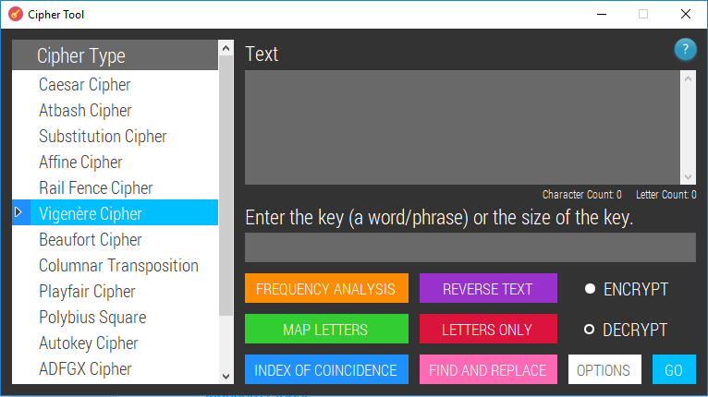

private void VigCheck()

{

int key;

bool isKeyNumeric = int.TryParse(textBoxKey.Text, out key); // checks if the given key value is an int

if (isKeyNumeric == false)

{

bool keyIsAllLetters = textBoxKey.Text.All(Char.IsLetter);

if (keyIsAllLetters == true)

{

// key is known and valid

Vigenère(textBox.Text, textBoxKey.Text.ToUpper());

}

else if (keyIsAllLetters == false)

{

MessageBox.Show("Every character in the key must be a letter. If you don't know the key, enter the " +

"size that you think the key is.", "Message");

}

}

else if (isKeyNumeric == true)

{

if (enOrDe == 'e')

{

MessageBox.Show("You must provide a keyword to encrypt with.", "Message");

}

else

{

// the key size is known but the actual keyword isn't known

if (key == 1)

{

MessageBox.Show("The key size should not be 1; if it is, it is just a Caesar cipher.", "Message");

}

else if (key <= textBox.Text.Length && key > 1)

{

VigSolver vS = new VigSolver(textBox.Text, key); // opens a new form that can be used to find the key

vS.Show();

}

else

{

MessageBox.Show("Key should be less than or equal to text length.", "Message");

}

}

}

}

private void Vigenère(string originalText, string key)

{

string inputText = new String(originalText.Where(Char.IsLetter).ToArray()).ToUpper(); // removes anything that is not a letter

char[] originalArray = inputText.ToArray(); // puts all the letters of the original message into an array

char[] keyArray = new char[inputText.Length]; // this array will store the key repeated to the same length as the message

for (int i = 0; i < keyArray.Length; i++)

{

keyArray[i] = key[i % key.Length]; // the mod allows the word to repeat over and over again

}

char[] newMessageArray = new char[originalArray.Length]; // this array will store the new message

for (int i = 0; i < originalArray.Length; i++)

{

int originalLetterValue = (int)originalArray[i] - 65; // the -65 is to make 'A' correspond to 0

int keyLetterValue = (int)keyArray[i] - 65;

if (enOrDe == 'e') // encrypt

{

newMessageArray[i] = (char)(((originalLetterValue + keyLetterValue) % 26) + 65); // mod 26 makes the alphabet wrap around

// and 65 is added so that letters are displayed not random symbols

}

else if (enOrDe == 'd') // decrypt

{

int subtractKey = originalLetterValue - keyLetterValue;

int findLetter = PositiveModulus(subtractKey, 26);

newMessageArray[i] = (char)(findLetter + 65); // adding 65 makes the letters actually display as letters

}

}

Output output = new Output(FormatOutput(new string(newMessageArray)));

output.Show();

}

### Beaufort Cipher

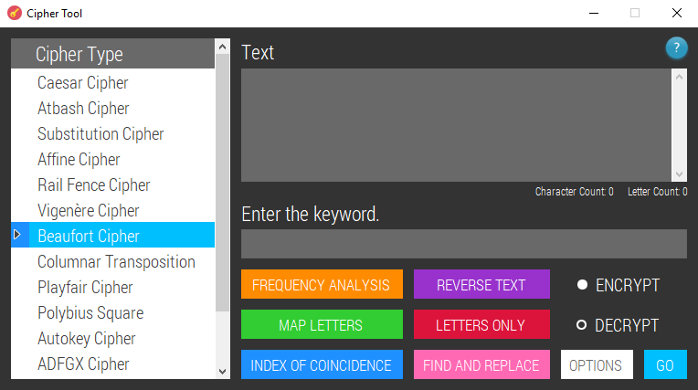

private void BeaufortCheck()

{

bool keyIsAllLetters = textBoxKey.Text.All(Char.IsLetter); // checks if the key given is made up of letters only

if (keyIsAllLetters == true)

{

// key is known and valid

Beaufort(textBox.Text, textBoxKey.Text.ToUpper());

}

else if (keyIsAllLetters == false)

{

MessageBox.Show("Every character in the key must be a letter.", "Message");

}

}

private void Beaufort(string originalText, string key)

{

string text = new String(originalText.Where(Char.IsLetter).ToArray()).ToUpper(); // removes anything that is not a letter

char[] originalArray = text.ToArray(); // puts all the letters of the original message into an array

char[] keyArray = new char[text.Length]; // this array will store the key repeated to the same length as the message

for (int i = 0; i < keyArray.Length; i++)

{

keyArray[i] = key[i % key.Length]; // the mod allows the word to repeat over and over again

}

char[] newMessageArray = new char[originalArray.Length]; // this array will store the new message

for (int i = 0; i < originalArray.Length; i++)

{

int originalLetterValue = (int)originalArray[i] - 65; // the -65 is to make 'A' correspond to 0

int keyLetterValue = (int)keyArray[i] - 65;

newMessageArray[i] = (char)(PositiveModulus((keyLetterValue - originalLetterValue),26) + 65); // encryption and decryption follow the same algorithm

}

Output output = new Output(FormatOutput(new string(newMessageArray)));

output.Show();

}

### Columnar Transposition Cipher

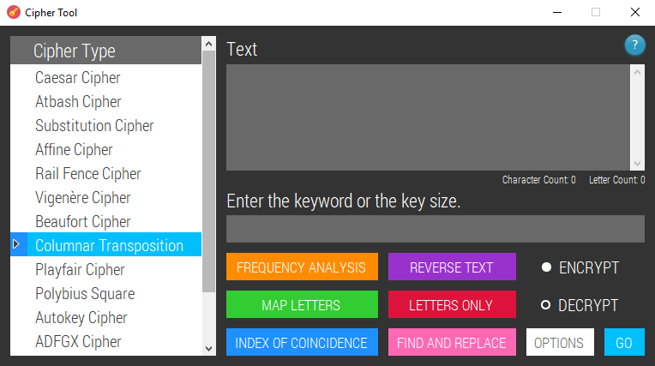

private void ColumnarCheck()

{

int key;

bool isKeyNumeric = int.TryParse(textBoxKey.Text, out key); // checks if the given key value is an int

string originalText = new String(textBox.Text.ToUpper().Where(Char.IsLetter).ToArray()); // only keeps the letters

if (isKeyNumeric == false)

{

bool keyIsAllLetters = textBoxKey.Text.All(Char.IsLetter);

if (keyIsAllLetters == true)

{

// key is known and valid

if (enOrDe == 'e') // encrypt

{

Columnar(originalText, textBoxKey.Text.ToUpper());

}

else if (enOrDe == 'd') // decrypt

{

Columnar(originalText, textBoxKey.Text.ToUpper());

}

}

else

{

MessageBox.Show("Every character in the key must be a letter. If you don't know the key, enter the " +

"size that you think the key is.", "Message");

}

}

else if (isKeyNumeric == true) // if a key size has been entered instead of the actual key

{

if (enOrDe == 'd')

{

int noOfRows = originalText.Length / key;

if (originalText.Length % key != 0)

{

MessageBox.Show("The ciphertext is not divisible by the key.", "Message");

}

else

{

string[] columns = new string[key];

int start = 0; // this value will increase by the number of rows so that each column contains the no. of rows amount of characters

for (int i = 0; i < columns.Length; i++)

{

columns[i] = originalText.Substring(start, noOfRows); // each column is filled with the same number of characters

start += noOfRows;

}

char[,] grid = new char[noOfRows, key]; // stores the text in grid form

for (int i = 0; i < key; i++)

{

char[] columnChars = columns[i].ToArray(); // stores each character in the current column

for (int j = 0; j < noOfRows; j++)

{

grid[j, i] = columnChars[j]; // goes through each row one at a time and places the current column char in the right column using the index

}

}

// so far, we have the grid with the ciphertext written in columns

// a datagridview is made using the inputs given. This is needed in the form that will open, allowing the user to manually solve the cipher

DataGridView colTransDGV = new DataGridView();

colTransDGV.ColumnCount = key;

colTransDGV.AllowUserToAddRows = false;

colTransDGV.AllowUserToDeleteRows = false;

colTransDGV.MultiSelect = false;

colTransDGV.AllowUserToResizeRows = false;

colTransDGV.AllowUserToResizeColumns = false;

colTransDGV.AutoSizeRowsMode = DataGridViewAutoSizeRowsMode.DisplayedCells;

colTransDGV.AutoSizeColumnsMode = DataGridViewAutoSizeColumnsMode.Fill;

colTransDGV.BackgroundColor = Color.White;

colTransDGV.BorderStyle = BorderStyle.None;

colTransDGV.CellBorderStyle = DataGridViewCellBorderStyle.None;

colTransDGV.ColumnHeadersBorderStyle = DataGridViewHeaderBorderStyle.Single;

DataGridViewCellStyle style = colTransDGV.ColumnHeadersDefaultCellStyle;

style.BackColor = Color.DimGray;

myFont = new Font(fonts.Families[0], 12.5F);

style.Font = myFont;

style.ForeColor = Color.White;

style.Alignment = DataGridViewContentAlignment.MiddleCenter;

style.WrapMode = DataGridViewTriState.True;

style.SelectionBackColor = Color.DarkGray;

DataGridViewCellStyle defaultCellStyle = colTransDGV.DefaultCellStyle;

defaultCellStyle.BackColor = Color.White;

defaultCellStyle.Font = myFont;

defaultCellStyle.ForeColor = Color.FromArgb(64, 64, 64);

defaultCellStyle.SelectionBackColor = Color.White;

defaultCellStyle.SelectionForeColor = Color.FromArgb(64, 64, 64);

defaultCellStyle.Alignment = DataGridViewContentAlignment.MiddleCenter;

DataGridViewCellStyle rowHeadersStyle = colTransDGV.RowHeadersDefaultCellStyle;

rowHeadersStyle.BackColor = Color.White;

colTransDGV.ColumnHeadersHeightSizeMode = DataGridViewColumnHeadersHeightSizeMode.AutoSize;

colTransDGV.RowHeadersWidth = 4;

colTransDGV.EnableHeadersVisualStyles = false;

colTransDGV.GridColor = Color.DimGray;

colTransDGV.ReadOnly = true;

colTransDGV.RowHeadersBorderStyle = DataGridViewHeaderBorderStyle.None;

colTransDGV.RowHeadersWidthSizeMode = DataGridViewRowHeadersWidthSizeMode.DisableResizing;

colTransDGV.ScrollBars = ScrollBars.Vertical;

for (int i = 0; i < key; i++)

{

colTransDGV.Columns[i].Name = (i + 1).ToString();

colTransDGV.Columns[i].HeaderCell.Style.Alignment = DataGridViewContentAlignment.MiddleCenter;

colTransDGV.Columns[i].SortMode = DataGridViewColumnSortMode.NotSortable;

}

for (int r = 0; r < noOfRows; r++)

{

DataGridViewRow row = new DataGridViewRow();

row.CreateCells(colTransDGV);

for (int c = 0; c < key; c++)

{

row.Cells[c].Value = grid[r, c];

}

colTransDGV.Rows.Add(row);

}

ColTransposition ct = new ColTransposition(colTransDGV, grid);

ct.Show();

}

}

else

{

MessageBox.Show("A keyword must be provided for encryption.", "Message");

}

}

}

private string columnarOutput; // the ADFGVX cipher uses the Columnar procedure as part of the algorithm; the output needs to be stored

private void Columnar(string originalText, string key)

{

int noOfRows = originalText.Length / key.Length;

bool roundedUp = false;

if (originalText.Length % key.Length != 0)

{

noOfRows++; // rounds up because even if the final row will only be partially filled there must be enough rows to store the text

roundedUp = true;

}

if (enOrDe == 'e') // encrypt

{

int letterCounter = 0; // ensures all the letters are added to the grid and starts adding 'X' in any extra gaps

char[,] grid = new char[noOfRows, key.Length]; // stores the text in grid form

for (int i = 0; i < noOfRows; i++)

{

for (int j = 0; j < key.Length; j++)

{

if (letterCounter < originalText.Length) // if there are still letters to be put into the grid

{

grid[i, j] = originalText[letterCounter]; // the letters are put in the right places

letterCounter++;

}

else

{

grid[i, j] = 'X'; // any extra spaces at the end are filled

}

}

}

string[] columns = new string[key.Length]; // will store the text in each column

for (int i = 0; i < key.Length; i++)

{

char[] columnArray = new char[noOfRows]; // stores the characters that make up a column

for (int j = 0; j < noOfRows; j++)

{

columnArray[j] = grid[j, i];

}

columns[i] = new string(columnArray); // each column is converted to a string

}

char[] keyChars = key.ToArray();

Array.Sort(keyChars, columns); // the characters in the key are sorted alphabetically and this sorts the columns at the same time

StringBuilder finalMessage = new StringBuilder();

foreach (string column in columns)

{

finalMessage.Append(column);

}

Output output = new Output(finalMessage.ToString());

output.Show();

}

else if (enOrDe == 'd')

{

int noOfFullCols = 0; // will be needed if the cipher is irregular and there are no nulls

if (roundedUp == true)

{

int temp = noOfRows * key.Length;

int noOfPlaceholders = temp - originalText.Length;

noOfFullCols = key.Length - noOfPlaceholders;

}

char[] sortedKey = key.ToArray();

int[] indexes = new int[sortedKey.Length];

for (int i = 0; i < sortedKey.Length; i++)

{

indexes[i] = i; // stores numbers from 0 to keyLength

}

Array.Sort(sortedKey, indexes); // the index numbers are re-ordered in conjunction with the alphabetical order of the key

string[] columns = new string[key.Length]; // makes a column for every character in the key

int start = 0; // this value will increase by the number of rows so that each column contains the no. of rows amount of characters

for (int i = 0; i < columns.Length; i++)

{

if (roundedUp == true)

{

if (indexes[i] < noOfFullCols)

{

columns[i] = originalText.Substring(start, noOfRows); // each column is filled with the same number of characters

start += noOfRows;

}

else

{

columns[i] = originalText.Substring(start, noOfRows - 1); // -1 because there is a placeholder

columns[i] += "X";

start += noOfRows - 1;

}

}

else

{

columns[i] = originalText.Substring(start, noOfRows); // each column is filled with the same number of characters

start += noOfRows;

}

}

char[,] grid = new char[noOfRows, key.Length]; // stores the text in grid form

for (int i = 0; i < key.Length; i++)

{

char[] columnChars = columns[i].ToArray(); // stores each character in the current column

for (int j = 0; j < noOfRows; j++)

{

grid[j, indexes[i]] = columnChars[j]; // goes through each row one at a time and places the current column char in the right column using the index

}

}

string finalMessage = "";

foreach (char c in grid)

{

finalMessage += c; // all the characters in the grid array are put into one string to be output

}

if (cipherType == "columnar")

{

Output output = new Output(finalMessage);

output.Show();

}

else // procedure is used in ADFGVX cipher

{

columnarOutput = finalMessage;

}

}

}

### Playfair Cipher

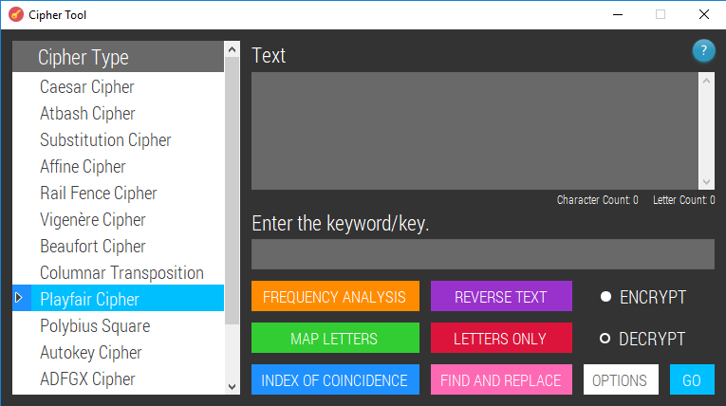

private void PlayfairCheck()

{

bool keyIsAllLetters = textBoxKey.Text.All(Char.IsLetter);

string originalText = new String(textBox.Text.ToUpper().Where(Char.IsLetter).ToArray()); // only keeps the letters

if (keyIsAllLetters == true)

{

if (textBoxKey.Text.ToUpper().Contains("J"))

{

MessageBox.Show("The key should not contain the character 'J' - replace it or remove it.", "Message");

}

else

{

Playfair(originalText, textBoxKey.Text.ToUpper());

}

}

else

{

MessageBox.Show("Every character in the key must be a letter.", "Message");

}

}

private void Playfair(string originalText, string key)

{

if (originalText.Length % 2 == 1)

{

originalText += "X"; // completes final digram if the text length is odd

}

string[] digrams = Digrams(originalText);

for (int i = 0; i < digrams.Length; i++)

{

char[] charsInTheDigram = digrams[i].ToArray();

if (charsInTheDigram[0] == charsInTheDigram[1]) // if both letters in the digram are the same

{

charsInTheDigram[1] = 'X'; // the second letter is changed to an X

digrams[i] = new string(charsInTheDigram);

}

}

// making the key table

string keyWithoutRepeats = new string(key.ToCharArray().Distinct().ToArray()); // removes any repeated letters in the key

char[,] keyTable = new char[5, 5]; // makes the 5x5 grid

int counter = 0;

char[] alphabet = new char[25]; // J is excluded

for (int i = 0; i < 5; i++)

{

for (int j = 0; j < 5; j++)

{

if (counter < keyWithoutRepeats.Length)

{

alphabet[counter] = keyWithoutRepeats[counter]; // puts each of the key letters into the list of letters first

counter++;

}

else

{

for (int k = 0; k < 26; k++)

{

string currentLetters = new string(alphabet);

if (!currentLetters.Contains((char)(k + 65))) // goes through the alphabet looking for characters that aren't already in the alphabet array

{

if ((k + 65) != 74) // J = 74 but we want to exclude J so characters are only added if they aren't J

{

alphabet[counter] = (char)(k + 65);

counter++;

}

}

}

}

}

}

counter = 0; // counter is reset and reused

for (int i = 0; i < 5; i++)

{

for (int j = 0; j < 5; j++)

{

keyTable[i, j] = alphabet[counter]; // the alphabet array has the letters in the right order; now they just need to be put into the 2D array

counter++;

}

}

string[] newDigrams = new string[originalText.Length / 2];

counter = 0;

bool newDigramFound = false;

int rowIndex1 = 0;

int colIndex1 = 0;

foreach (string digram in digrams)

{

char[] lettersInDigram = digram.ToArray();

for (int row = 0; row < 5; row++)

{

for (int col = 0; col < 5; col++)

{

// finds keyTable row and column index of the second letter in the digram

if (lettersInDigram[1] == keyTable[row, col])

{

rowIndex1 = row;

colIndex1 = col;

}

}

}

for (int row = 0; row < 5; row++)

{

for (int col = 0; col < 5; col++)

{

if (lettersInDigram[0] == keyTable[row, col])

{

newDigramFound = false;

for (int k = 0; k < 5; k++)

{

if (k != col)

{

if (lettersInDigram[1] == keyTable[row, k])

{

if (enOrDe == 'e') // encrypt

{

// same row - replace with letters on immediate right on grid

char[] newLetters = { keyTable[row, (col + 1) % 5], keyTable[row, (k + 1) % 5] };

newDigrams[counter] = new string(newLetters);

}

else // decrypt

{

// same row - replace with letters on immediate left on grid

char[] newLetters = { keyTable[row, PositiveModulus((col - 1), 5)], keyTable[row, PositiveModulus((k - 1), 5)] };

newDigrams[counter] = new string(newLetters);

}

counter++;

newDigramFound = true;

}

}

if (k != row)

{

if (lettersInDigram[1] == keyTable[k, col])

{

if (enOrDe == 'e') // encrypt

{

// same column - replace with letters immediately below

char[] newLetters = { keyTable[(row + 1) % 5, col], keyTable[(k + 1) % 5, col] };

newDigrams[counter] = new string(newLetters);

}

else // decrypt

{

// same column - replace with letters immediately above

char[] newLetters = { keyTable[PositiveModulus((row - 1), 5), col], keyTable[PositiveModulus((k - 1), 5), col] };

newDigrams[counter] = new string(newLetters);

}

counter++;

newDigramFound = true;

}

}

}

if (newDigramFound == false) // if the second letter in the digram wasn't in the same row or column as the first

{

char[] newLetters = { keyTable[row, colIndex1], keyTable[rowIndex1, col] };

newDigrams[counter] = new string(newLetters);

counter++;

}

}

}

}

}

StringBuilder builder = new StringBuilder();

foreach (string digram in newDigrams)

{

builder.Append(digram); // puts all the digrams into one big string

}

string tempString = builder.ToString();

string finalMessage = tempString;

if (enOrDe == 'd')

{

if (tempString.Contains("X"))

{

string tempMessage = tempString;

foreach (Match match in Regex.Matches(tempString, "X"))

{

char letter = tempMessage[match.Index - 1];

char[] temp = tempMessage.ToArray();

temp[match.Index] = letter;

tempMessage = new string(temp);

}

if (tempMessage[tempMessage.Length - 1] == tempMessage[tempMessage.Length - 2])

{

tempMessage = tempMessage.Remove(tempMessage.Length - 1);

}

finalMessage = tempString + "\r\n\r\nAssuming all 'X's were double letters and/or appended during encryption:\r\n" + tempMessage;

}

}

Output output = new Output(finalMessage);

output.Show();

}

### Polybius Square

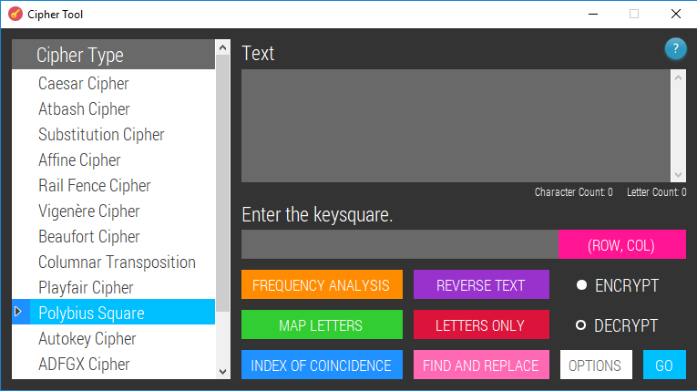

private void PolybiusCheck()

{

if (textBoxKey.Text.Length != 25)

{

MessageBox.Show("The key must be 25 characters long.", "Message");

}

else

{

Match match = Regex.Match(textBoxKey.Text, @"^[A-Za-z-]+$"); // if the key textbox only contains letters and/or hyphens the match will be successful

if (match.Success)

{

Polybius(textBox.Text.ToUpper(), textBoxKey.Text.ToUpper());

}

else

{

MessageBox.Show("Key must only contain letters and/or hyphens (-).", "Message");

}

}

}

private void Polybius(string originalText, string key)

{

char[,] grid = MakeGrid(key, 5);

if (enOrDe == 'e')

{

originalText = new String(originalText.Where(Char.IsLetter).ToArray());

string ciphertext = ""; // will have numbers appended to it

for (int i = 0; i < originalText.Length; i++)

{

for (int j = 0; j < 5; j++)

{

for (int k = 0; k < 5; k++)

{

if (originalText[i] == grid[j, k]) // if the plaintext letter matches the grid letter

{

if (btnOrder.Text == "(ROW, COL)")

{

ciphertext += (j + 1).ToString() + (k + 1).ToString() + " "; // the coordinates are written (row, column)

}

else

{

ciphertext += (k + 1).ToString() + (j + 1).ToString() + " "; // the coordinates are written (column, row)

}

}

}

}

}

Output output = new Output(ciphertext);

output.Show();

}

else if (enOrDe == 'd')

{

originalText = new String(originalText.Where(Char.IsDigit).ToArray());

if (originalText.Length % 2 != 0) // if there aren't an even number of digits

{

MessageBox.Show("There must be an even number of digits in the ciphertext.", "Message");

}

else

{

string plaintext = ""; // plaintext characters will be appended to this

string[] digitPairs = new string[originalText.Length / 2];

int index = 0;

// stores the digits in pairs

for (int i = 0; i < originalText.Length / 2; i++)

{

digitPairs[i] = originalText.Substring(index, 2);

index += 2;

}

// each pair is used as coordinates to locate the correct letter in the grid

foreach (string pair in digitPairs)

{

if (btnOrder.Text == "(ROW, COL)")

{

plaintext += grid[int.Parse(pair[0].ToString()) - 1, int.Parse(pair[1].ToString()) - 1];

}

else

{

plaintext += grid[int.Parse(pair[1].ToString()) - 1, int.Parse(pair[0].ToString()) - 1];

}

}

Output output = new Output(plaintext);

output.Show();

}

}

}

### Autokey Cipher

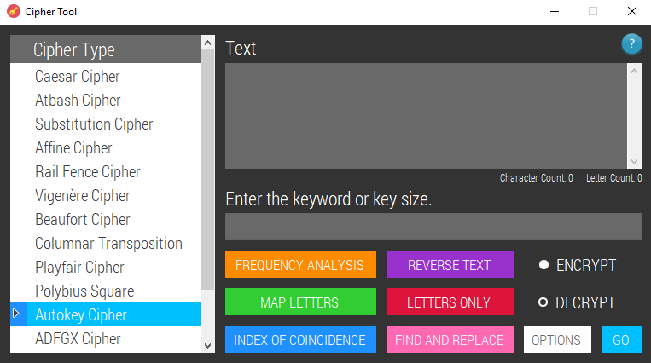

private void AutokeyCheck()

{

int key;

bool isKeyNumeric = int.TryParse(textBoxKey.Text, out key); // checks if the given key value is an int

if (isKeyNumeric == false)

{

bool keyIsAllLetters = textBoxKey.Text.All(Char.IsLetter);

if (keyIsAllLetters == true)

{

// key is known and valid

Autokey(new String(textBox.Text.Where(Char.IsLetter).ToArray()).ToUpper(), textBoxKey.Text.ToUpper());

}

else if (keyIsAllLetters == false)

{

MessageBox.Show("Every character in the key must be a letter. If you don't know the key, enter the " +

"size that you think the key is.", "Message");

}

}

else

{

if (enOrDe == 'e')

{

MessageBox.Show("You must provide a keyword to encrypt with.", "Message");

}

else

{

if (key <= textBox.Text.Length && key > 1) // if key size given is a valid size

{

AutokeySolver auto = new AutokeySolver(textBox.Text, key); // a new form opens

auto.Show();

}

else

{

MessageBox.Show("Key should be less than or equal to text length.", "Message");

}

}

}

}

private void Autokey(string originalText, string key)

{

int lettersFromTextToAppend = originalText.Length - key.Length;

if (enOrDe == 'e')

{

string longKey = key + originalText.Substring(0, lettersFromTextToAppend);

char[] newMessageArray = new char[originalText.Length]; // this array will store the new message

for (int i = 0; i < originalText.Length; i++)

{

int originalLetterValue = (int)originalText[i] - 65; // the -65 is to make 'A' correspond to 0

int keyLetterValue = (int)longKey[i] - 65;

newMessageArray[i] = (char)(((originalLetterValue + keyLetterValue) % 26) + 65); // mod 26 makes the alphabet wrap around

// and 65 is added so that letters are displayed not random symbols

}

Output output = new Output(FormatOutput(new string(newMessageArray)));

output.Show();

}

else if (enOrDe == 'd')

{

char[] longKey = new char[originalText.Length];

char[] plaintext = new char[longKey.Length]; // will store the decrypted message

for (int i = 0; i < key.Length; i++)

{

longKey[i] = key[i]; // puts the keyword given by the user into the array

}

for (int i = 0; i < longKey.Length; i++)

{

int originalLetterValue = (int)originalText[i] - 65; // the -65 is to make 'A' correspond to 0

int keyLetterValue = (int)longKey[i] - 65;

int subtractKey = originalLetterValue - keyLetterValue;

int findLetter = PositiveModulus(subtractKey,26);

plaintext[i] = (char)(findLetter + 65);

if (i < longKey.Length - key.Length) // if letters still need to be added to the key so that the next plaintext letters can be decrypted

{

longKey[i + key.Length] = (char)(findLetter + 65);

}

}

Output output = new Output(FormatOutput(new string(plaintext)));

output.Show();

}

}

### ADFGX Cipher

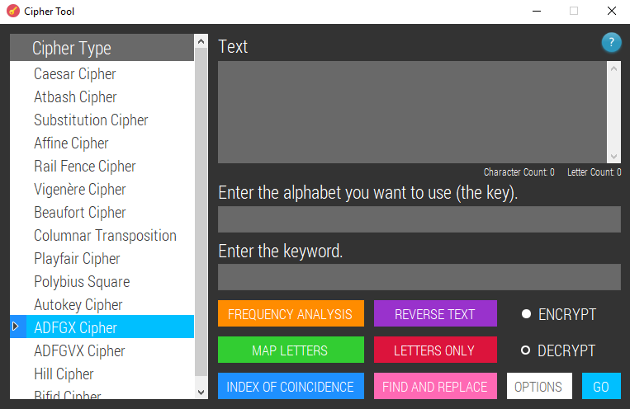

private void ADFGX(string originalText, string keyGrid, string keyword)

{

char[,] grid = MakeGrid(keyGrid, 5);

originalText = Regex.Replace(originalText, @"\s", ""); // removes whitespace

if (enOrDe == 'e')

{

string numbers = ""; // will have numbers appended to it

string ciphertext = ""; // ciphertext will be appended

for (int i = 0; i < originalText.Length; i++)

{

for (int j = 0; j < 5; j++)

{

for (int k = 0; k < 5; k++)

{

if (originalText[i] == grid[j, k]) // if the plaintext letter matches the grid letter

{

numbers += (j).ToString() + (k).ToString(); // the coordinates are written (row, column)

}

}

}

}

foreach (char c in numbers)

{

switch (c)

{

case '0':

{ ciphertext += 'A'; break; }

case '1':

{ ciphertext += 'D'; break; }

case '2':

{ ciphertext += 'F'; break; }

case '3':

{ ciphertext += 'G'; break; }

case '4':

{ ciphertext += 'X'; break; }

}

}

Columnar(ciphertext, keyword);

}

else if (enOrDe == 'd')

{

Columnar(originalText, keyword);

string numbers = "";

foreach (char c in columnarOutput)

{

switch (c)

{

case 'A':

{ numbers += '0'; break; }

case 'D':

{ numbers += '1'; break; }

case 'F':

{ numbers += '2'; break; }

case 'G':

{ numbers += '3'; break; }

case 'X':

{ numbers += '4'; break; }

}

}

string plaintext = ""; // plaintext characters will be appended to this

string[] digitPairs = Digrams(numbers);

foreach (string pair in digitPairs)

{

plaintext += grid[int.Parse(pair[0].ToString()), int.Parse(pair[1].ToString())];

}

Output output = new Output(plaintext);

output.Show();

}

}

### ADFGVX Cipher

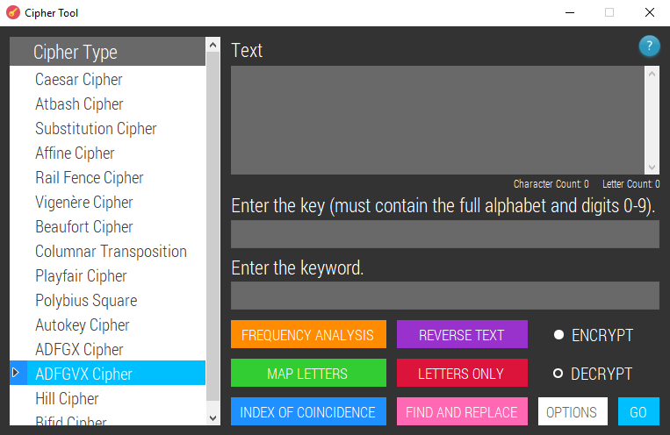

private void ADFGVXCheck()

{

if (String.IsNullOrWhiteSpace(tbKeyword.Text))

{

MessageBox.Show("You must enter a keyword.", "Message");

}

else

{

if (cipherType == "adfgvx")

{

if (textBoxKey.Text.Length != 36)

{

MessageBox.Show("The key must be 36 characters long.", "Message");

}

else

{

ADFGVX(textBox.Text.ToUpper(), textBoxKey.Text.ToUpper(), tbKeyword.Text.ToUpper());

}

}

else

{

if (textBoxKey.Text.Length != 25)

{

MessageBox.Show("The key must be 25 characters long.", "Message");

}

else

{

Match match = Regex.Match(textBoxKey.Text, @"^[A-Za-z]+$"); // checks that the key contains letters only

if (match.Success)

{

ADFGX(textBox.Text.ToUpper(), textBoxKey.Text.ToUpper(), tbKeyword.Text.ToUpper());

}

else

{

MessageBox.Show("The key must contain letters only.", "Message");

}

}

}

}

}

private void ADFGVX(string originalText, string keyGrid, string keyword)

{

char[,] grid = MakeGrid(keyGrid, 6);

originalText = Regex.Replace(originalText, @"\s", ""); // removes whitespace

if (enOrDe == 'e')

{

string numbers = ""; // will have numbers appended to it

string ciphertext = ""; // ciphertext will be appended

for (int i = 0; i < originalText.Length; i++)

{

for (int j = 0; j < 6; j++)

{

for (int k = 0; k < 6; k++)

{

if (originalText[i] == grid[j, k]) // if the plaintext letter matches the grid letter

{

numbers += (j).ToString() + (k).ToString(); // the coordinates are written (row, column)

}

}

}

}

foreach (char c in numbers)

{

switch (c)

{

case '0':

{ ciphertext += 'A'; break; }

case '1':

{ ciphertext += 'D'; break; }

case '2':

{ ciphertext += 'F'; break; }

case '3':

{ ciphertext += 'G'; break; }

case '4':

{ ciphertext += 'V'; break; }

case '5':

{ ciphertext += 'X'; break; }

}

}

Columnar(ciphertext, keyword);

}

else if (enOrDe == 'd')

{

Columnar(originalText, keyword);

string numbers = "";

foreach (char c in columnarOutput)

{

switch (c)

{

case 'A':

{ numbers += '0'; break; }

case 'D':

{ numbers += '1'; break; }

case 'F':

{ numbers += '2'; break; }

case 'G':

{ numbers += '3'; break; }

case 'V':

{ numbers += '4'; break; }

case 'X':

{ numbers += '5'; break; }

}

}

string plaintext = ""; // plaintext characters will be appended to this

string[] digitPairs = Digrams(numbers);

foreach (string pair in digitPairs)

{

plaintext += grid[int.Parse(pair[0].ToString()), int.Parse(pair[1].ToString())];

}

Output output = new Output(plaintext);

output.Show();

}

}

### Hill Cipher

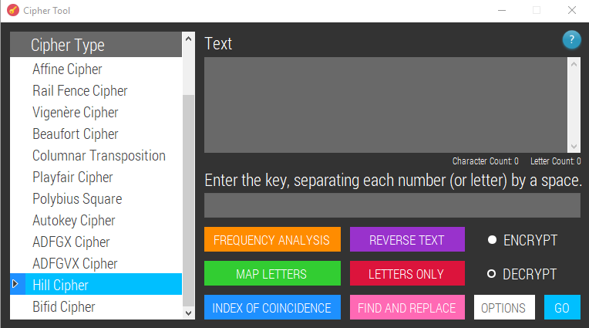

private void HillCheck()

{

Match match = Regex.Match(textBoxKey.Text, @"[0-9 ]+"); // the key must contain numbers and spaces only

if (!match.Success)

{

MessageBox.Show("The key must only contain numbers (or letters) and spaces.", "Message");

}

else

{

List<string> inputValues = new List<string>();

inputValues.AddRange(textBoxKey.Text.ToUpper().Split(' '));

double result = Math.Sqrt(inputValues.Count);

bool isSquare = result % 1 == 0; // checks if the number of values entered is a square number

if (isSquare == false)

{

MessageBox.Show("The matrix must be square - the number of values given in the key text box must be a square number.", "Message");

}

else

{

List<int> matrixValues = new List<int>();

foreach (string value in inputValues)

{

Match isLetter = Regex.Match(value, @"[A-Za-z]");

if (isLetter.Success)

{

char letter = value[0];

int temp = (int)(Char.ToUpper(letter)) - 65; // converts letters to numbers

matrixValues.Add(temp);

}

else

{

matrixValues.Add(int.Parse(value));

}

}

Hill(new String(textBox.Text.Where(Char.IsLetter).ToArray()).ToUpper(), (int)result, matrixValues);

}

}

}

private void Hill(string originalText, int size, List<int> matrixValues)

{

int[,] keyMatrix = new int[size, size];

int counter = 0;

// the key matrix is set up

for (int row = 0; row < size; row++)

{

for (int col = 0; col < size; col++)

{

keyMatrix[row, col] = matrixValues[counter];

counter++;

}

}

string outputText = HillEncryption(originalText, size, keyMatrix);

if (enOrDe == 'e')

{

Output output = new Output(outputText);

output.Show();

}

else if (enOrDe == 'd')

{

string finalMessage = "Assuming the key given is the decryption key:\r\n\t" + FormatOutput(outputText) + "\r\n\r\n----------------------------------------------------------------------------------------------------------------------------------------------------------" +

"\r\nAssuming the key given is the encryption key:\r\n";

string temp = CalculateInverseMatrix(ref keyMatrix); // the inverse matrix (if found) will be stored in keyMatrix

if (temp != "") // if an inverse matrix was found, "" will be returned to temp & the code contained in the 'else' will execute. Otherwise, a message saying an inverse doesn't exist will be returned

{

finalMessage += temp;

}

else

{

outputText = HillEncryption(originalText, size, keyMatrix); // the new keyMatrix is the decryption matrix; performing the encryption algorithm with the decryption matrix should revert the ciphertext to plaintext

string decryptionKey = "The inverse matrix of the matrix provided is: ";

for (int i = 0; i < size; i++)

{

for (int j = 0; j < size; j++)

{

decryptionKey += keyMatrix[i, j] + " ";

}

}

finalMessage += decryptionKey + "\r\n\t" + FormatOutput(outputText);

}

Output output = new Output(finalMessage);

output.Show();

}

}

private string HillEncryption(string originalText, int size, int[,] keyMatrix)

{

int remainder = originalText.Length % size;

if (remainder != 0)

{

for (int i = 0; i < size - remainder; i++)

{

originalText += "X"; // appends extra letters to make text divisible by n

}

}

int[,] ptChunks = new int[originalText.Length / size, size];

int counter = 0;

for (int i = 0; i < originalText.Length / size; i++)

{

for (int j = 0; j < size; j++)

{

ptChunks[i, j] = (int)originalText[counter] - 65; // stores the int values of the letters in chunks of n

counter++;

}

}

int[,] tempMatrix = new int[size, size];

char[,] ctChunks = new char[originalText.Length / size, size];

string ciphertext = "";

for (int i = 0; i < originalText.Length / size; i++)

{

for (int tempRow = 0; tempRow < size; tempRow++)

{

for (int tempCol = 0; tempCol < size; tempCol++)

{

tempMatrix[tempRow, tempCol] = keyMatrix[tempRow, tempCol] * ptChunks[i, tempCol]; // makes a matrix of numbers that will be added together (each row) to form the final matrix

}

}

for (int row = 0; row < size; row++)

{

int sum = 0;

for (int col = 0; col < size; col++)

{

sum += tempMatrix[row, col]; // the values in each row are totalled

}

ciphertext += (char)((sum % 26) + 65); // each letter is appended to the ciphertext string

}

}

return ciphertext;

}

### Bifid Cipher

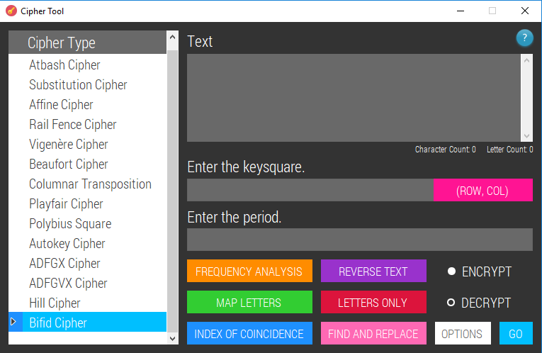

private void BifidCheck()

{

if (textBoxKey.Text.Length == 25)

{

Match match = Regex.Match(textBoxKey.Text.ToUpper(), @"[A-Z]+");

if (match.Success)

{

// square

if (BifidPeriodCheck() == true)

{

Bifid(textBox.Text.ToUpper().Replace(" ", ""), textBoxKey.Text.ToUpper(), int.Parse(tbKeyword.Text));

}

}

else

{

MessageBox.Show("Not all characters entered in the key textbox are letters.", "Message");

}

}

else

{

MessageBox.Show("Invalid input. The key textbox must contain 25 letters.", "Message");

}

}

private bool BifidPeriodCheck()

{

int period = 0;

return int.TryParse(tbKeyword.Text, out period);

}

private void Bifid(string originalText, string keysquare, int period)

{

char[,] grid = MakeGrid(keysquare, 5);

originalText = new String(originalText.Where(Char.IsLetter).ToArray());

int numberOfGroups = originalText.Length / period;

if (originalText.Length % period != 0)

{

numberOfGroups += 1; // rounds the number of groups up so that there is enough groups to fit all the characters

}

if (enOrDe == 'e') // if encrypting

{

int[] rowCoordinates = new int[originalText.Length];

int[] colCoordinates = new int[originalText.Length];

for (int i = 0; i < originalText.Length; i++)

{

for (int j = 0; j < 5; j++)

{

for (int k = 0; k < 5; k++)

{

if (originalText[i] == grid[j, k]) // if the plaintext letter matches the grid letter

{

// the coordinates of the letters are stored

if (btnOrder.Text == "(ROW, COL)")

{

rowCoordinates[i] = j + 1;

colCoordinates[i] = k + 1;

}

else

{

rowCoordinates[i] = k + 1;

colCoordinates[i] = j + 1;

}

}

}

}

}

int[,,] groups = new int[numberOfGroups, 2, period]; // [group number, row/col, position in the group]

int rowCharCounter = 0;

int colCharCounter = 0;

// the coordinates are put into the appropriate groups

for (int i = 0; i < numberOfGroups; i++)

{

for (int j = 0; j < period; j++)

{

if (rowCharCounter < originalText.Length)

{

groups[i, 0, j] = rowCoordinates[rowCharCounter];

rowCharCounter++;

}

if (colCharCounter < originalText.Length)

{

groups[i, 1, j] = colCoordinates[colCharCounter];

colCharCounter++;

}

}

}

string numbers = "";

// the groups are ordered and their contents are stored in one string

for (int i = 0; i < numberOfGroups; i++)

{

for (int j = 0; j < period; j++)

{

if (groups[i, 0, j] != 0)

{

numbers += groups[i, 0, j];

}

}

for (int k = 0; k < period; k++)

{

if (groups[i, 0, k] != 0)

{

numbers += groups[i, 1, k];

}

}

}

string ciphertext = ""; // ciphertext characters will be appended to this

string[] digitPairs = Digrams(numbers);

foreach (string pair in digitPairs)

{

// the pairs are used as coordinates to locate the ciphertext letters

if (btnOrder.Text == "(ROW, COL)")

{

ciphertext += grid[int.Parse(pair[0].ToString()) - 1, int.Parse(pair[1].ToString()) - 1];

}

else

{

ciphertext += grid[int.Parse(pair[1].ToString()) - 1, int.Parse(pair[0].ToString()) - 1];

}

}

Output output = new Output(ciphertext);

output.Show();

}

else if (enOrDe == 'd')

{

string numbers = "";

for (int i = 0; i < originalText.Length; i++)

{

for (int j = 0; j < 5; j++)

{

for (int k = 0; k < 5; k++)

{

if (originalText[i] == grid[j, k]) // if the ciphertext letter matches the grid letter

{

if (btnOrder.Text == "(ROW, COL)")

{

numbers += (j + 1).ToString() + (k + 1).ToString(); // the coordinates are written (row, column)

}

else

{

numbers += (k + 1).ToString() + (j + 1).ToString(); // the coordinates are written (column, row)

}

}

}

}

}

int[,,] groups = new int[numberOfGroups, 2, period]; // [group number, row/col, position in the group]

int numCounter = 0;

int mod = originalText.Length % period;

// the numbers are put into groups

for (int i = 0; i < numberOfGroups; i++)

{

for (int j = 0; j < period; j++)

{

if (numCounter + mod < originalText.Length * 2)

{

groups[i, 0, j] = numbers[numCounter] - 48; // -48 changes the ASCII vaules of the numbers to the actual numbers (48 = 0)

numCounter++;

}

}

for (int k = 0; k < period; k++)

{

if (numCounter < originalText.Length * 2)

{

groups[i, 1, k] = numbers[numCounter] - 48;

numCounter++;

}

}

}

string orderedNums = "";

// the numbers are ordered by group

for (int i = 0; i < numberOfGroups; i++)

{

for (int j = 0; j < period; j++)

{

if (orderedNums.Length < numbers.Length)

{

if (groups[i, 0, j] != 0)

{

orderedNums += groups[i, 0, j];

}

}

}

}

for (int i = 0; i < numberOfGroups; i++)

{

for (int k = 0; k < period; k++)

{

if (orderedNums.Length < numbers.Length)

{

if (groups[i, 0, k] != 0)

{

orderedNums += groups[i, 1, k];

}

}

}

}

int[] rowNumbers = new int[orderedNums.Length / 2];

int[] colNumbers = new int[orderedNums.Length / 2];

int rowCounter = 0;

int colCounter = 0;

// the numbers are sorted into row coordinates & column coordinates

for (int i = 0; i < orderedNums.Length; i++)

{

if (i < orderedNums.Length / 2)

{

rowNumbers[rowCounter] = int.Parse(orderedNums[i].ToString());

rowCounter++;

}

else

{

colNumbers[colCounter] = int.Parse(orderedNums[i].ToString());

colCounter++;

}

}

orderedNums = "";

for (int i = 0; i < rowNumbers.Length; i++)

{

orderedNums += rowNumbers[i];

orderedNums += colNumbers[i];

}

string plaintext = ""; // plaintext characters will be appended to this

string[] digitPairs = Digrams(orderedNums);

foreach (string pair in digitPairs) // need to read top then bottom, not left to right

{

if (pair != "00")

{

if (btnOrder.Text == "(ROW, COL)")

{

plaintext += grid[int.Parse(pair[0].ToString()) - 1, int.Parse(pair[1].ToString()) - 1];

}

else

{

plaintext += grid[int.Parse(pair[1].ToString()) - 1, int.Parse(pair[0].ToString()) - 1];

}

}

}

Output output = new Output(plaintext);

output.Show();

}

}

## Output (normal)

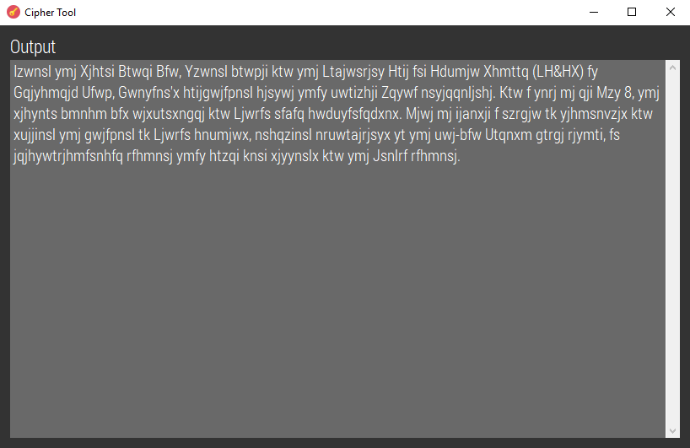

public Output(string outputText)

{

InitializeComponent();

textBoxOut.Text = outputText;

}

## Output (brute force)

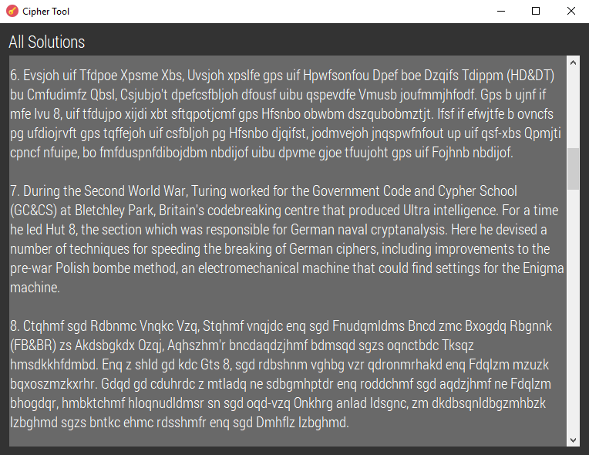

public Brute(string[] solutions, string originalText)

{

InitializeComponent();

SetFont();

// the text that the user entered is displayed first and new lines are made

textBoxOut.Text += "Original text: " + originalText + "\r\n\r\n";

DisplaySolutions(solutions);

}

private void DisplaySolutions(string[] solutions)

{

bool potentialAnswerFound = false; // will turn true if any of the keywords are spotted in any of the solutions

List<string> potentialAnswers = new List<string>(); // will store solutions that contain any of the keywords

List<string> compareAnswers = new List<string>(); // compares potential answers

List<int> commonWordCount = new List<int>(); // stores how often the keywords appear in each solution

List<string> keywords = new List<string>(); // will store each keyword in the text file

if (File.Exists(keywordsFile)) // if there is a keyword file to read from

{

using (FileStream file = new FileStream(keywordsFile, FileMode.Open, FileAccess.Read, FileShare.Read, 4096))

{

using (StreamReader reader = new StreamReader(file))

{

while (!reader.EndOfStream)

{

keywords.Add(reader.ReadLine()); // each keyword is stored in the list

}

reader.Close();

}

file.Close();

}

}

for (int i = 0; i < solutions.Length; i++)

{

textBoxOut.Text += (i + 1).ToString() + ". " + solutions[i] + "\r\n\r\n"; // displays the key/solution number

// and the actual solution

string currentSolution = solutions[i].ToUpper(); // temporarily stores each solution

currentSolution = Regex.Replace(currentSolution, @"\s", "");

// checks each solution for keywords and counts how many times they occur

if (File.Exists(keywordsFile))

{

foreach (string keyword in keywords)

{

if (currentSolution.Contains(keyword.ToUpper()))

{

bool alreadyAdded = false; // checks if the solution has already been added to the list of possible solutions

foreach (string answer in compareAnswers)

{

string currentAnswer = Regex.Replace(answer, @"\s", "");

if (currentAnswer == currentSolution)

{

alreadyAdded = true;

int wordCount = Regex.Matches(Regex.Escape(currentSolution), keyword.ToUpper()).Count;

int index = compareAnswers.IndexOf(answer);

commonWordCount[index] += wordCount; // commonWordCount stores the total occurences of all keywords

}

}

if (alreadyAdded == false)

{

potentialAnswerFound = true; // this will cause a new screen to open later displaying the suggested solutions

// counts how many times the keyword appears in the text

commonWordCount.Add(Regex.Matches(Regex.Escape(currentSolution), keyword.ToUpper()).Count);

potentialAnswers.Add((i+1).ToString() + ". " + solutions[i]);

compareAnswers.Add(solutions[i].ToUpper());

}

}

}

}

}

if (potentialAnswerFound == true)

{

PotentialAnswers potAns = new PotentialAnswers(potentialAnswers, commonWordCount);

potAns.Show();

potAns.TopMost = true;

}

}

## Suggested Solutions

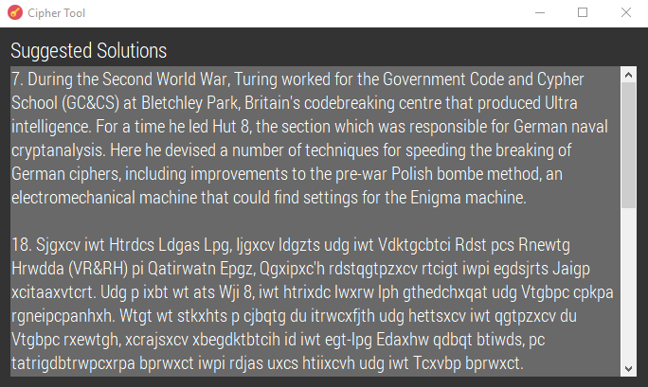

public PotentialAnswers(List<string> potentialAnswers, List<int> comWordCount)

{

InitializeComponent();

SetFont();

string[] solutions = potentialAnswers.ToArray();

int[] counts = comWordCount.ToArray();

Array.Sort(counts, solutions); // sorts the count array into ascending order and sorts the corresponding solution

// reversing the array using the stack

Stack<string> stack = new Stack<string>();

solutions = stack.ReverseArray(solutions);

foreach (var solution in solutions)

{

textBoxOut.Text += solution + "\r\n\r\n";

}

}

## Frequency Analysis

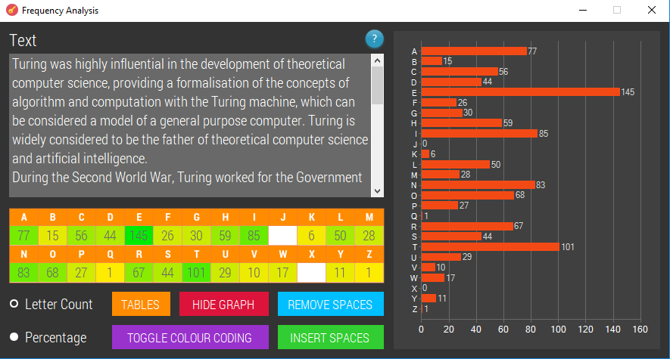

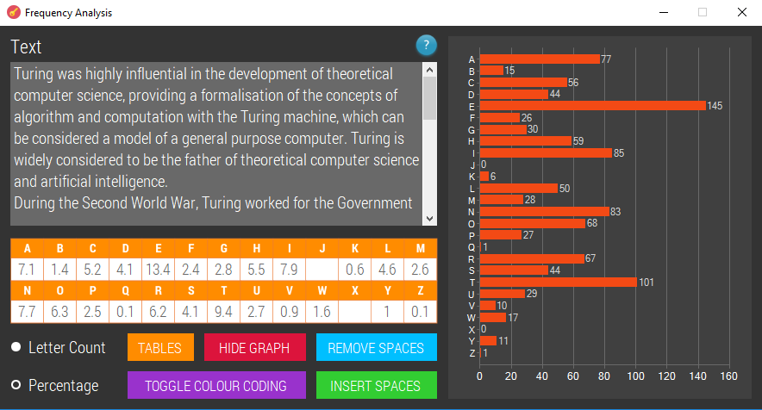

private bool colourOn = true; // colour codes the frequencies by default

private int[] letterCount = new int[26];

private void textBox_TextChanged(object sender, EventArgs e)

{

letterCount = new int[26];

double totalLetters = 0;

double percentage = 0;

int highestLetterCount = 0;

string onlyLetters = new String(textBox.Text.Where(Char.IsLetter).ToArray());

totalLetters = onlyLetters.Length;

foreach (Control c in this.Controls)

{

if (c.GetType().ToString() == "System.Windows.Forms.TextBox" && c.Name != "textBox")

{

c.ResetText();

c.BackColor = Color.White;

}

}

for (int i = 0; i < 26; i++)

{

char letter = (char)(i + 97); // lowercase a = 97

letterCount[i] = Regex.Matches(textBox.Text.ToLower(), letter.ToString()).Count;

string textboxName = "textBox" + i;

if (radioButtonLC.Checked == true)

{

foreach (Control c in this.Controls)

{

if (c.Name == textboxName && letterCount[i] != 0)

{

c.Enabled = true;

c.Text = letterCount[i].ToString();

if (letterCount[i] > highestLetterCount)

{

highestLetterCount = letterCount[i];

}

}

}

}

else if (radioButtonPrcnt.Checked == true)

{

percentage = ((double)letterCount[i] / totalLetters) * 100;

foreach (Control c in this.Controls)

{

if (c.Name == textboxName && letterCount[i] != 0)

{

c.Enabled = true;

c.Text = percentage.ToString("0.#");

if (letterCount[i] > highestLetterCount)

{

highestLetterCount = letterCount[i];

}

}

}

}

}

if (colourOn == true)

{

for (int i = 0; i < 26; i++)

{

string textboxName = "textBox" + i;

foreach (Control c in this.Controls)

{

if (c.Name == textboxName)

{

if (letterCount[i] != 0)

{

double coefficient = 1 - ((double)letterCount[i] / highestLetterCount);

Color c1 = Color.Orange;

c.BackColor = Color.FromArgb(c1.A, (int)(c1.R * coefficient), 235, (int)(c1.B * coefficient));

}

}

}

}

}

if (buttonGraph.Text == "HIDE GRAPH") // if a chart has been made and is shown

{

chartFA.Dispose();

putDataInGraph();

}

}

private void radioButtonPrcnt_CheckedChanged(object sender, EventArgs e)

{

textBox_TextChanged(this, EventArgs.Empty);

}

private void radioButtonLC_CheckedChanged(object sender, EventArgs e)

{

textBox_TextChanged(this, EventArgs.Empty);

}

private void buttonRS_Click(object sender, EventArgs e) // remove spaces

{

string newText = textBox.Text;

newText = newText.Replace(" ", "");

newText = Regex.Replace(newText, @"\r\n?|\n", "");

textBox.Text = newText;

}

private void buttonColour_Click(object sender, EventArgs e)

{

colourOn = !colourOn;

textBox_TextChanged(this, EventArgs.Empty);

}

private void buttonInsert_Click(object sender, EventArgs e)

{

textBox.Text = Regex.Replace(textBox.Text, ".{5}", "$0 "); // inserts a space after every 5 characters

}

private bool btnGraphClickedAlready = false;

private void buttonGraph_Click(object sender, EventArgs e)

{

string text = new String(textBox.Text.Where(Char.IsLetter).ToArray());

if (btnGraphClickedAlready == true)

{

this.Size = new Size(535, 484);

this.CenterToScreen();

btnGraphClickedAlready = false;

buttonGraph.Text = "SHOW GRAPH";

chartFA.Dispose();

}

else

{

buttonGraph.Text = "HIDE GRAPH";

this.Size = new Size(900, 484);

this.CenterToScreen();

putDataInGraph();

btnGraphClickedAlready = true;

}

}

private void putDataInGraph()

{

SetupBarChart();

string[] letterLabels = createAlphabetArray();

int[] frequencies = new int[26];

foreach (Control c in this.Controls)

{

if (c.GetType().ToString() == "System.Windows.Forms.TextBox" && c.Name != "textBox" && c.Text != "")

{

int index = 0;

if (c.Name.Length == 8)

{

index = int.Parse(c.Name.Substring(7, 1));

}

else

{

index = int.Parse(c.Name.Substring(7, 2));

}

frequencies[c.TabIndex - 1] = letterCount[index];

}

}

Stack<string> stack = new Stack<string>();

letterLabels = stack.ReverseArray(letterLabels);

Stack<int> stack2 = new Stack<int>();

frequencies = stack2.ReverseArray(frequencies);

chartFA.Series[0].Points.DataBindXY(letterLabels, frequencies);

}

private string[] createAlphabetArray()

{

string[] letterLabels = new string[26];

for (int i = 0; i < 26; i++)

{

letterLabels[i] = (char)(65 + i) + "";

}

return letterLabels;

}

private Chart chartFA;

private void SetupBarChart()

{

chartFA = new Chart();

chartFA.Size = new Size(352, 421);

chartFA.Location = new Point(520, 12);

chartFA.BackColor = Color.FromArgb(64, 64, 64);

ChartArea chartArea = new ChartArea();

chartArea.BackColor = Color.FromArgb(64,64,64);

chartArea.AxisX.Interval = 1;

chartArea.AxisX.MajorGrid.LineWidth = 0;

chartArea.AxisY.MajorGrid.LineWidth = 1;

chartArea.AxisY.MajorGrid.LineColor = Color.DimGray;

chartArea.AxisX.MajorGrid.LineColor = Color.White;

chartArea.AxisX.LineColor = Color.DimGray;

chartArea.AxisY.LineColor = Color.DimGray;

chartArea.AxisX.LabelStyle.ForeColor = Color.White;

chartArea.AxisY.LabelStyle.ForeColor = Color.White;

chartArea.AxisX.MajorTickMark.LineColor = Color.DimGray;

chartArea.AxisY.MajorTickMark.LineColor = Color.DimGray;

chartFA.ChartAreas.Add(chartArea);

Series series = new Series();

series.Color = Color.FromArgb(243,74,21);

series.LabelForeColor = Color.LightGray;

series.ChartType = SeriesChartType.Bar;

series.XValueType = ChartValueType.String;

series.YValueType = ChartValueType.Int32;

series.IsVisibleInLegend = false;

series.IsXValueIndexed = true;

series.IsValueShownAsLabel = true;

chartFA.Series.Add(series);

Controls.Add(chartFA);

chartFA.BringToFront();

}

## Index of Coincidence

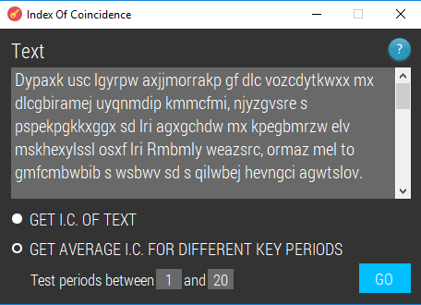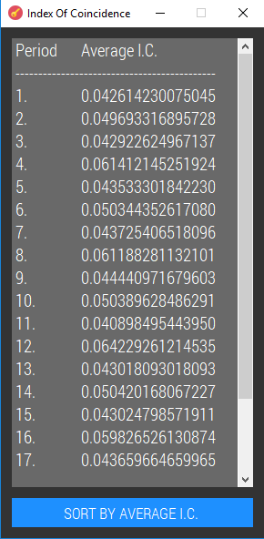

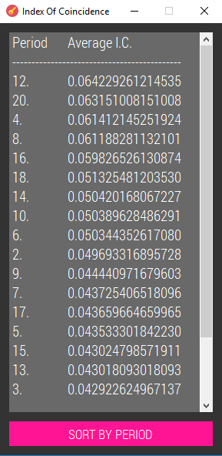

private System.Windows.Forms.ToolTip myToolTip = new System.Windows.Forms.ToolTip();

private void radioButtonGetAvgIC_CheckedChanged(object sender, EventArgs e)

{

if(radioButtonGetAvgIC.Checked == true)

{

this.Size = new Size(473, 337);

label2.Visible = true;

textBoxStart.Visible = true;

textBoxEnd.Visible = true;

buttonGo.Location = new Point(389, 254);

}

else if (radioButtonGetAvgIC.Checked == false)

{

this.Size = new Size(473, 305);

label2.Visible = false;

textBoxStart.Clear();

textBoxEnd.Clear();

textBoxStart.Visible = false;

textBoxEnd.Visible = false;

buttonGo.Location = new Point(389, 222);

}

}

private int startingPeriod;

private int endingPeriod;

private bool InputGiven()

{

if (radioButtonGetIC.Checked == true)

{

if (textBox.Text != "")

{

return true;

}

else

{

MessageBox.Show("You haven't entered any text.", "Message");

return false;

}

}

else

{

if (textBox.Text != "")

{

if (textBoxStart.Text == "" || textBoxEnd.Text == "")

{

MessageBox.Show("You need to enter a range of period values to test.", "Message");

return false;

}

else

{

int start;

bool startIsInt = int.TryParse(textBoxStart.Text, out start);

int end;

bool endIsInt = int.TryParse(textBoxEnd.Text, out end);

if (startIsInt == false || endIsInt == false)

{

MessageBox.Show("The period values must be integers.", "Message");

return false;

}

else

{

if (start > end) // if for some reason the user enters the numbers the wrong way round

{ // they are switched so that the lowest number is the startingPeriod

endingPeriod = start;

startingPeriod = end;

}

else

{

startingPeriod = start;

endingPeriod = end;

}

return true;

}

}

}

else

{

MessageBox.Show("You haven't entered any text.", "Message");

return false;

}

}

}

private double GetIC(string text)

{

double numerator = 0;

double denominator = text.Length * (text.Length - 1);

double IC;

int[] intArray = new int[text.Length];

for (int i = 0; i < text.Length; i++)

{

intArray[i] = (int)(text[i] - 65); // stores the int values of each character in the text (A = 0)

}

for (int i = 0; i < 25; i++)

{

int count = 0;

foreach (int c in intArray)

{

if (c == i)

{

count += 1;

}

}

numerator += count * (count - 1);

}

IC = numerator / denominator;

return IC;

}

private double GetAvgIC(string text, int period)

{

List<string> streams = new List<string>();

List<double> ICs = new List<double>();

int offset = 0;

for (int i = 0; i < period; i++)

{

streams.Add(""); // adds N amount of streams where N is the period number

for (int j = 0; j < text.Length; j += period)

{

if ((j+offset) < text.Length)

{

streams[i] += text[j + offset];

}

}

offset += 1;

}

for (int i = 0; i < streams.Count; i++)

{

ICs.Add(GetIC(streams[i]));

}

double sum = ICs.Sum();

double average = sum / (double)streams.Count;

return average;

}

private void buttonGo_Click(object sender, EventArgs e)

{

bool inputGiven = InputGiven();

if (inputGiven == true)

{

string text = textBox.Text.ToUpper();

text = new string(text.Where(Char.IsLetter).ToArray());

if (radioButtonGetIC.Checked == true)

{

double IC = GetIC(text);

MessageBox.Show("The index of coincidence is: " + IC.ToString("0.000000000000000"), "Message");

}

else if (radioButtonGetAvgIC.Checked == true)

{

string outputByPeriod = "Period\tAverage I.C.\r\n--------------------------------------------\r\n";

string outputByAvg = "Period\tAverage I.C.\r\n--------------------------------------------\r\n";

double[] avgICs = new double[endingPeriod - startingPeriod + 1];

double[] periods = new double[endingPeriod - startingPeriod + 1];

int counter = 0;

for (int i = startingPeriod; i <= endingPeriod; i++)

{

periods[counter] = i;

avgICs[counter] = GetAvgIC(text, i);

outputByPeriod += i + ".\t" + avgICs[counter].ToString("0.000000000000000") + "\r\n";

counter += 1;

}

Array.Sort(avgICs, periods);

Stack<double> stack = new Stack<double>();

avgICs = stack.ReverseArray(avgICs);

periods = stack.ReverseArray(periods);

for (int i = 0; i < periods.Length; i++)

{

outputByAvg += periods[i] + ".\t" + avgICs[i].ToString("0.000000000000000") + "\r\n";

}

IofCOutput output = new IofCOutput(outputByPeriod, outputByAvg);

output.Show();

}

}

}

private void textBoxEnd_MouseHover(object sender, EventArgs e)

{

myToolTip.Show("Enter a period value to end at.", textBoxEnd, 3000);

}

private void textBoxStart_MouseHover(object sender, EventArgs e)

{

myToolTip.Show("Enter a period value to start from.", textBoxStart, 3000);

}

public IofCOutput(string byPeriod, string byAVG)

{

InitializeComponent();

SetFont();

textBox.Text = byPeriod; // displays in order of period by default

sortByPeriod = byPeriod;

sortByAVG = byAVG;

}

string sortByPeriod;

string sortByAVG;

private void buttonSort_Click(object sender, EventArgs e)

{

if (buttonSort.Text == "SORT BY AVERAGE I.C.")

{

textBox.Text = sortByAVG;

buttonSort.Text = "SORT BY PERIOD";

buttonSort.BackColor = Color.DeepPink;

buttonSort.FlatAppearance.BorderColor = Color.DeepPink;

}

else if (buttonSort.Text == "SORT BY PERIOD")

{

textBox.Text = sortByPeriod;

buttonSort.Text = "SORT BY AVERAGE I.C.";

buttonSort.BackColor = Color.DodgerBlue;

buttonSort.FlatAppearance.BorderColor = Color.DodgerBlue;

}

}

## Find & Replace

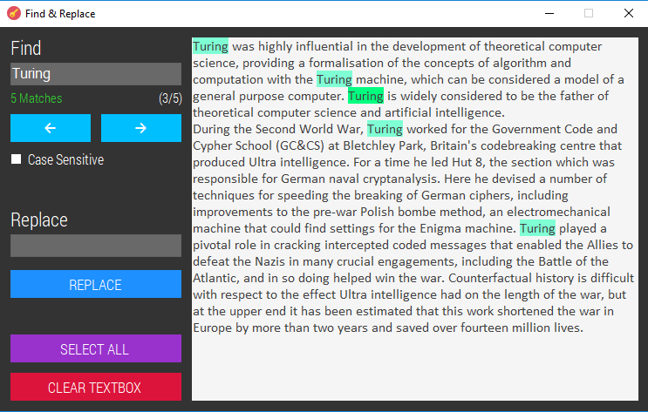

private void ResetHighlight() // removes highlight from text

{

mainRTB.SelectAll();

mainRTB.SelectionColor = Color.FromArgb(64, 64, 64);

mainRTB.SelectionBackColor = Color.WhiteSmoke;

}

private void EnableButtons()

{

currentSelection = 0;

btnNext.BackColor = Color.DeepSkyBlue;

btnNext.FlatAppearance.BorderColor = Color.DeepSkyBlue;

btnPrev.BackColor = Color.DeepSkyBlue;

btnPrev.FlatAppearance.BorderColor = Color.DeepSkyBlue;

btnReplace.BackColor = Color.DodgerBlue;

btnReplace.FlatAppearance.BorderColor = Color.DodgerBlue;

btnNext.Enabled = true;

btnPrev.Enabled = true;

btnReplace.Enabled = true;

tbReplace.Enabled = true;

lblOutOf.Visible = true;

}

private void DisableButtons()

{

currentSelection = -1;

btnNext.BackColor = Color.FromArgb(78,78,78);

btnNext.FlatAppearance.BorderColor = Color.FromArgb(78, 78, 78);

btnPrev.BackColor = Color.FromArgb(78, 78, 78);

btnPrev.FlatAppearance.BorderColor = Color.FromArgb(78, 78, 78);

btnReplace.BackColor = Color.FromArgb(78, 78, 78);

btnReplace.FlatAppearance.BorderColor = Color.FromArgb(78, 78, 78);

btnNext.Enabled = false;

btnPrev.Enabled = false;

btnReplace.Enabled = false;

tbReplace.Clear();

tbReplace.Enabled = false;

lblOutOf.Visible = false;

}

MatchCollection matches = Regex.Matches("", "");

int currentSelection = -1;

private void tbFind_TextChanged(object sender, EventArgs e)

{

currentSelection = -1;

string escaped = Regex.Escape(tbFind.Text); // allows special characters to be used without errors

if (cbCaseSensitive.Checked == true) // if the user wants the search to be case sensitive

{

matches = Regex.Matches(mainRTB.Text, escaped, RegexOptions.None);

}

else

{

matches = Regex.Matches(mainRTB.Text, escaped, RegexOptions.IgnoreCase);

}

if (matches.Count > 0 && tbFind.Text.Length > 0) // if matches have been found

{

lblMatches.Text = matches.Count + " Matches";

lblMatches.ForeColor = System.Drawing.Color.LimeGreen;

EnableButtons();

lblOutOf.Text = "(1/" + matches.Count + ")";

}

else if (tbFind.Text.Length == 0)

{

lblMatches.Text = "Enter a string to locate.";

lblMatches.ForeColor = Color.FromArgb(255, 128, 0);

DisableButtons();

}

else

{

lblMatches.Text = "No Matches";

lblMatches.ForeColor = System.Drawing.Color.Red;

DisableButtons();

}

ResetHighlight();

foreach (Match match in matches)

{

mainRTB.SelectionStart = match.Index;

mainRTB.SelectionLength = match.Length;

if (match == matches[0])

{

mainRTB.SelectionColor = Color.FromArgb(64,64,64);

mainRTB.SelectionBackColor = Color.SpringGreen;

}

else

{

mainRTB.SelectionColor = Color.FromArgb(64, 64, 64);

mainRTB.SelectionBackColor = Color.Aquamarine;

}

}

if (matches.Count > 0)

{

mainRTB.Select(matches[0].Index, 0);

mainRTB.ScrollToCaret();

}

}

private void cbCaseSensitive_CheckedChanged(object sender, EventArgs e)

{

tbFind_TextChanged(tbFind, EventArgs.Empty); // when the check box is changed the matches might be different so the text is re-checked

}

private void btnNext_Click(object sender, EventArgs e)

{

currentSelection++;

lblMatches.Text = matches.Count + " Matches";

lblOutOf.Text = "(" + (currentSelection + 1) + "/" + matches.Count + ")";

if (currentSelection == matches.Count)

{

currentSelection = 0;

lblMatches.Text = matches.Count + " Matches";

lblOutOf.Text = "(1/" + matches.Count + ")";

}

int currentMatch = 0;

foreach (Match match in matches)

{

mainRTB.SelectionStart = match.Index;

mainRTB.SelectionLength = match.Length;

if (currentMatch == currentSelection)

{

mainRTB.ScrollToCaret();

mainRTB.SelectionColor = Color.FromArgb(64, 64, 64);

mainRTB.SelectionBackColor = Color.SpringGreen;

}

else

{

mainRTB.SelectionColor = Color.FromArgb(64, 64, 64);

mainRTB.SelectionBackColor = Color.Aquamarine;

}

currentMatch++;

}

}

private void btnPrev_Click(object sender, EventArgs e)

{

currentSelection--;

lblMatches.Text = matches.Count + " Matches";

lblOutOf.Text = "(" + (currentSelection + 1) + "/" + matches.Count + ")";

if (currentSelection <= -1)

{

currentSelection = matches.Count - 1;

lblMatches.Text = matches.Count + " Matches";

lblOutOf.Text = "("+ matches.Count +"/" + matches.Count + ")";

}

int currentMatch = 0;

foreach (Match match in matches)

{

mainRTB.SelectionStart = match.Index;

mainRTB.SelectionLength = match.Length;

if (currentMatch == currentSelection)

{

mainRTB.ScrollToCaret();

mainRTB.SelectionColor = Color.FromArgb(64, 64, 64);

mainRTB.SelectionBackColor = Color.SpringGreen;

}

else

{

mainRTB.SelectionColor = Color.FromArgb(64, 64, 64);

mainRTB.SelectionBackColor = Color.Aquamarine;

}

currentMatch++;

}

}

private void btnReplace_Click(object sender, EventArgs e)

{

int oldNoOfMatches = 0;

if (matches.Count > 0 && tbFind.Text.Length > 0)

{

string escaped = Regex.Escape(tbFind.Text); // allows special characters to be used without errors

oldNoOfMatches = matches.Count;

if (cbCaseSensitive.Checked == true)

{

mainRTB.Text = Regex.Replace(mainRTB.Text, escaped, tbReplace.Text, RegexOptions.None);

}

else

{

mainRTB.Text = Regex.Replace(mainRTB.Text, escaped, tbReplace.Text, RegexOptions.IgnoreCase);

}

}

ResetHighlight();

if (matches.Count == 1)

{

MessageBox.Show(oldNoOfMatches + " occurence has been replaced.", "Message");

}

else

{

MessageBox.Show(oldNoOfMatches + " occurences have been replaced.", "Message");

}

tbFind.Text = tbReplace.Text;

tbReplace.Text = "";

}

private void btnSelectAll_Click(object sender, EventArgs e)

{

mainRTB.Focus();

mainRTB.SelectAll();

}

private void btnClear_Click(object sender, EventArgs e)

{

mainRTB.Text = "";

mainRTB.Focus();

tbFind_TextChanged(tbFind, EventArgs.Empty);

}

private string textBefore;

private void mainRTB_TextChanged(object sender, EventArgs e)

{

if (mainRTB.Text != textBefore)

{

textBefore = mainRTB.Text;

DisableButtons();

int index = mainRTB.SelectionStart;

tbFind.Clear();

mainRTB.SelectionStart = index;

}

}

## Options

public static string keywordsFile = "keywords.txt"; // text file storing the keywords

private static int keywordIndex = 0; // stores the row index of the selected word in the dgv

private void Options_Load(object sender, EventArgs e)

{

this.DoubleBuffered = true; // prevents flickering of help label

dgvWords.ClearSelection(); // clears any selections made in the DGV

dgvWords.CurrentCell = null;

if (!File.Exists(keywordsFile))

{

File.WriteAllText(keywordsFile, ""); // if no keyword file currently exists, a new one is created

}

else

{

FillDGV(); // if a keyword file already exists, the dgv is filled with the words from the text file

}

}

private void FillDGV()

{

using (FileStream file = new FileStream(keywordsFile, FileMode.Open, FileAccess.Read, FileShare.Read, 4096))

{

using (StreamReader reader = new StreamReader(file))

{

string fields = ""; // this is where each line of the text file is stored temporarily

while (!reader.EndOfStream)

{

fields = reader.ReadLine();

dgvWords.Rows.Add(fields); // displays each keyword from the file in the grid view

}

reader.Close();

}

file.Close();

}

if (dgvWords.Rows.Count != 0) // if the dgv isn't empty

{

dgvWords.CurrentCell = dgvWords.Rows[0].Cells[0]; // selects the first keyword type by default

dgvWords_CellClick(this.dgvWords, new DataGridViewCellEventArgs(0, 0));

}

}

private void buttonDelete_Click(object sender, EventArgs e)

{

if (dgvWords.SelectedCells.Count != 0) // if there is actually a keyword selected for deletion

{

List<string> linesList = File.ReadAllLines(keywordsFile).ToList(); // puts all the lines in the text file into a list

linesList.RemoveAt(keywordIndex); // removes the selected keyword from the list of keywords

File.WriteAllLines(keywordsFile, linesList.ToArray()); // the keyword file is rewritten without the deleted word

dgvWords.Rows.Clear(); // all of the words in the dgv are removed

FillDGV(); // the words are added back into the dgv - this is so that it is updated & does not show the deleted word any longer

}

else

{

MessageBox.Show("No keyword has been selected.", "Message");

}

}

private void buttonAdd_Click(object sender, EventArgs e)

{

if (!string.IsNullOrWhiteSpace(textBoxWord.Text)) // if a keyword has been entered into the textbox

{

bool alreadyExists = false; // for checking whether the keyword entered is already recognised

string newWord = ""; // will store the user's input as it will be written to file

using (FileStream file = new FileStream(keywordsFile, FileMode.Open, FileAccess.Read, FileShare.Read, 4096))

{

using (StreamReader reader = new StreamReader(file))

{

string fields = ""; // will temporarily store each line in the keyword file

do

{

fields = reader.ReadLine(); // the current line in the text file is stored in 'fields'

newWord = textBoxWord.Text.ToUpper(); // the user's input is converted to uppercase

newWord = newWord.Replace(" ", String.Empty); // removes any spaces that may have been entered

if (fields == newWord)

{

alreadyExists = true; // if any of the lines in the text file match the user's input,

} // the keyword entered won't be added - prevents redundant data

} while (!reader.EndOfStream); // reads the whole file

reader.Close();

}

file.Close();

}

if (alreadyExists == false) // if the user's input is a new word

{

using (StreamWriter writer = File.AppendText(keywordsFile))

{

writer.WriteLine(newWord); // the new keyword is added to the text file

writer.Close();

}

dgvWords.Rows.Add(newWord); // the new keyword is shown in the datagridview

dgvWords.CurrentCell = dgvWords.Rows[dgvWords.Rows.Count - 1].Cells[0]; // the new word is selected

keywordIndex = dgvWords.CurrentCell.RowIndex;

textBoxWord.Clear();

}

else

{

MessageBox.Show("The keyword you entered already exists.", "Message");

}

}

else

{

MessageBox.Show("You haven't entered a keyword.", "Message");

}

}

private void dgvWords_CellClick(object sender, DataGridViewCellEventArgs e)

{

keywordIndex = dgvWords.CurrentCell.RowIndex;

}

## Map Letters

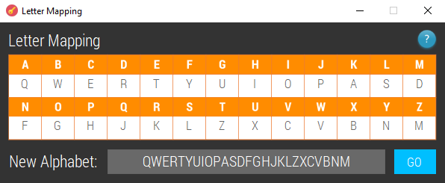

private void buttonGo_Click(object sender, EventArgs e)

{

char[] letters = new char[26]; // will store the new alphabet

int counter = 0;

label2.Visible = true;

textBoxNewAlphabet.Visible = true;

textBoxNewAlphabet.Enabled = true;

foreach (Control c in this.Controls.Cast<Control>().OrderBy(c => c.TabIndex))

{

if (c.GetType().ToString() == "System.Windows.Forms.TextBox")

{

if (c.Name != "textBoxNewAlphabet")

{

if (c.Text != "")

{

letters[counter] = char.Parse(c.Text);

}

else

{

letters[counter] = '-';

}

counter += 1;

}

}

}

textBoxNewAlphabet.Text = new string(letters);

}

private void textBox_KeyPress(object sender, KeyPressEventArgs e)

{

if (!Char.IsControl(e.KeyChar)) // all the "control" characters like the backspace key and clipboard keyboard shortcuts are exempted.

{

SendKeys.Send("{TAB}"); // automatically moves to next textbox once a letter is entered

TextBox focusedTxt = Controls.OfType<TextBox>().FirstOrDefault(x => x.Focused);

focusedTxt.SelectAll();

}

}

## Autokey Cipher Solver

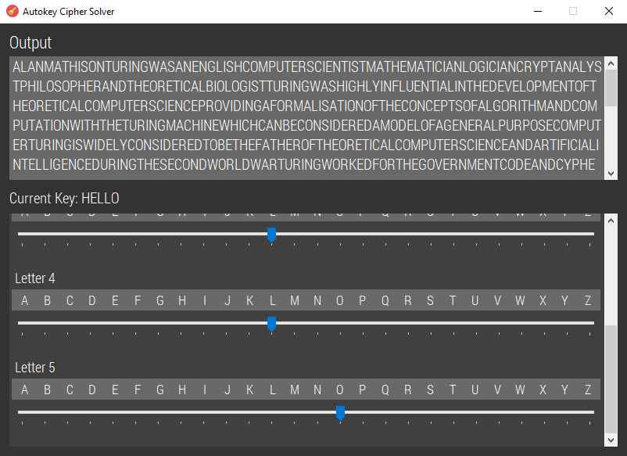

private int key;

private string originalText;

private List<Label> streamLabels = new List<Label>();

private List<Label> shiftLabels = new List<Label>();

private List<TrackBar> trackbars = new List<TrackBar>();

private List<DataGridView> dgvs = new List<DataGridView>();

private int[] trackbarValueBefore; // keeps track of the values of the trackbars

private char[] currentKey; // stores each character in the key

public AutokeySolver(string o_Text, int keyNum)

{

InitializeComponent();

SetFont();

key = keyNum;

originalText = o_Text.ToUpper();

trackbarValueBefore = new int[key];

currentKey = new char[key];

for (int i = 0; i < key; i++)

{

string labelName = "labelSFA" + i; // SFA = stream frequency analysis

string label2Name = "labelShift" + i;

string textboxName = "textBoxSFA" + i;

string trackbarName = "trackBarSFA" + i;

string dgvName = "dgvSFA" + i;

Label streamLabel = new Label();

streamLabel.Name = labelName;

streamLabel.Text = "Letter " + (i + 1);

streamLabel.AutoSize = true;

myFont = new Font(fonts.Families[0], 13.0F);

streamLabel.Font = myFont;

streamLabel.ForeColor = Color.White;

streamLabel.BackColor = Color.Transparent;

streamLabel.Anchor = AnchorStyles.Top | AnchorStyles.Left;

streamLabels.Add(streamLabel);

flowLayoutPanelStreams.Controls.Add(streamLabel);

myFont = new Font(fonts.Families[0], 12.5F);

DataGridView streamDGV = new DataGridView();

streamDGV.Name = dgvName;

streamDGV.AllowUserToAddRows = false;

streamDGV.AllowUserToDeleteRows = false;

streamDGV.AllowUserToResizeRows = false;

streamDGV.AllowUserToResizeColumns = false;

streamDGV.AutoSizeRowsMode = DataGridViewAutoSizeRowsMode.DisplayedCells;

streamDGV.AutoSizeColumnsMode = DataGridViewAutoSizeColumnsMode.Fill;

streamDGV.BackgroundColor = Color.White;

streamDGV.BorderStyle = BorderStyle.None;

streamDGV.CellBorderStyle = DataGridViewCellBorderStyle.None;

streamDGV.ColumnHeadersBorderStyle = DataGridViewHeaderBorderStyle.Single;

DataGridViewCellStyle style = streamDGV.ColumnHeadersDefaultCellStyle;

style.BackColor = Color.DimGray;

style.Font = myFont;

style.ForeColor = Color.White;

style.Alignment = DataGridViewContentAlignment.MiddleCenter;

style.WrapMode = DataGridViewTriState.True;

DataGridViewCellStyle defaultCellStyle = streamDGV.DefaultCellStyle;

defaultCellStyle.BackColor = Color.White;

defaultCellStyle.Font = myFont;

defaultCellStyle.ForeColor = Color.FromArgb(64, 64, 64);

defaultCellStyle.SelectionBackColor = Color.White;

defaultCellStyle.SelectionForeColor = Color.FromArgb(64, 64, 64);

defaultCellStyle.Alignment = DataGridViewContentAlignment.MiddleCenter;

DataGridViewCellStyle rowHeadersStyle = streamDGV.RowHeadersDefaultCellStyle;

rowHeadersStyle.BackColor = Color.White;

streamDGV.ColumnHeadersHeightSizeMode = DataGridViewColumnHeadersHeightSizeMode.AutoSize;

streamDGV.Columns.Add("A", "A"); streamDGV.Columns.Add("B", "B"); streamDGV.Columns.Add("C", "C"); streamDGV.Columns.Add("D", "D"); streamDGV.Columns.Add("E", "E");

streamDGV.Columns.Add("F", "F"); streamDGV.Columns.Add("G", "G"); streamDGV.Columns.Add("H", "H"); streamDGV.Columns.Add("I", "I"); streamDGV.Columns.Add("J", "J"); streamDGV.Columns.Add("K", "K");

streamDGV.Columns.Add("L", "L"); streamDGV.Columns.Add("M", "M"); streamDGV.Columns.Add("N", "N"); streamDGV.Columns.Add("O", "O"); streamDGV.Columns.Add("P", "P"); streamDGV.Columns.Add("Q", "Q");

streamDGV.Columns.Add("R", "R"); streamDGV.Columns.Add("S", "S"); streamDGV.Columns.Add("T", "T"); streamDGV.Columns.Add("U", "U"); streamDGV.Columns.Add("V", "V"); streamDGV.Columns.Add("W", "W");

streamDGV.Columns.Add("X", "X"); streamDGV.Columns.Add("Y", "Y"); streamDGV.Columns.Add("Z", "Z");

streamDGV.RowHeadersWidth = 4;

streamDGV.EnableHeadersVisualStyles = false;

streamDGV.GridColor = Color.DimGray;

streamDGV.ReadOnly = true;

streamDGV.RowHeadersBorderStyle = DataGridViewHeaderBorderStyle.None;

streamDGV.RowHeadersWidthSizeMode = DataGridViewRowHeadersWidthSizeMode.DisableResizing;

streamDGV.Size = new Size(753, 27);

streamDGV.Enabled = false;

dgvs.Add(streamDGV);

flowLayoutPanelStreams.Controls.Add(streamDGV);

TrackBar trackbar = new TrackBar();

trackbar.Name = trackbarName;

trackbar.Anchor = AnchorStyles.Top | AnchorStyles.Left;

trackbar.BackColor = Color.FromArgb(64, 64, 64);

trackbar.Maximum = 25;

trackbar.Size = new Size(753, 45);

trackbar.ValueChanged += new EventHandler(trackbar_ValueChanged);

trackbar.LargeChange = 1;

trackbars.Add(trackbar);

flowLayoutPanelStreams.Controls.Add(trackbar);

Label gap = new Label();

gap.BackColor = Color.Transparent;

gap.MaximumSize = new Size(10, 6);

flowLayoutPanelStreams.Controls.Add(gap);

}

string text = new string(originalText.Where(Char.IsLetter).ToArray());

textBox.Text = text.ToUpper();

for (int i = 0; i < trackbars.Count; i++)

{

trackbar_ValueChanged(trackbars[i], EventArgs.Empty);

}

}

private void trackbar_ValueChanged(object sender, EventArgs e)

{

TrackBar trackbar = sender as TrackBar; // the trackbar that caused this event to take place can be referred to as 'trackbar'

for (int i = 0; i < trackbars.Count; i++) // searches through all the trackbars to find the matching one; this is so the index of the trackbar can be used

{

if (trackbars[i] == trackbar)

{

currentKey[i] = (char)(trackbar.Value + 65); // the letter will be shown in the key label

}

}

labelCurrentKey.Text = "Current Key: " + new String(currentKey);

char[] longKey = new char[originalText.Length];

char[] plaintext = new char[longKey.Length]; // will store the decrypted message

for (int i = 0; i < key; i++)

{

longKey[i] = currentKey[i]; // puts the keyword given by the user into the array

}

for (int i = 0; i < longKey.Length; i++)

{

int originalLetterValue = (int)originalText[i] - 65; // the -65 is to make 'A' correspond to 0

int keyLetterValue = (int)longKey[i] - 65;

int subtractKey = originalLetterValue - keyLetterValue;

int findLetter = ((subtractKey % 26) + 26) % 26; // +26 prevents wrong mod answers when the value being modded is negative

plaintext[i] = (char)(findLetter + 65);

if (i < longKey.Length - key)

{

longKey[i + key] = (char)(findLetter + 65);

}

}

textBox.Text = new String(plaintext);

}

## Columnar Transposition Solver

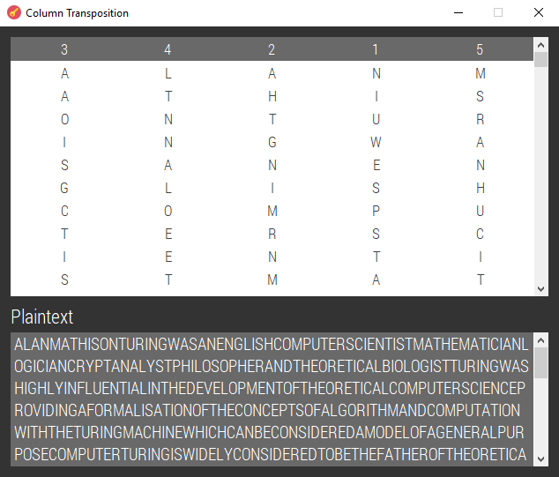

private void SetupDGV()

{

colTransDGV.Location = new Point(12, 12);

colTransDGV.Size = new Size(610, 294);

colTransDGV.CellMouseEnter += new DataGridViewCellEventHandler(colTransDGV_CellMouseEnter);

colTransDGV.MouseClick += new MouseEventHandler(colTransDGV_MouseClick);

colTransDGV.DragEnter += new DragEventHandler(colTransDGV_DragEnter);

colTransDGV.DragDrop += new DragEventHandler(colTransDGV_DragDrop);

colTransDGV.AllowDrop = true;

colTransDGV.AllowUserToOrderColumns = true;

colTransDGV.CellMouseMove += new DataGridViewCellMouseEventHandler(colTransDGV_CellMouseMove);

colTransDGV.CellMouseLeave += new DataGridViewCellEventHandler(colTransDGV_CellMouseLeave);

Controls.Add(colTransDGV);

colTransDGV.TabIndex = 1;

colTransDGV.ShowCellToolTips = false;

// Make every column not sortable.

for (int i = 0; i < colTransDGV.Columns.Count; i++)

{

colTransDGV.Columns[i].SortMode = DataGridViewColumnSortMode.NotSortable;

}

// Set selection mode to Column.

colTransDGV.SelectionMode = DataGridViewSelectionMode.FullColumnSelect;

} // the datagridview is set up

public ColTransposition(DataGridView ctDGV, char[,] tempGrid)

{

InitializeComponent();

colTransDGV = ctDGV;

SetFont();

SetupDGV();

displayIndexes = new int[colTransDGV.Columns.Count];

grid = tempGrid; // 2D character array

GetPlaintext();

}

private char[,] grid;

private int[] displayIndexes;

private void GetPlaintext() // reads off the rows and converts it into one string which is printed in the text box

{

string output = "";

for (int i = 0; i < grid.GetLength(0); i++)

{

for (int j = 0; j < grid.GetLength(1); j++)

{

output += grid[i, j];

}

}

textBox.Text = output;

}

private void colTransDGV_CellMouseEnter(object sender, DataGridViewCellEventArgs e)

{

if (e.RowIndex == -1 && e.ColumnIndex != -1)

{

toolTip1.SetToolTip(this.colTransDGV, "Drag and drop columns to rearrange them.");

}

else

{

toolTip1.Hide(this.colTransDGV);

}

}

private void colTransDGV_MouseClick(object sender, MouseEventArgs e)

{

if (colTransDGV.SelectedColumns.Count == 1)

{

if (e.Button == MouseButtons.Left)

{

col = colTransDGV.SelectedColumns[0];

colIndexFromMouseDown = colTransDGV.SelectedColumns[0].Index;

colDispIndexFromMouseDown = colTransDGV.SelectedColumns[0].DisplayIndex;

colTransDGV.DoDragDrop(col, DragDropEffects.Move);

}

}

}

private void colTransDGV_DragEnter(object sender, DragEventArgs e)

{

if (colTransDGV.SelectedColumns.Count > 0)

{

e.Effect = DragDropEffects.Move;

}

}

private void colTransDGV_DragDrop(object sender, DragEventArgs e)

{

int colIndexOfItemUnderMouseToDrop;

int colDispIndexOfItemUnderMouseToDrop;

Point clientPoint = colTransDGV.PointToClient(new Point(e.X, e.Y));

colIndexOfItemUnderMouseToDrop = colTransDGV.HitTest(clientPoint.X, clientPoint.Y).ColumnIndex;

colDispIndexOfItemUnderMouseToDrop = colTransDGV.Columns[colIndexOfItemUnderMouseToDrop].DisplayIndex;

if (e.Effect == DragDropEffects.Move)

{

colTransDGV.Columns[colIndexFromMouseDown].DisplayIndex = colDispIndexOfItemUnderMouseToDrop;

colTransDGV.Columns[colIndexOfItemUnderMouseToDrop].DisplayIndex = colDispIndexFromMouseDown;

colTransDGV.ClearSelection();

char[,] newGrid = new char[grid.GetLength(0), grid.GetLength(1)];

for (int i = 0; i < grid.GetLength(0); i++)

{

for (int j = 0; j < grid.GetLength(1); j++)

{

if (j == colDispIndexOfItemUnderMouseToDrop)

{

newGrid[i, colDispIndexOfItemUnderMouseToDrop] = grid[i, colDispIndexFromMouseDown];

}

else if (j == colDispIndexFromMouseDown)

{

newGrid[i, colDispIndexFromMouseDown] = grid[i, colDispIndexOfItemUnderMouseToDrop];

}

else

{

newGrid[i, j] = grid[i, j];

}

}

}

grid = newGrid;

GetPlaintext();

}

}

private void colTransDGV_CellMouseMove(object sender, DataGridViewCellMouseEventArgs e)

{

if (e.RowIndex == -1 && e.ColumnIndex != -1) //column header

{

colTransDGV.Columns[e.ColumnIndex].HeaderCell.Style.BackColor = Color.Gray;

}

}

private void colTransDGV_CellMouseLeave(object sender, DataGridViewCellEventArgs e)

{

if (e.RowIndex == -1 && e.ColumnIndex != -1) //column header

{

colTransDGV.Columns[e.ColumnIndex].HeaderCell.Style.BackColor = Color.DimGray;

}

}

private void ColTransposition_Load(object sender, EventArgs e)

{

// Clear all selected cells or rows in the DGV.

colTransDGV.ClearSelection();

}

## Vigenère Cipher Solver

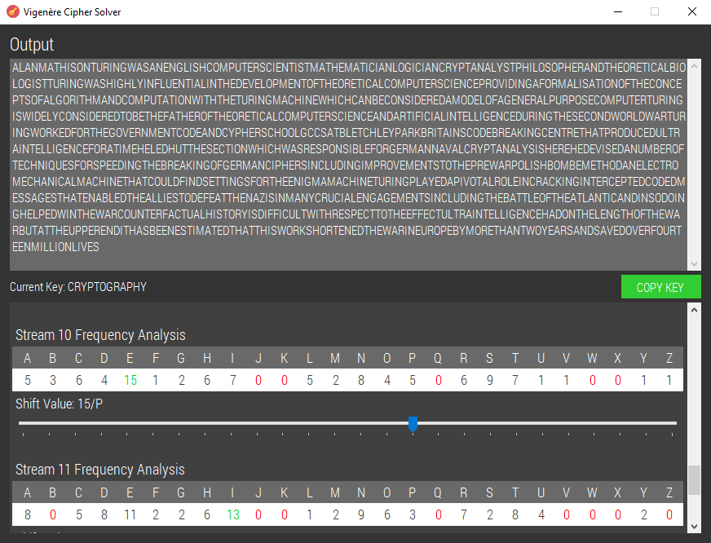

private int key;

private string originalText;

private int[] trackbarValueBefore; // keeps track of the values of the trackbars

private int[] shiftValues; // when the form starts it automatically guesses each shift by moving the most common letter to 'E' and the amount it has to shift to do this is stored here

private char[] currentKey; // stores each character in the key

public VigSolver(string o_Text, int keyNum)

{

InitializeComponent();

key = keyNum;

originalText = o_Text;

trackbarValueBefore = new int[key];

shiftValues = new int[key];

currentKey = new char[key];

this.DoubleBuffered = true;

SetFont();

for (int i = 0; i < key; i++)

{

string labelName = "labelSFA" + i; // SFA = stream frequency analysis

string label2Name = "labelShift" + i;

string textboxName = "textBoxSFA" + i;

string trackbarName = "trackBarSFA" + i;

string dgvName = "dgvSFA" + i;

Label streamLabel = new Label();

streamLabel.Name = labelName;

streamLabel.Text = "Stream " + (i+1) + " Frequency Analysis";

streamLabel.AutoSize = true;

myFont = new Font(fonts.Families[0], 13.0F);

streamLabel.Font = myFont;

streamLabel.ForeColor = Color.White;

streamLabel.BackColor = Color.Transparent;

streamLabel.Anchor = AnchorStyles.Top | AnchorStyles.Left;

streamLabels.Add(streamLabel);

flowLayoutPanelStreams.Controls.Add(streamLabel);

myFont = new Font(fonts.Families[0], 12.5F);

DataGridView streamDGV = new DataGridView();

streamDGV.Name = dgvName;

streamDGV.AllowUserToAddRows = false;

streamDGV.AllowUserToDeleteRows = false;

streamDGV.AllowUserToResizeRows = false;

streamDGV.AllowUserToResizeColumns = false;

streamDGV.AutoSizeRowsMode = DataGridViewAutoSizeRowsMode.DisplayedCells;

streamDGV.AutoSizeColumnsMode = DataGridViewAutoSizeColumnsMode.Fill;

streamDGV.BackgroundColor = Color.White;

streamDGV.BorderStyle = BorderStyle.None;

streamDGV.CellBorderStyle = DataGridViewCellBorderStyle.None;

streamDGV.ColumnHeadersBorderStyle = DataGridViewHeaderBorderStyle.Single;

DataGridViewCellStyle style = streamDGV.ColumnHeadersDefaultCellStyle;

style.BackColor = Color.DimGray;

style.Font = myFont;

style.ForeColor = Color.White;

style.Alignment = DataGridViewContentAlignment.MiddleCenter;

style.WrapMode = DataGridViewTriState.True;

DataGridViewCellStyle defaultCellStyle = streamDGV.DefaultCellStyle;

defaultCellStyle.BackColor = Color.White;

defaultCellStyle.Font = myFont;

defaultCellStyle.ForeColor = Color.FromArgb(64, 64, 64);

defaultCellStyle.SelectionBackColor = Color.White;

defaultCellStyle.SelectionForeColor = Color.FromArgb(64, 64, 64);

defaultCellStyle.Alignment = DataGridViewContentAlignment.MiddleCenter;

DataGridViewCellStyle rowHeadersStyle = streamDGV.RowHeadersDefaultCellStyle;

rowHeadersStyle.BackColor = Color.White;

streamDGV.ColumnHeadersHeightSizeMode = DataGridViewColumnHeadersHeightSizeMode.AutoSize;

streamDGV.Columns.Add("A","A"); streamDGV.Columns.Add("B", "B"); streamDGV.Columns.Add("C", "C"); streamDGV.Columns.Add("D", "D"); streamDGV.Columns.Add("E", "E");

streamDGV.Columns.Add("F", "F"); streamDGV.Columns.Add("G", "G"); streamDGV.Columns.Add("H", "H"); streamDGV.Columns.Add("I", "I"); streamDGV.Columns.Add("J", "J"); streamDGV.Columns.Add("K", "K");

streamDGV.Columns.Add("L", "L"); streamDGV.Columns.Add("M", "M"); streamDGV.Columns.Add("N", "N"); streamDGV.Columns.Add("O", "O"); streamDGV.Columns.Add("P", "P"); streamDGV.Columns.Add("Q", "Q");

streamDGV.Columns.Add("R", "R"); streamDGV.Columns.Add("S", "S"); streamDGV.Columns.Add("T", "T"); streamDGV.Columns.Add("U", "U"); streamDGV.Columns.Add("V", "V"); streamDGV.Columns.Add("W", "W");

streamDGV.Columns.Add("X", "X"); streamDGV.Columns.Add("Y", "Y"); streamDGV.Columns.Add("Z", "Z");

streamDGV.RowHeadersWidth = 4;

streamDGV.EnableHeadersVisualStyles = false;

streamDGV.GridColor = Color.DimGray;

streamDGV.ReadOnly = true;

streamDGV.RowHeadersBorderStyle = DataGridViewHeaderBorderStyle.None;

streamDGV.RowHeadersWidthSizeMode = DataGridViewRowHeadersWidthSizeMode.DisableResizing;

streamDGV.Size = new Size(823, 55);

streamDGV.Rows.Add();

streamDGV.Enabled = false;

dgvs.Add(streamDGV);

flowLayoutPanelStreams.Controls.Add(streamDGV);

Label shiftLabel = new Label();

shiftLabel.Name = label2Name;

shiftLabel.Text = "Shift Value: 0/A";

shiftLabel.AutoSize = true;

shiftLabel.Font = myFont;

shiftLabel.ForeColor = Color.White;

shiftLabel.BackColor = Color.FromArgb(64,64,64);

shiftLabel.Anchor = AnchorStyles.Top | AnchorStyles.Left;

shiftLabels.Add(shiftLabel);

flowLayoutPanelStreams.Controls.Add(shiftLabel);

TrackBar trackbar = new TrackBar();

trackbar.Name = trackbarName;

trackbar.Anchor = AnchorStyles.Top | AnchorStyles.Left;

trackbar.BackColor = Color.FromArgb(64, 64, 64);

trackbar.Maximum = 25;

trackbar.Size = new Size(823, 45);

trackbar.ValueChanged += new EventHandler(trackbar_ValueChanged);

trackbar.LargeChange = 1;

trackbars.Add(trackbar);

flowLayoutPanelStreams.Controls.Add(trackbar);

Label gap = new Label();

gap.BackColor = Color.Transparent;

gap.MaximumSize = new Size(10, 6);

flowLayoutPanelStreams.Controls.Add(gap);

}

string text = new string(originalText.Where(Char.IsLetter).ToArray());

textBox.Text = text.ToUpper();

List<string> streams = new List<string>();

int offset = 0;

for (int i = 0; i < key; i++)

{

streams.Add(""); // adds N amount of streams where N is the period number

for (int j = 0; j < text.Length; j += key)

{

if ((j + offset) < text.Length)

{

streams[i] += text[j + offset]; // each stream is filled with text

}

}

offset += 1; // changes the starting point of each stream

}

int[,] letterCount = new int[streams.Count ,26]; // stores [stream number, count of each letter]

for (int i = 0; i < streams.Count; i++)

{

for (int j = 0; j < 26; j++)

{

char letter = (char)(j + 97); // lowercase a = 97

letterCount[i,j] = Regex.Matches(streams[i].ToLower(), letter.ToString()).Count; // counts the number of times each letter appears

}

}

for (int i = 0; i < dgvs.Count; i++)

{

for (int j = 0; j < 26; j++)

{

dgvs[i].Rows[0].Cells[j].Value = letterCount[i,j]; // the letter counts for each letter in each stream is stored in the right cells

}

}

for (int i = 0; i < trackbars.Count; i++)

{

trackbar_ValueChanged(trackbars[i], EventArgs.Empty); // colour changes

trackbars[i].Value = ((shiftValues[i] - 4)+26) % 26; // the most frequent letter is aligned to 'E' as a guess

}

}

private void trackbar_ValueChanged(object sender, EventArgs e) // whenever any of the trackbars are slid, this event is triggered

{

TrackBar trackbar = sender as TrackBar; // the trackbar that caused this event to take place can be referred to as 'trackbar'

for (int i = 0; i < trackbars.Count; i++) // searches through all the trackbars to find the matching one; this is so the index of the trackbar can be used

{

int highestValue = 0; // cells that match the highest value will have green text

if (trackbars[i] == trackbar)

{

shiftLabels[i].Text = "Shift Value: " + trackbar.Value + "/" + (char)(trackbar.Value + 65); // +65 allows the ASCII capital letters to be displayed

currentKey[i] = (char)(trackbar.Value + 65); // the letter that the stream has been shifted to will be shown in the key label

int[] beforeShift = new int[26]; // stores the values inside the dgv before they are moved

for (int j = 0; j < 26; j++)

{

beforeShift[j] = (int)dgvs[i].Rows[0].Cells[j].Value;

if (beforeShift[j] > highestValue)

{

highestValue = beforeShift[j]; // the highest value stored in the dgv will be stored

}

}

for (int k = 0; k < 26; k++)

{

int difference = trackbar.Value - trackbarValueBefore[i]; // calculates the number that everything should be shifted by

if (difference < 0)

{

difference += 26; // can't have negative indexes; this prevents the mod of negative numbers being taken in the next line

}

dgvs[i].Rows[0].Cells[k].Value = beforeShift[(k + difference) % 26]; // mod 26 wraps the indexes around so they don't exceed 25

if ((int)dgvs[i].Rows[0].Cells[k].Value == 0) // any 0 values will be displayed in red

{

dgvs[i].Rows[0].Cells[k].Style.ForeColor = Color.Red;

dgvs[i].Rows[0].Cells[k].Style.SelectionForeColor = Color.Red;

}

else if((int)dgvs[i].Rows[0].Cells[k].Value == highestValue) // any cells that contain the highest value are displayed in green

{

dgvs[i].Rows[0].Cells[k].Style.ForeColor = Color.FromArgb(0,204,0);

dgvs[i].Rows[0].Cells[k].Style.SelectionForeColor = Color.FromArgb(0, 204, 0);

shiftValues[i] = k;

}

else // other cell values are displayed in dark grey

{

dgvs[i].Rows[0].Cells[k].Style.ForeColor = Color.FromArgb(64, 64, 64);

dgvs[i].Rows[0].Cells[k].Style.SelectionForeColor = Color.FromArgb(64, 64, 64);

}

}

string text = new String(originalText.ToUpper().Where(Char.IsLetter).ToArray()); // stores only letters from the input text

char[] textArray = new char[text.Length]; // will store any letters that have been changed by the trackbar being slid

for (int m = 0; m < textArray.Length; m++)

{

textArray[m] = ' '; // each array position is first filled with a space so any that remain unfilled after changed letters are stored

} // can then be told to store the same letter as before

for (int j = i; j < textBox.Text.Length; j += key)

{

int index = (int)text[j] - 65; // every Nth letter is changed; where N is the key size

textArray[j] = (char)((((index - trackbar.Value)+26) % 26) + 65);

}

for (int l = 0; l < textArray.Length; l++)

{

if (textArray[l] == ' ')

{

textArray[l] = textBox.Text[l]; // other letters are kept the same

}

}

text = new string(textArray);

textBox.Text = text; // the output text changes in realtime

trackbarValueBefore[i] = trackbar.Value; // allows the difference to be calculated next time the trackbar is changed

}

}

labelCurrentKey.Text = "Current Key: " + new string(currentKey); // displays what the keyword would be if the current slider positions were correct

}

private void btnCopy_Click(object sender, EventArgs e)

{

string key = new string(currentKey);

Clipboard.SetText(key);

}

# Testing

## Test Table

This table shows the tests carried out on the main features of the program. The screenshot reference corresponds to the various screenshots listed under the ‘Screenshots’ heading later in the document.

|  |  |  |  |  |  |
| --- | --- | --- | --- | --- | --- |
| Test No. | Description | Data Type | Expected Result | Pass/ Fail | Screenshot Reference |
|  | Using a shift value of 5 to encrypt and decrypt a message with the Caesar cipher. | Typical | The plaintext “THE CAESAR CIPHER IS A SUBSTITUTION CIPHER” should encrypt to “YMJ HFJXFW HNUMJW NX F XZGXYNYZYNTS HNUMJW” using a key of 5 and should decrypt back to the original plaintext. | Pass | 1 (encrypt)  2 (decrypt) |
|  | The shift value for the Caesar cipher must be within the range 1-25. | Erroneous | When a shift value of over 25 i.e. 92 is entered, an error message should be displayed and no encryption/decryption should take place. | Pass | 3 |
|  | The shift value is allowed to be 1 or 25; these are the boundaries. | Extreme | A shift value of 25 should be accepted and encryption/decryption should take place. | Pass | 4 |
|  | Encryption using the Atbash cipher | Typical | The message “Plaintext message” should encrypt to “Kozrmgvcg nvhhztv”. | Pass | 5 |
|  | Decryption using the Atbash cipher | Typical | The message “Kozrmgvcg nvhhztv” should decrypt to “Plaintext message”. | Pass | 6 |
|  | Encryption using the Substitution cipher | Typical | “This is an example message” should encrypt to “Qabp bp ki ovkhlgo hoppkdo” using the key “K E Y W O R D A B C F G H I J L M N P Q S T U V X Z”. | Pass | 7 |
|  | Decryption using the Substitution cipher | Typical | The ciphertext created in the previous test should decrypt back into the plaintext. | Pass | 8 |
|  | The key for the substitution cipher must be 26 characters long. | Erroneous | Entering a key that is too short e.g. “key” should cause an error message to appear and encryption/decryption should not take place. | Pass | 9 |
|  | Encryption & decryption using the Affine cipher | Typical | The message “Affine plaintext” should encrypt to “Izzevg hjievfgdf” using an A value of 19 and a B value of 8. It should decrypt back into the original message using the same A & B values. | Pass | 10  (encrypt)  11  (decrypt) |
|  | Some values cannot be used as A values in the Affine cipher. | Erroneous | Trying to use a value that is not valid for the A value e.g. 13 should cause an error message to appear. | Pass | 12 |
|  | Encryption & decryption using the Rail Fence cipher (zigzag down) | Typical | The message “COMPUTERSCIENCEISGREAT” should encrypt to “CUSNSAOPTRCECIGETMEIER” using a rail key of 3 and zigzagging down first. It should decrypt back again. | Pass | 13 (encrypt)  14  (decrypt) |
|  | The rail key should be an integer | Erroneous | Trying to use a word instead of a number as the key should result in an error message. | Pass | 15 |
|  | Encryption & decryption using the Rail Fence cipher (zigzag up) | Typical | The message “COMPUTERSCIENCEISGREAT” should encrypt to “PCITMUSIESAOTRECGECENR” using a rail key of 4 and zigzagging up first. It should decrypt back again. | Pass | 16  (encrypt)  17  (decrypt) |
|  | Encryption & decryption using the Vigenère cipher | Typical | The plaintext message “This cipher is named after a French guy” should encrypt to “Yyif emuyee kw srmrf ekkee c Jwvnpj kzp” using the key “France” and decrypt accordingly. | Pass | 18  (encrypt)  19  (decrypt) |
|  | Encryption & decryption using the Beaufort cipher | Typical | The plaintext “Cryptography is interesting” should encrypt to “Zncfmalcbptw xw jgiajqnvjgv” using the key “Beaufort” and decrypt back again. | Pass | 20  (encrypt)  21  (decrypt) |
|  | The key for the Beaufort cipher must be made up of letters only. | Erroneous | Trying to use a number as a key should result in an error message being displayed. | Pass | 22 |
|  | Encryption & decryption using the Columnar Transposition cipher | Typical | The plaintext “the columnar transposition cipher” should encrypt to “turscorpoecasihhmaiienntpltonr” using the keyword “CIPHER”. It should also revert back when decrypted. | Pass | 23  (encrypt)  24  (decrypt) |
|  | The key textbox for the Columnar Transposition cipher should only accept letters OR numbers | Erroneous | When characters that are not either letters or numbers (and not a mixture of both) are inputted, an error message should occur. | Pass | 25  (using symbols)  26  (using a mix of letters & numbers) |
|  | Encryption & decryption using the Playfair cipher | Typical | Encrypting the message “Hello my name is Sophie” with the key “PLAYFIRBCDEGHKMNOQSTUVWXZ” should result in the ciphertext: “KGYVTGPSFHNEXYNLEBKU”. It should decrypt to the original message. | Pass | 27  (encrypt)  28  (decrypt) |
|  | The key for the Playfair cipher must only contain letters. | Erroneous | An error message should show when the user enters a key that does not contain letters only. | Pass | 29 |
|  | Encryption & decryption using the Polybius Square cipher (ROW, COL) | Typical | Using the keysquare “POLYBIUSACDEFGHKMNQRTVWXZ”, the message “Fractionation” should encrypt to “33 45 24 25 51 21 12 43 24 51 21 12 43” and decrypt back again. | Pass | 30  (encrypt)  31  (decrypt) |
|  | Encryption & decryption using the Polybius Square cipher (COL, ROW) | Typical | Using the keysquare “POLYBIUSACDEFGHKMNQRTVWXZ”, the message “Fractionation” should encrypt to “33 54 42 52 15 12 21 34 42 15 12 21 34” and decrypt back again. | Pass | 32  (encrypt)  33  (decrypt) |
|  | The Polybius Square key should consist of 25 letters. | Erroneous | Using a key that is too short and/or contains invalid characters should result in an error message. | Pass | 34  (too short)  35  (symbols) |
|  | Encryption & decryption using the Autokey cipher | Typical | “Plaintext message” should encrypt to “Pftwxxcme mmfledx” using the key “AUTOKEY” and should decrypt back again. | Pass | 36  (encrypt)  37  (decrypt) |
|  | Encryption & decryption using the ADFGX cipher | Typical | The plaintext “Encryption example” should encrypt to “AXDAXFDXXDDAFFGFDADDAGFDFFGXAAAGAGG” using the keysquare “RANDOMKEYBCFGHILPQSTUVWXZ” and the keyword “KEYWORD”. It should decrypt back again. | Pass | 38  (encrypt)  39  (decrypt) |
|  | Encryption & decryption using the ADFGVX cipher | Typical | The message “attack at 1200am” should encrypt to “DGDD DAGD DGAF ADDF DADV DVFA ADVX” using the keysquare “NA1C3H8TB2OME5WRPD4F6G7I9J0KLQSUVXYZ” and the keyword “PRIVACY”. It should decrypt back again. | Pass | 40  (encrypt)  41  (decrypt) |
|  | Encryption & decryption using the Hill cipher | Typical | The plaintext “Plaintext” should encrypt to “ZRWTCDDSX” using the key $\left(\begin{matrix}16 & 23 & 10 \\ 6 & 17 & 1 \\ 13 & 15 & 20\end{matrix}\right)$ and it should decrypt back again. | Pass | 42  (encrypt)  43  (decrypt) |
|  | Encryption & decryption using the Bifid cipher  (ROW, COL) | Typical | “THIS IS THE PLAINTEXT MESSAGE” should encrypt to “RDDRMTENTKLFQWOKSE OETIGPM” and decrypt back again using the keysquare “BIFDACEGHKLMNOPQRSTUVWXYZ” and a period of 5. | Pass | 44  (encrypt)  45  (decrypt) |
|  | Encryption & decryption using the Bifid cipher  (COL, ROW) | Typical | “THIS IS THE PLAINTEXT MESSAGE” should encrypt to “TMRIDSHUHMVMOBSMHEUGNPRDE” and decrypt back again using the keysquare “BIFDACEGHKLMNOPQRSTUVWXYZ” and a period of 5. | Pass | 46  (encrypt)  47  (decrypt) |
|  | Information should be provided about each cipher to aid users in learning about how each one works. | Typical | Each cipher type (when selected) should display an appropriate message with a description of how it works when the help button is pressed. | Pass | 48 |
|  | Frequency analysis: displaying letter counts | Typical | The correct counts of each letter entered in the textbox should be displayed. | Pass | 49 |
|  | Frequency analysis: displaying percentages | Typical | The letter frequencies should be displayed as percentages when the radio button labelled “Percentage” is selected. | Pass | 50 |
|  | Frequency analysis: graphing the letter counts | Typical | The counts of each letter should be able to be displayed in a graph. Clicking on ‘Show Graph’ should cause the graph to appear. | Pass | 51 |
|  | Calculating the index of coincidence of a text | Typical | The index of coincidence of “Defend the east wall of the castle” should be 0.082010582010582. | Pass | 52 |
|  | Calculating the index of coincidence using different periods | Typical | The IC values for the period range chosen (1-10) should be outputted. | Pass | 53 |
|  | Caesar cipher: brute force decryption | Typical | Using the ciphertext from test number 1, the program should be able to find the plaintext and shift value used via brute force. | Pass | 54 |
|  | Affine cipher: brute force decryption | Typical | The ciphertext from test number 9 should be decrypted without knowing the key values. | Pass | 55 |
|  | Rail Fence cipher: brute force decryption | Typical | The ciphertext from test number 11 should be decrypted without the key. | Pass | 56 |
|  | Options: creating a new text file to hold keywords if one does not already exist | Typical | If there is not a keywords text file to read from already, one should be created. After the ‘Options’ button is pressed, a new text file called ‘keywords’ should appear in the file location of the program. | Pass | 57  (before)  58  (after) |
|  | Options: adding keywords | Typical | A user should be able to add keywords to file via the program. The words “hello” and “testing” will be entered into the program and they should appear in the data grid view as well as the text file. | Pass | 59 |
|  | Options: adding keywords that are already stored | Erroneous | If a user tries to add a word that is already in file, it should be rejected and an error message should appear. Attempting to add “hello” again should not work and it should not save to the text file. | Pass | 60 |
|  | Options: deleting keywords from file | Typical | When the delete button is pressed, the word that is currently selected in the data grid view (“hello”) should be removed from both the data grid view and the text file. | Pass | 61 |
|  | Vigenère cipher solver: automatic best guess | Typical | The sliders should automatically move to the setting where the most common letter is assumed to be ‘E’ in the plaintext. | Pass | 62  (encrypting a message)  63 & 64  (solver) |
|  | Columnar Transposition solver: column dragging | Typical | When the user tries to drag columns to different positions, they should move to where the user let go of the left click button. | Pass | 65  (encrypting a message)  66  (opening the solver)  67  (after column dragging) |
|  | Autokey cipher solver | Typical | Dragging the sliders so that they match the key that was used should result in the right plaintext being displayed in the textbox. | Pass | 68  (encryptinga message)  69  (solver) |
|  | Find and replace: finding a substring | Typical | When a substring is entered into the appropriate textbox, all occurrences should be highlighted in the main textbox. | Pass | 70 |
|  | Find and replace: replacing a substring | Typical | When the ‘Replace’ button is pressed, all highlighted words should be replaced with whatever has been entered in the replacement textbox. | Pass | 71  (before)  72  (after) |

## Screenshots

|  |  |
| --- | --- |
| Screenshot Reference | Screenshot |
|  |  |
|  |  |
|  |  |
|  |  |
|  |  |
|  |  |
|  |  |
|  |  |
|  |  |
|  |  |
|  |  |
|  |  |
|  |  |
|  |  |
|  |  |
|  |  |
|  |  |
|  |  |
|  |  |
|  |  |
|  |  |
|  |  |
|  |  |
|  |  |
|  |  |
|  |  |
|  |  |
|  |  |
|  |  |
|  |  |
|  |  |
|  |  |
|  |  |
|  |  |
|  |  |
|  |  |
|  |  |
|  |  |
|  |  |
|  |  |
|  |  |
|  |  |
|  |  |
|  |  |
|  |  |
|  |  |
|  |  |
|  |  |
|  |  |
|  |  |
|  |  |
|  |  |
|  |  |
|  |  |
|  |  |
|  |  |
|  |  |
|  |  |
|  |  |
|  |  |
|  |  |
|  |  |
|  |  |
|  |  |
|  |  |
|  |  |
|  |  |
|  |  |
|  |  |
|  |  |
|  |  |
|  |  |

## Trace Tables

Here are trace tables demonstrating how some of the more complex sections of code work.

### GetGCDByModulus

The code for this function can be found on page 77.

To test this section of code, I am going to input the value 9 into the ‘A’ textbox for the Affine cipher as this number will be checked by the GetGCDByModulus function to see if it is coprime with 26 before being used. The output should be 1 because the factors of 9 are 1, 3, 9 and the factors of 26 are 1, 2, 13, 26 therefore the greatest common divisor is 1.

|  |  |  |  |  |
| --- | --- | --- | --- | --- |
| Call Number | number | modValue | remainder | output |
| 1 | 9 | 26 | 9 |  |
| 2 | 26 | 9 | 8 |  |
| 3 | 9 | 8 | 1 |  |
| 4 | 8 | 1 | 0 |  |
| 5 | 1 | 0 |  | 1 |

### ModularInverse & ExtendedEuclidean

The code for these functions can be found on page 77.

To test these functions, I will use the Affine cipher decryption again because the modular inverse of the A value needs to be found as part of the algorithm; and finding the modular inverse involves using the extended Euclidean algorithm. I will input an A value of 19 and the modular inverse should be 11 (using modulo 26).

#### ExtendedEuclidean Trace Table

|  |  |  |  |  |  |  |  |  |  |  |  |  |  |  |
| --- | --- | --- | --- | --- | --- | --- | --- | --- | --- | --- | --- | --- | --- | --- |
| Call No. | a | b | d | s | t | dst  [0] | dst  [1] | dst  [2] | dst1  [0] | dst1  [1] | dst1  [2] | return  Array[0] | return  Array[1] | return  Array[2] |
| 1 | 19 | 26 |  |  |  |  |  |  |  |  |  |  |  |  |
| 2 | 26 | 19 |  |  |  |  |  |  |  |  |  |  |  |  |
| 3 | 19 | 7 |  |  |  |  |  |  |  |  |  |  |  |  |
| 4 | 7 | 5 |  |  |  |  |  |  |  |  |  |  |  |  |
| 5 | 5 | 2 |  |  |  |  |  |  |  |  |  |  |  |  |
| 6 | 2 | 1 |  |  |  |  |  |  |  |  |  |  |  |  |
| 7 | 1 | 0 |  |  |  |  |  |  |  |  |  | 1 | 1 | 0 |
| 6 | 2 | 1 | 1 | 0 | 1 | 1 | 1 | 0 | 1 | 0 | 1 |  |  |  |
| 5 | 5 | 2 | 1 | 1 | -2 | 1 | 0 | 1 | 1 | 1 | -2 |  |  |  |
| 4 | 7 | 5 | 1 | -2 | 3 | 1 | 1 | -2 | 1 | -2 | 3 |  |  |  |
| 3 | 19 | 7 | 1 | 3 | -8 | 1 | -2 | 3 | 1 | 3 | -8 |  |  |  |
| 2 | 26 | 19 | 1 | -8 | 11 | 1 | 3 | -8 | 1 | -8 | 11 |  |  |  |
| 1 | 19 | 26 | 1 | 11 | -8 | 1 | -8 | 11 | 1 | 11 | -8 |  |  |  |

The final ‘s’ value from the ExtendedEuclidean function is returned as the inverse by the ModularInverse function. In this case, it is 11 which is what is expected.

### Stack

The code for this can be found on page 74.

To test that this code works as expected, I will use it to reverse the message “Testing” by clicking the ‘Reverse Text’ button (code on page 84).

|  |  |  |  |  |  |  |  |  |  |  |  |  |  |  |
| --- | --- | --- | --- | --- | --- | --- | --- | --- | --- | --- | --- | --- | --- | --- |
| pointer | array[] | | | | | | | items[] | | | | | | |
| **[0]** | **[1]** | **[2]** | **[3]** | **[4]** | **[5]** | **[6]** | **[0]** | **[1]** | **[2]** | **[3]** | **[4]** | **[5]** | **[6]** |
| -1 | T | e | s | t | i | n | g |  |  |  |  |  |  |  |
| 0 |  |  |  |  |  |  |  | T |  |  |  |  |  |  |
| 1 |  |  |  |  |  |  |  |  | e |  |  |  |  |  |
| 2 |  |  |  |  |  |  |  |  |  | s |  |  |  |  |
| 3 |  |  |  |  |  |  |  |  |  |  | t |  |  |  |
| 4 |  |  |  |  |  |  |  |  |  |  |  | i |  |  |
| 5 |  |  |  |  |  |  |  |  |  |  |  |  | n |  |
| 6 |  |  |  |  |  |  |  |  |  |  |  |  |  | g |
| 5 | g |  |  |  |  |  |  |  |  |  |  |  |  |  |
| 4 |  | n |  |  |  |  |  |  |  |  |  |  |  |  |
| 3 |  |  | i |  |  |  |  |  |  |  |  |  |  |  |
| 2 |  |  |  | t |  |  |  |  |  |  |  |  |  |  |
| 1 |  |  |  |  | s |  |  |  |  |  |  |  |  |  |
| 0 |  |  |  |  |  | e |  |  |  |  |  |  |  |  |
| -1 |  |  |  |  |  |  | T |  |  |  |  |  |  |  |

The final contents of ‘array’ are {g, n, i, t, s, e, T}, which is the expected result.

# Evaluation

## Have the objectives been met?

Below, I have commented on how each of the objectives have been achieved. In addition, I have detailed ways I have expanded on the objectives where appropriate and described how I could extend the functionality of the program if I had more time. The list of objectives can be found on page 26.

1a. The program can encrypt and decrypt Caesar cipher messages and the shift values are validated appropriately. This is demonstrated by tests 1, 2 and 3. The program rejects shift values that aren’t within 1-25 and displays an appropriate error message to alert the user that their shift value is invalid. This extension of the objective is appropriate because if the program simply didn’t do anything when an invalid shift value was given, the user might assume that the program wasn’t working properly as they may not realise that their input is not acceptable. This feature could be expanded by showing different error messages based on the situation i.e. if the shift entered is invalid because the user has entered letters instead of numbers, the error message could tell them the *exact* problem with their input (“The shift value should be a number.”).

1b. The program can encrypt and decrypt using the Atbash cipher. This is shown by tests 4 and 5. This could be extended by allowing the user to use alphabets from different languages instead of English as the key.

1c. Substitution cipher messages can be both encrypted and decrypted using different arrangements of letters as shown by tests 6, 7 and 8. I expanded on this objective by allowing hyphens to be used in place of letters in the key that are unknown. This makes it easier for a user to tell which letters they have already made assumptions for and which still need to be decrypted.

1d. The Affine cipher can be used to encrypt and decrypt messages using different A and B values as shown by tests 9 and 10, as well as the first two trace tables. Since there are a fixed number of values that the A value could be, I could adapt my program so that instead of relying on the user to enter a valid value, the program could utilise a drop-down box with the possible values to make it easier for the user to select a value that will work.

1e. The Rail Fence cipher can be used to encrypt and decrypt messages in two different ways; zigzagging up and zigzagging down. This is evidenced by tests 11, 12 and 13. An extension of this could consist of adding an option to choose the rail that the cipher starts from i.e. instead of starting from the top rail (zigzag down) or bottom rail (zigzag up), the user could start on one of the middle rails.

1f. The Vigenère cipher can be used to encrypt and decrypt messages with any keyword as shown by test 14.

1g. Tests 15 and 16 show that the program can encrypt and decrypt messages using the Beaufort cipher. If I had more time, I could have added some form of ‘solver’ similar to the Vigenère cipher solver to aid a user in solving a Beaufort cipher without the key.

1h. Messages encrypted using the Columnar Transposition cipher can be decrypted and plaintext messages can be encrypted using the cipher as shown by tests 17 and 18.

1i. The Playfair cipher can be used to encrypt and decrypt messages as shown in tests 19 and 20. I adapted this by allowing the user to either enter the full 25 letter key, or just enter a keyword and have the program generate the 25 letter key by adding the unused letters of the alphabet to the end of the keyword given.

1j. The Polybius Square can be used to encrypt and decrypt messages. This is shown in tests 21, 22 and 23. Different settings can be used – the numbers in the ciphertext can be read/written in (row, column) order or (column, row) order.

1k. Messages can be encrypted and decrypted using the Autokey cipher. This is evidenced in test 24.

1l. The ADFGX cipher can be used to encrypt and decrypt messages as shown in test 25. I could extend my implementation by showing the user what letters from the alphabet are missing from their key and whether they have accidentally used the same letter twice in their key.

1m. The ADFGVX cipher can be used to encrypt and decrypt messages as shown in test 26. Similar to the possible extension of the program described in the previous point, I could improve my program by making a feature that tells the user which characters they still need to enter into their key.

1n. Messages can be encrypted and decrypted using the Hill cipher as shown in test 27. I could improve my implementation by allowing matrices that are larger than 3 x 3 to be used as a key.

1o. Messages can be encrypted and decrypted using the Bifid cipher. This is shown in tests 28 and 29. I extended this by adding the option to read the ‘coordinates’ of each letter in (row, column) order or (column, row) order.

2a. The number of occurrences of each letter is displayed by the program. This is evidenced in test 31.

2b. The frequencies can also be displayed as percentages. This is shown in test 32.

2c. The data from the frequency analysis can be displayed in a graph that changes in real time. This is shown in test 33. This could be extended by showing the frequencies of all types of characters in the text, not just the letters.

3a. The index of coincidence of a piece of text can be calculated by the program as demonstrated by test number 34. I could extend this by suggesting to the user what the index of coincidence value calculated may say about their text i.e. if it is similar to the expected value for English text, the program could tell the user so.

3b. The index of coincidence of text using a range of different periods can be found as shown in test 35.

4. There is relevant information and instructions given about each cipher through the help button. An example of this is shown in test 30.

5a. Brute force can be used with the Caesar cipher to find a solution without knowing the key. This is evidenced in test 36.

5b. Brute force can be used to decrypt Affine cipher ciphertext as shown in test 37. I extended my program so that the A and B values used for each brute force solution is shown as well as the decrypted text.

5c. The Rail Fence cipher can be decrypted using brute force as shown in test 38. I adapted my program so that all of the brute force solutions show the rail key and zigzag setting used.

6a. The program can create, read, and write to text files as shown in tests 39, 40, 41 and 42. A possible extension of this could be to add a button that allows the user to locate an existing text file on their drive, select it and open it to be used in place of the default keyword file.

7a. Test 43 shows that the program offers ways to try and decrypt a Vigenère cipher without knowing the key. I extended the program by making it automatically make a best guess for a key by using frequency analysis to shift the most common letter to ‘E’.

7b. The Columnar Transposition cipher can be solved without the key as shown in test 44.

7c. There is an Autokey solver which can be used to find the key and plaintext as shown in test 45.

8a. Substrings can be found in a piece of text. This is shown in test 46. I extended my program so that the user can specify whether their search should be case-sensitive or not.

8b. Substrings can be replaced in a piece of text. This is shown in test 47. I extended this by displaying a message whenever substrings have successfully been replaced telling the user how many occurrences have been replaced.

## User Feedback

After allowing Year 12 students who took part in this year’s National Cipher Challenge to use the program, they were impressed by the wide variety of different ciphers that the program includes. They also approved of the help and instructions that are provided for each cipher because it makes it easier to understand why the keys have to be of a certain format and how each cipher works. Also, they thought that it was easy to tell what should be entered into each textbox because the labels clearly state the input required.

They were particularly impressed with the Frequency Analysis form. They found that the colour coding of the counts was very helpful because it was a lot easier to tell which letters were the most/least common in comparison to when the colours were turned off. The students also liked the graph and were impressed by how it changes automatically as text is entered into the textbox.

The fact that the program split different features into different forms was found to be helpful because not every feature (e.g. frequency analysis, index of coincidence) is needed on every occasion so it ensured that the forms were not cluttered with too many different things. The students generally liked the user interface because it was consistent between forms.

An issue raised by a student was that they didn’t like being told that there was an issue with their input AFTER filling everything in and pressing ‘GO’. They suggested that the textboxes used for input should be highlighted red until an acceptable string is given and the program should automatically tell the user what is wrong with their input as they are typing.

Overall, the students felt that the program fulfilled all the key requirements and thought that it was straightforward enough for future Year 12 students to make use of.

## Final Comments

After reviewing the objectives and user feedback, I feel that the project was successful because it met the user needs and objectives that were set before the creation of the program. However, I think that there are still many improvements that could be made, both small and large.

If I had more time to develop the program, I would try to add in all of the suggested extensions from the objective evaluation and user feedback above. I particularly liked the idea suggested by the student where inputs should be checked for validity as they are being entered. This would make the program easier to use and save users time when trying to form keys that will work with the ciphers.

I would also like to improve the program’s ability to decrypt messages without keys by adding a ‘simulated annealing’ feature which would try to find the optimal solution to a cipher by trying different keys and picking the solution that best matches English text after a certain number of iterations [7]. This would make it a lot easier to decrypt ciphertext of some of the more difficult ciphers that currently can only decrypt messages when the key is known, such as the Polybius Square and Bifid cipher.

I could also add more text analysis features such as frequency analysis of digrams, trigrams etc. which would aid users in finding keys for ciphers that form multiple ciphertext characters for every plaintext character. For example, the Polybius Square replaces each plaintext character with two numbers, so if frequency analysis could be conducted on pairs of numbers in the ciphertext, the key could be found.

Another extension of the program could be to make visual representations of what is going on when each cipher is being used. For example, when the Caesar cipher is used, it could show the alphabet wheels set to the user-specified shift and when the Rail Fence cipher is used, it could display the letters on each rail. This would make it easier for users who have no prior knowledge of the ciphers to understand how the text is converted between plaintext and ciphertext.

To conclude, I am pleased with how the program turned out overall and I am happy with the user feedback.

# Bibliography

[1] Practical Cryptography, 2012. *Ciphers* [online] Available at:

<http://practicalcryptography.com/ciphers/> [Accessed 3rd October 2017]

[2] Count On, 2006. *Codebreaking – Frequency Analysis* [online] Available at:

<http://www.counton.org/explorer/codebreaking/frequency-analysis.php>

[Accessed 4th October 2017]

[3] Wikipedia, 3 May 2015. *Vigenère Cipher - Tabula Recta* [online] Available at:

[https://en.wikipedia.org/wiki/Vigen%C3%A8re_cipher#/media/File:Vigen%C3%A8re_square_shading.svg](https://en.wikipedia.org/wiki/Vigen%C3%A8re_cipher) [Accessed 4th October 2017]

[4] Practical Cryptography, 2012. *Index of Coincidence* [online] Available at:

<http://practicalcryptography.com/cryptanalysis/text-characterisation/index-coincidence/> [Accessed 7th October 2017]

[5] Maths Is Fun, 2016. *Inverse of a Matrix using Minors, Cofactors and Adjugate* [online] Available at:

<https://www.mathsisfun.com/algebra/matrix-inverse-minors-cofactors-adjugate.html> [Accessed 4th November 2017]

[6] mathcentre, 2009. *The inverse of a 2 × 2 matrix* [online] Available at:  
<http://www.mathcentre.ac.uk/resources/uploaded/sigma-matrices7-2009-1.pdf>

[Accessed 5th November 2017]

[7] Katrina Ellison Geltman, 20th February 2014. *The Simulated Annealing Algorithm* [online] Available at:  
<http://katrinaeg.com/simulated-annealing.html> [Accessed 20th January 2018]